Eucharistic Ministry Guidelines
Guidelines Updated 2026

Dear Eucharistic Minister,

Thank you for your willingness to serve the Body and Blood of Christ to our sisters and brothers in Christ at mass and to our homebound. We will recognize and recommission you for this ministry each year on the Feast of Corpus Christi. May your ministry be spiritually enriching for you and for all those who receive Christ from you.

Sincerely,
Fr. Tony Davis

Scheduling

All of our Liturgical Ministries are scheduled through a software program called ‘Ministry Scheduler Pro.’ A link can be found on the website under ‘Liturgical Ministries.’ Each minister will have their own login email and password. This scheduler handles all our liturgical ministries (including lectors, ushers, and Altar Servers) and honors your requested inputs prior to generating the schedule. Schedules are generated by the Parish Offices quarterly: January - March (1), April - June (2), July - September (3), and October - December (4). The software also allows users to request and accept substitute ministers as needed. The following weekend ministers are also published in the weekly bulletin.

The Eucharistic minister also known as an extraordinary minister distributes Holy Communion to God’s people on occasions when there are an insufficient number of priests and deacons known as ordinary ministers. The number of scheduled lay Eucharistic Ministers therefore varies based on the presence or absence of a deacon(s). When present, deacons will help in the distribution of communion. If additional clergy are present, they will take on the role of Eucharistic Minister in your place. The deacon or sacristan will notify scheduled Eucharistic Ministers who are no longer needed of these changes prior to the start of mass. Thank you for being flexible if the need arises.

Communication

Our Clergy, Ministry Leader and Administrative Assistants use the ‘Eucharistic Ministers - St. Josephine Bakhita’ Flocknote group to communicate for procedural updates, reminders about upcoming scheduling requests, and additional mass opportunities that aren’t pre-schedule, such as Feast Days and Holy Days. Please stay active on both Ministry Scheduler Pro and Flocknote.

Pre-Mass Preparation

Please arrive and sign in on the ministry sign-in sheet in the West Hallway outside the sacristy at least 15 minutes before mass begins. Take a cross necklace from inside the sacristy and
identify your communion station by placing your initials next to your preferred location on the diagram.

Positions will be selected by ministers on a first come basis prior to mass. As each minister arrives, they are to select a position by signing in next to a position on map. Please note “Section Numbers” on map. This numbering will help facilitate adjustments on short notice. For example – if low mass number anticipated, the celebrant may relieve ministers in sections 3 & 4 of service prior to mass. If all Eucharistic Ministers scheduled are not present 5 minutes before mass begins, the sacristan will assign a replacement. A sacristan will be present if you have any questions.

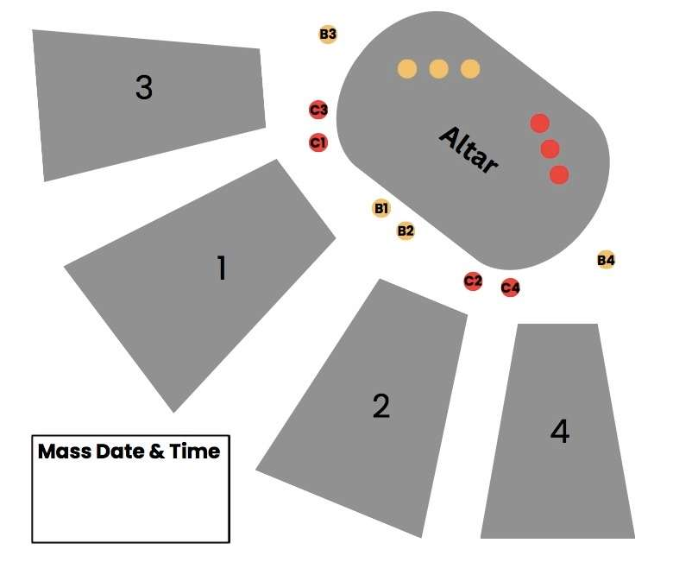

During Mass

The lead Eucharistic Minister (first listed on the sign-in sheet or first listed after the deacon) moves towards the tabernacle after the ‘Our Father’ to retrieve the Blessed Sacrament. The minister leaves the lid from the ciborium on the tabernacle altar and brings the already consecrated Eucharist to the main altar. If there is no deacon, the lead Eucharistic Minister remains standing close to the presider near the altar. S/he will receive first and assist in the distribution of the chalice to the other Eucharistic Ministers.

All other Eucharistic Ministers come to sanctuary during the ‘Lamb of God’ and line up behind the altar. Please use hand sanitizer from the credence table. Those closest to the Presider’s chairs of the sanctuary will get plates and those closest to the ambo will get cups. Leave space between cup and plate ministers as wide as the credence table (table on the back wall)

After the priest (and deacon/lead Eucharistic Minister) receive, communion is distributed to the other Eucharistic Ministers, starting from the ambo side and ending on the presider chair side. The priest or deacon will hand you a plate or a cup. Once the priest moves towards his distribution location, all Eucharistic Ministers take their places.

Note: Altar Servers will not be in the sanctuary at this time, but be the first in line for communion near the St. Elizabeth devotional space.

Configurations for Holy Communion
Large  8 EMs Total  4 Plates  4 Cups | 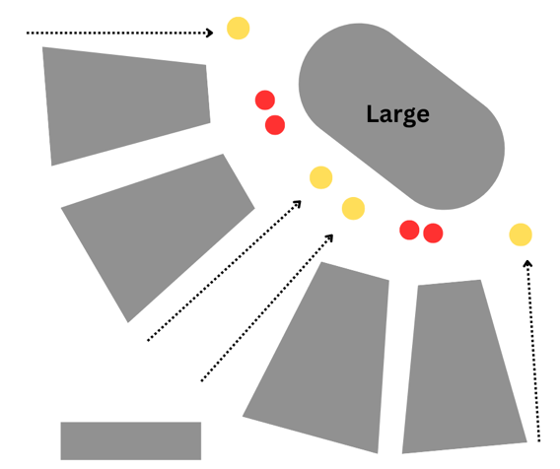
Medium  6 EMs Total  4 Plates  2 Cups | 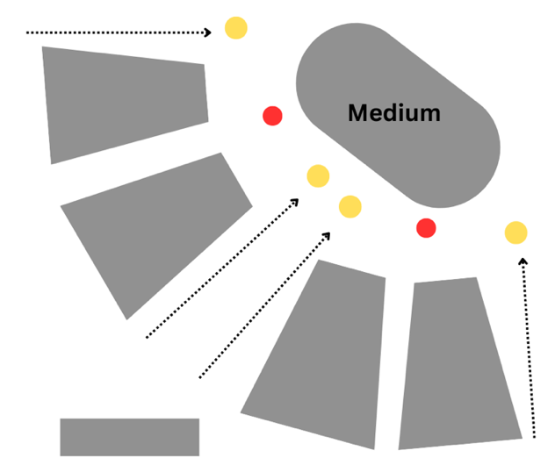
Small  3-4 EMs Total  1-2 Plates  2 Cups | 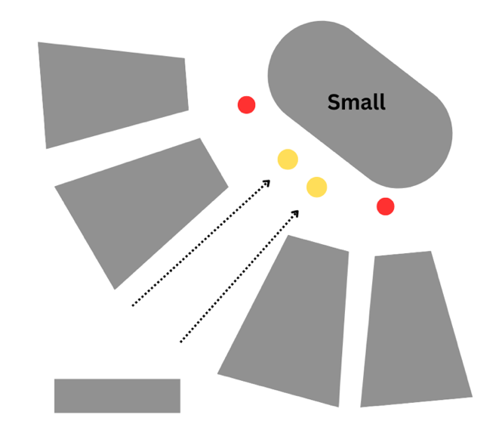

When present, the choir will come forward down the center aisle to receive Communion first. A choir member may have a pyx and request hosts for the Music Director/Musicians unable to come forward.

For the distribution of Holy Communion, please say, ‘The Body of Christ’ or the ‘The Blood of Christ’ as each person receives. Once your line is finished, wait in place until the other line on your side of the Church is finished. For example, ministers in section #2 should wait until all in Section #4 have received before proceeding to those who are unable to come forward; and ministers in section #1 should wait until all in Section #3 have received before proceeding to those unable to come forward. This helps avoid ministers being pulled into the other section and adding confusion.

Once both communion lines on your side of the Church are finished, the Eucharistic Ministers circle their sections. This practice is for people unable to physically come forward for communion but wish to receive. Please move against the communion line looking for people with their hand raised to give them communion. Please always circle your section, even if you don’t see anyone needing communication brought to them at first. Look for the elderly, those with crutches/wheelchairs, or families with young children. Also, please do not move into the section next to you, as each set of Eucharistic Ministers will cover their own section. When present, the ushers will also direct you to the people unable to come forward.

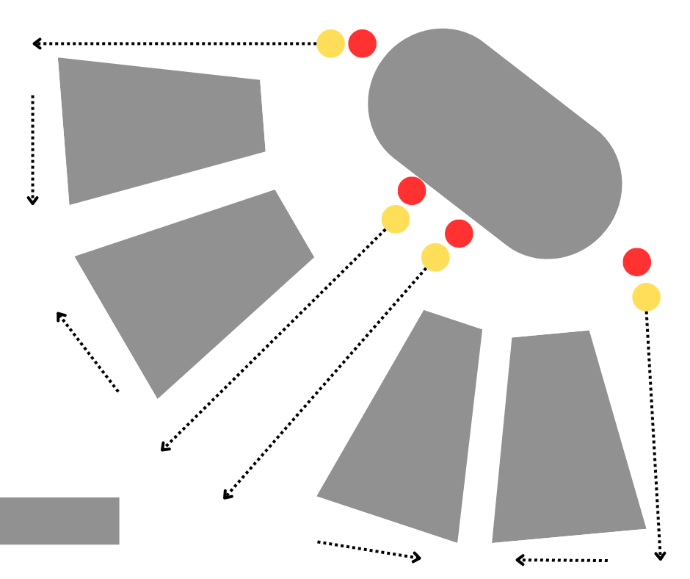
Communion to those unable to come forward

After making a loop around your entire section, return down the diagonal aisles and move to Eucharistic chapel to return the extra hosts or consume the rest of the cup. The lead Eucharistic Minister will combine the extra hosts, fill any pyxs on the altar, and lock the tabernacle. A Eucharistic Minister can take the priest’s plate from him on their way to the tabernacle. After communion, when all ministers move to the Eucharistic chapel and have returned any extra hosts or consumed the rest of the cup, please file out together to bow at the altar and return to your seats.

Additional Information

- Remember to return your cross necklace to the sacristy after mass.
- Sacristans will handle washing the vessels and putting them away/setting up for the next mass.
- Overflow or congregants in the vestibule or Pastors’ Hall should come into the church for communion in one of the designated lines.
- Low Gluten hosts are available by request. Those asking for a low gluten host will tell the sacristan before mass, as we do not consecrate extras in advance. All communicants receiving low gluten should be instructed to go to the presider’s line.
- Please do not stack the Ciborium (plates) unless they have a lid on them.
- The Tabernacle Key is very unique to our tabernacle. Please familiarize yourself with the tabernacle key and how to open the tabernacle before mass if you are the lead Eucharistic Minister. A sacristan can help you.
- Those taking Holy Communion to the homebound will place their empty pyx on the tabernacle Altar in the Eucharistic chapel before mass. If there are any pyxs on the tabernacle Altar, the lead Eucharistic Minister will put one (1) host in each pyx (unless there is a note otherwise) when consolidating after communion. Please use the small hosts in the special ciboria in the tabernacle since they are easier to consume. Those taking communion will pick up their pyx after mass.
- Thank you for your service and dedication to our Lord in this much needed and valued ministry.

