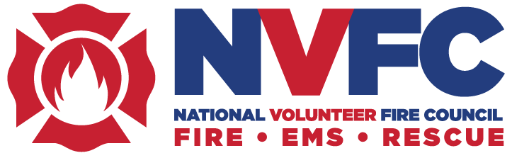

Application Period Now Open for the 2026 NVFC Scholarship to Columbia Southern University

For the 18th year, Columbia Southern University (CSU) and the National Volunteer Fire Council (NVFC) are helping volunteer responders achieve their educational goals through the annual CSU scholarship program. Two NVFC members will receive scholarships to CSU covering up to 60 credit hours towards any one online degree program.

To be eligible, applicants must be an active volunteer responder and a member of the NVFC (join at www.nvfc.org/join). The scholarship will be applied directly to tuition and is valid for up to three years or until degree completion, whichever comes first.

“Training and education are the most requested benefits that our members ask for, and through this annual program we have been able to provide 34 NVFC members with a scholarship they can use towards any CSU degree program,” said NVFC Chair Steve Hirsch. “We appreciate CSU’s ongoing commitment to helping our members attain the education that will propel them forward.”

“Volunteer responders give so much of themselves to their communities, often while balancing careers, families, and public service. At Columbia Southern University, we’re proud to partner with the National Volunteer Fire Council to help support those individuals in reaching their educational goals,” said Natasha Willett, CSU corporate outreach coordinator.

CSU’s online learning platform offers greater flexibility, helping emergency services personnel advance their education while maintaining a healthy work-life balance. Scholarship recipients can select from CSU’s wide range of degree programs, including fire science, fire administration, emergency medical services, emergency management, organizational leadership, and more. Degree options include associate, bachelor’s, and master’s programs. CSU is accredited by the Southern Association of Colleges and Schools Commission on Colleges.

The scholarship application period is open from May 15 through August 17. Winners will be announced in October 2026.

Learn more about this scholarship opportunity and apply on the CSU web site. For questions, please email the scholarship liaison at Scholarships@ColumbiaSouthern.edu or call 888-785-3006.

About Columbia Southern University
As an innovator in online education for 30 years, CSU was established to provide an alternative to the traditional university experience. CSU offers online associate, bachelor’s, master’s, and doctoral degrees such as business administration, criminal justice, fire administration, and occupational safety and health. Visit ColumbiaSouthern.edu or call (877) 347-6050 to learn more. NVFC members and their families receive a 10% discount on tuition.

About the NVFC
The National Volunteer Fire Council (NVFC) is the leading nonprofit membership association representing the interests of the volunteer fire and emergency medical services. The NVFC unites and supports volunteer and combination fire and EMS organizations through education, advocacy, leadership development, and collaboration. Guided by professionalism and innovation, we provide the tools and resources needed to protect communities, advance responder health and safety, and prepare leaders for the future. Learn more and join at www.nvfc.org.

