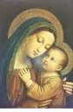 | Reverence Life Committee  Joan Wiering  Tyler, MN 56178  mjwiering@gmail.com  (507)828-5116  www.nudccw.org | Supporting, empowering, and educating members in spirituality, leadership and service; reaching out with Gospel values to meet the needs of Church and society
Reverence Life Newsletter
September 2025

Welcome to Joan Wiering who has accepted the Diocesan Reverence Life Committee Commission. We are grateful and blessed to have her serve in this position!

**********************************
Plan to attend your deanery gathering. If you click on the Deanery, it should take you to their flyer. If not, you can find it on the nudccw.org website. Each Deanery has a wonderful program planned. The Deanery 3 is during the day and is a pilgrimage to the holy sites in New Ulm and Sleepy Eye.

- Deanery gatherings
Deanery 1 - September 25, 2025 at the Holy Rosary in North Mankato, MN
Deanery 2 - September 15, 2025
Deanery 3 - October 13, 2025 /Pilgrimage open to all

******************************************
October is Respect Life Month - Life: Our Sign of Hope
What are you planning to do in your parish for Respect Life Month? Visit the website: www.respectlife.org/respect-life-month

Below are 3 bulletin announcements and clipart which were taken from the website under the Word of Life section. There are also two pulpit announcements. There is a lot of information on the website. Check it out and see what would work for your parish.

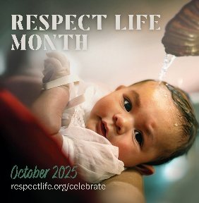
Sunday, October 5th, 2025: It’s Respect Life Month! Join Catholics nationwide in celebrating Respect Life Month. Visit respectlife.org/celebrate.

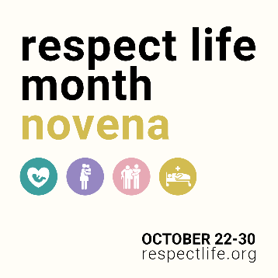
Sunday, October 19th, 2025: Join thousands of Catholics praying a Respect Life Month novena Wednesday, October 22 – Thursday, October 30. Get daily prayers, reflections, and more. Sign up at respectlife.org!

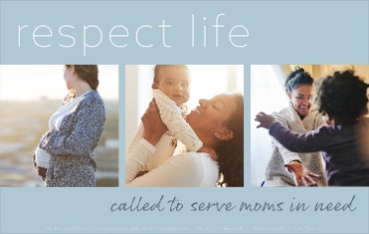
Sunday, October 26th, 2025: The witness of our Blessed Mother [in the Gospel account of her visit to her pregnant cousin, Elizabeth,] invites us to become more aware of the needs of pregnant and parenting moms in our own parishes and communities. Read more at respectlife.org/called-to-serve-reflection.

Pulpit Announcements Option 1: Respect Life Sunday (First Sunday of October) Today is Respect Life Sunday, which kicks off Respect Life Month. We consider more deeply why every human life is valuable and reflect on how to build a culture that protects life from conception to natural death. See the bulletin for more information

Option 2: Respect Life Month (Any Weekend in October) Every October, we celebrate Respect Life Month. We consider more deeply why every human life is valuable and reflect on how to build a culture that protects life from conception to natural death. See the bulletin for more information.

**************************************
From Catholic Vote by Grace Porto on August 27, 2025
Sisters of Life create new website for women seeking abortion

The Sisters of Life have launched a new website offering support and resources for women considering abortions, women whose children have an adverse prenatal diagnosis, and women seeking healing after an abortion.

The website is named the Vis Center, for the Latin word for force or power.
“As women, we know that real power is unleashed when we feel listened to,” the website states.
The Sisters of Life offer to spiritually and emotionally accompany women throughout their pregnancies, and connect women with resources such as legal advice, housing, and medical assistance. They also provide opportunities for healing for women who have already had an abortion. (https://www.viscenter.org/vision)

