Catechesis of the Good Shepherd
List of Additional Atrium Materials Needed
Items need to be in good condition but used items are welcome.
Materials are child-sized, beautiful and used for the purpose they are used in the adult world.

Items No. each needed

Items to Purchase:
Child-sized tables 1
Shelving units 4’ long x 2-3’ tall 1
Prayer Table 2-½’ x 3’wide x 18” tall 1
Art Work (Nativity scene, City of Jerusalem,
Angel, Temple, Altar, Good Shepherd,etc) 4-6
Good Shepherd Statue - 1
Miniature Candelabra birthday candle size 2
Miniature trinkets for gold, frankincense and myrrh
Lacing, bead stringing. 2
(related to the church, mass, Jesus, Bible
stories, the natural world)
Single hole punch 1

Votive candles - 1 box (12) Red
Items No. each needed

Handmade Items:*
Work rugs or mats 36-40” by 12-18” 6
Model lectern 16” tall by 8” wide 3” deep 1 1

CGS Materials Descriptive Inventory List for 3-6 Atrium
(All measurements given are approximate and not designed as absolutes).
Furniture
Tables: 12”-15” high - child-size 20x36” (approximate size) no longer than 4’
- Shelving Units: 4’ long, 2.5-3’ tall, 12”-18” between shelves. Each unit should have 3 shelves (bottom, middle, top). Bottom shelf should stand 2”-3” off floor. We just need one more of these - don’t have to be exact dimensions.
- Prayer Table: (12”-15” high – surface area flexible (15”x30”)).
Art Work: Selection of art postcards for prayer table containing themes from the 3-6 atrium and/or medium sized pictures for hanging
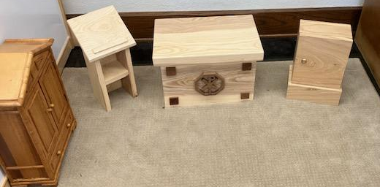
- Altar: Sacristy Cabinet for all Altar work
- and model Lectern

