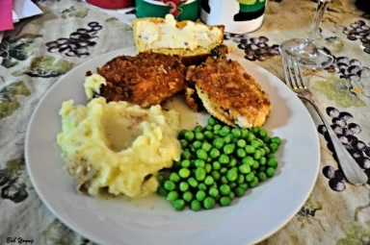
Chicken Dinner
Including vegetables, mashed potatoes and gravy, cole slaw & ice cream!

Sunday, October 4, 2026
11:30 AM – 1:00 PM
Lincoln Street
(west of the Fire Hall)
St. Genevieve’s (Lake Benton)
Parish Festival



ADULTS: $15.00 Children 10 & under: $5.00
Meals on Wheels – Call Before Sunday:
(507) 829-4094 (Eileen)



Winners for the Cash Raffle

will be drawn at 1:00 PM


