
SWO Nazarene Missions International

Local President's Handbook
  - 2026-2027 Edition

Equipping local churches to engage the world through prayer, generosity, education, and service.
PURPOSE OF THIS HANDBOOK
This handbook is designed to help every local NMI president understand the role, plan the year, involve the church, care for missionaries, and finish the year well.
Southwestern Ohio District

Welcome to the Adventure

Whether you volunteered, were elected, or were asked by your pastor to serve, thank you for saying yes.
Serving as the Local Nazarene Missions International (NMI) President is one of the most meaningful leadership opportunities in your church. Through your leadership, people of every age can discover God's heart for the world and become personally involved in making Christlike disciples in the nations.
As Local NMI President, you are more than an organizer of events or promoter of offerings. You are a missions leader. You help your congregation pray for missionaries, support global ministry, welcome missionaries into your church, inspire children and youth to care about the world, and encourage people to answer God's call to serve.

YOU ARE NOT ALONE
Your pastor, your local NMI council, the Southwestern Ohio District NMI Council, and Global NMI are available to help you succeed. Ask questions early. We would rather answer ten small questions than help fix one large problem later.

Keep this handbook nearby throughout the year. Write in it. Highlight it. Bring it to council meetings. Use it as a field guide, not decoration.
Thank you for serving Christ and His Church through missions.
Pam Carroll
District NMI President
Southwestern Ohio District
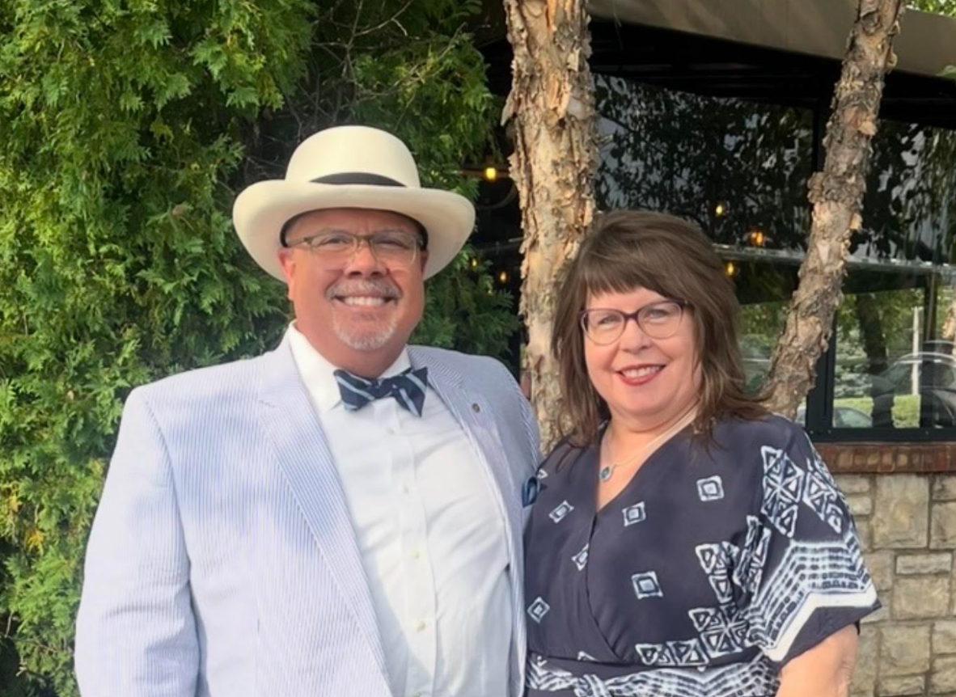

How to Use This Handbook

This handbook is built around the rhythm of a local NMI year. It begins with your calling as a leader, moves into planning and ministry, and ends with reporting, convention, and transition.

Each chapter answers four questions
- Why does this matter?
- What am I responsible for?
- How do I lead this in my church?
- Who can help me?

First Five Actions
☐ Meet with your pastor.
☐ Identify your local NMI council or begin recruiting one.
☐ Put district convention and reporting deadlines on your calendar.
☐ Review the Five Areas of Impact with your council.
☐ Contact your zone chair or district NMI president with any questions.

Table of Contents

Part One — Becoming an NMI Leader 5
1. What is NMI? 6
2. The Five Areas of Impact 7
3. Your Role as Local President 8
4. Working with Your Pastor and Council 9
Part Two — Beginning the Church Year 10
5. Your First 30 Days 11
6. Planning the NMI Year 12
7. Building a Local NMI Council 13
8. Communicating Missions 14
Part Three — Funding the Mission 15
9. World Evangelism Fund 16
10. Faith Promise 17
11. Easter and Thanksgiving Offerings 18
12. Alabaster and Special Offerings 19
Part Four — Caring for Missionaries 20
13. LINKS 21
26-27 LINKS Missionaries 22
14. Hosting Missionaries and Deputation 23
15. Missionary Health Care, Awards, and Memorial Roll 24
Part Five — Serving Beyond Your Church 25
16. District Ministries 25
17. Children’s Project 26
18. Compassionate Ministries and Disaster Response 27
Part Six — Finishing the Year Well 30
19. End-of-Year Reports 31
20. Convention, Delegates, and Awards 32
Part Seven — Resources 33
21. Contacts (Council Members) 34
22. Useful Web Links……..…….…………..……………………………..………………………………………………………………35
Appendices 36
Appendix A. Missionary Visit Checklist 37
Appendix B. Faith Promise Planning Timeline 38
Appendix C. Council Meeting Agenda Template 39
Appendix D. Year-End Tracking Worksheet 40

PART ONE
Becoming an NMI Leader
GUIDING THOUGHT
The role of the Local NMI President is to help people discover God's heart for the world.

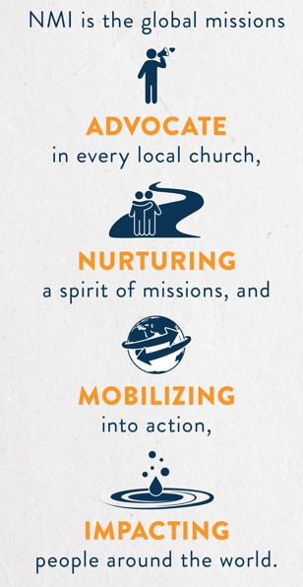


1. What is NMI?

Nazarene Missions International exists to mobilize the church in mission.
NMI is the global missions advocate in the local church. Its purpose is to help every congregation participate in God's mission through prayer, giving, education, missionary care, and personal involvement.
NMI is not simply a program or committee. It is a way of helping the whole church see beyond its own walls and participate in making Christlike disciples in the nations.

NMI helps the local church
- Develop missionaries.
- Send missionaries.
- Support missionaries through prayer and giving.
- Educate individuals and congregations in Nazarene missions.
- Welcome and host missionaries on home assignment.
- Equip missionaries to return to their field of service.
- Nurture the spirit of missions in everyone.

LEADERSHIP PRINCIPLE
People become excited about missions when they see what God is doing. Tell stories all year long, not only when receiving offerings.

Quick Win
This week, share one short missions story in worship, Sunday School, a newsletter, or social media post. Keep it under three minutes and end with one prayer request.

2. The Five Areas of Impact


The Five Areas of Impact provide a simple framework for a healthy missions ministry.

Prayer

Mission begins with prayer. Pray regularly for missionaries, world areas, local outreach, and those who have not yet heard the gospel.

World Evangelism Fund

The World Evangelism Fund fuels the Church of the Nazarene's global mission through the shared generosity of local churches and individuals.

Alabaster

Alabaster offerings help provide land, buildings, and ministry facilities around the world.

Engaging Children and Youth

Children and youth should not only hear about missions; they should pray, give, learn, serve, and imagine their own role in God's mission.

Links
Links connects districts and churches with assigned missionary families for prayer, communication, encouragement, and giving.

REMEMBER
The Five Areas do not limit NMI. They give every church a strong starting point. Once these are healthy, your church can add additional mission emphases that fit your congregation.

Five Areas Health Check
☐ Does our church pray publicly for missions at least monthly?
☐ Do we understand and support World Evangelism Fund?
☐ Do we promote Alabaster at least twice a year?
☐ Are children and youth intentionally included?
☐ Do we know our Links missionaries and communicate with them?

3. Your Role as Local President

You help your church become a missions-minded church.
The Local NMI President promotes NMI in cooperation with the pastor, leads the local NMI council, and serves as a voting member of the church board. The exact rhythm will look different in every congregation, but the mission is the same: help the church participate in God's mission locally and globally.

Core responsibilities
- Lead the local NMI council.
- Work closely with the pastor.
- Promote the Five Areas of Impact.
- Encourage giving to World Evangelism Fund and mission offerings.
- Support Links missionaries.
- Help schedule and host missionary speakers.
- Keep missions visible throughout the year.
- Submit annual NMI reports.
- Attend and promote district NMI convention.

SUCCESS IS NOT MEASURED BY CHURCH SIZE
A small church can be a strong missions church. Faithfulness, consistency, prayer, and generosity matter more than attendance numbers.

Common mistakes
- Waiting until offering time to talk about missions.
- Trying to do everything alone.
- Assuming people already know why NMI matters.
- Letting the year pass without a calendar.
- Forgetting to track mission activity until report time.

4. Working with Your Pastor and Council

Healthy missions leadership begins with partnership. The Local NMI President should not operate as a separate ministry disconnected from the pastor or church board. Missions should be woven into the life of the church.

Working with your pastor
- Ask how missions can support the church's overall vision.
- Schedule mission emphases early so they fit the church calendar.
- Clarify who approves speakers, offerings, and announcements.
- Discuss how often mission moments can be included in worship.
- Share annual goals and celebrate progress together.

Working with your council
A strong council does not need to be large. It needs to be faithful, prayerful, and willing to help. Look for people who care about prayer, children, finances, hospitality, communication, and service.

COUNCIL IDEA
Consider assigning one person to each major area: Prayer, WEF/Faith Promise, Alabaster, Links, Children/Youth, Missionary Hospitality, and Compassionate Ministries. One person may cover more than one area in a smaller church.

Pastor Meeting Agenda
☐ What are the church's mission priorities this year?
☐ When should Faith Promise or WEF emphasis happen?
☐ Which Sundays are available for missionary speakers?
☐ How will we include children and youth?
☐ What does the pastor need from the NMI council?

PART TWO
Beginning the Church Year
GUIDING THOUGHT
A missions year becomes easier when the calendar is planned before the calendar fills itself.



5. Your First 30 Days

A new Local NMI President does not need to fix everything immediately. Start with relationships, calendar, and clarity.

First 30 Days
☐ Pray for your church, pastor, council, and missionaries.
☐ Meet with your pastor.
☐ Find last year's NMI report and review it.
☐ Confirm who serves on the local NMI council.
☐ Identify your church's strongest and weakest Five Areas of Impact.
☐ Put report deadlines and district convention on the calendar.
☐ Review current Links assignments and district projects.
☐ Make a simple 90-day plan.

First council meeting
Keep the first council meeting simple. Do not begin by assigning too much. Begin with prayer, review the Five Areas, look at the calendar, and choose a few immediate priorities.

QUICK WIN
At the first council meeting, ask each person to answer this question: What is one thing our church already does well in missions, and what is one area where we could grow this year?

6. Planning the NMI Year

The best missions calendar is intentional but not crowded. Your goal is not to promote everything every month. Your goal is to keep missions visible, meaningful, and connected to the life of the church.

Suggested annual priorities
Season | Focus
June-July | Review reports, set goals, update contacts, and prepare for the new church year.
August-September | Launch the year, promote prayer, and plan fall offerings or projects.
October-November | Highlight Thanksgiving Offering, missionary care, and compassionate ministries.
December-January | Tell mission stories, promote prayer, and review midyear progress.
February-March | Prepare for Faith Promise, Easter Offering, or Alabaster emphasis.
April-May | Collect report information, elect delegates, celebrate the year, and prepare transition notes.

7. Building a Local NMI Council

A local NMI council helps the president lead without carrying the entire ministry alone. In smaller churches, the council may be informal. In larger churches, each person may lead a specific area.

Suggested roles
- Prayer Coordinator
- WEF / Faith Promise Coordinator
- Alabaster Coordinator
- Links Coordinator
- Children and Youth Missions Leader
- Missionary Hospitality Coordinator
- Compassionate Ministries Coordinator
- Communications Coordinator
- Secretary / Reporting Helper

SMALL CHURCH NOTE
A smaller church may only have two or three people. That is enough. Start with prayer, giving, and one visible mission story each month.

Council Recruitment Checklist
☐ Ask the pastor for recommendations.
☐ Invite people personally; do not only announce.
☐ Give each person a clear role.
☐ Keep meetings focused and brief.
☐ Celebrate completed tasks.

8. Communicating Missions

Missions becomes part of the culture of a church when people hear about it regularly. Communication does not need to be long. It needs to be consistent.

Simple communication channels
- A three-minute mission moment in worship.
- Monthly prayer request in the bulletin.
- Short newsletter article.
- Church social media post.
- Mission bulletin board.
- Children's missions spotlight.
- Testimony from someone who participated in a project.

RULE OF THUMB
Tell one story, give one fact, and name one action. Anything more may be too much for a quick mission moment.

Sample mission moment

Free NMI education resources
- NMI Central - a free weekly missions email; subscribe at nazarene.org/nmi.
- "Nazarene Missions International" on Facebook - stories, updates, and reels (13,000+ followers).
- NMI Podcast - missions stories and conversations, plus short-form Podcast Shorts.
- Send Me - Nazarene Missions' video series on the call to go and serve.
- Nazarene Fast Facts - quick, shareable facts about the worldwide Church of the Nazarene.
- Kid's Kaleidoscope - a printable children's page featuring a Country of the Month.
- NMI Snapshot - first-person stories from the field.
This month we are praying for our Links missionaries. They serve through Nazarene missions and depend on churches like ours for prayer and encouragement. Please take this card home and pray for them this week. We will also receive a Links offering at the end of the month.

PART THREE
Funding the Mission
GUIDING THOUGHT
Generosity grows when people understand what their giving makes possible.

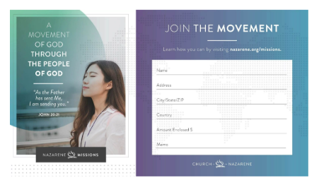
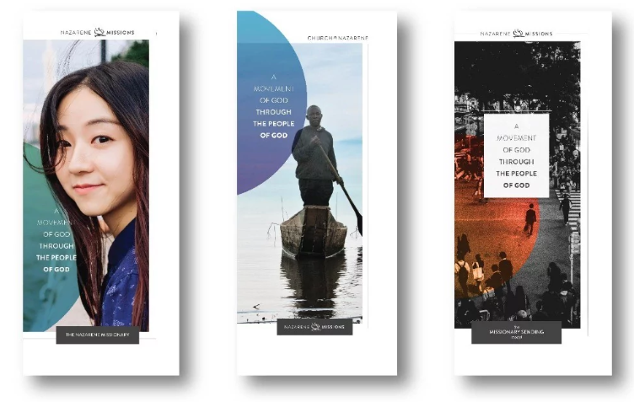


9. World Evangelism Fund

The World Evangelism Fund (WEF) fuels the Church of the Nazarene's mission by combining gifts from churches and individuals around the world. Every local church is encouraged to participate faithfully in supporting this shared mission.

What WEF supports
- Missionary sending and support.
- Global ministry infrastructure.
- Leadership development.
- Church planting.
- Education, evangelism, compassionate ministry, and regional ministry support.

WEF GIVING GUIDELINE
The suggested World Evangelism Fund goal is 5.5 percent of the church's current income.

How to promote WEF
- Explain what WEF is before asking people to give.
- Share stories showing how WEF supports real ministry.
- Report progress throughout the year.
- Celebrate when the church reaches its goal.
- Connect WEF to the larger Nazarene mission: making Christlike disciples in the nations.

WEF President Checklist
☐ Know your church's WEF goal.
☐ Ask the treasurer for giving updates at least quarterly.
☐ Promote Easter and Thanksgiving offerings if your church uses them.
☐ Consider Faith Promise as a year-round approach.
☐ Celebrate progress publicly.

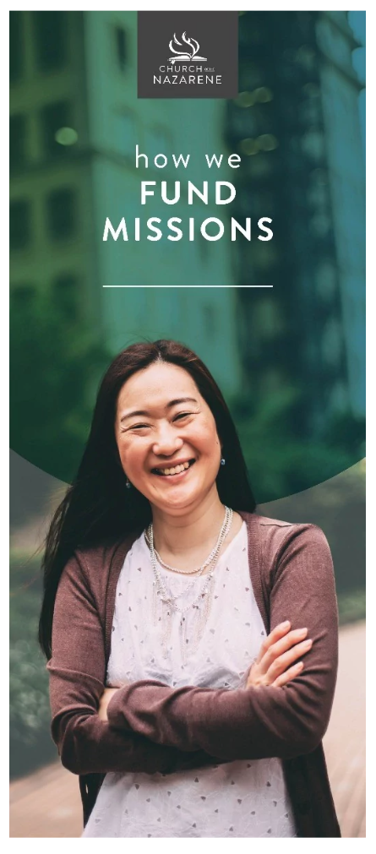

10. Faith Promise

Faith Promise is a plan for systematic missions giving above the tithe. Instead of only receiving one or two mission offerings each year, individuals and families pray about what God would have them give to missions over time.

Why Faith Promise helps
- It teaches prayerful generosity.
- It gives families a concrete way to participate in missions.
- It helps the church plan mission giving throughout the year.
- It keeps missions visible beyond one Sunday.

Planning questions
- When will the emphasis happen?
- Who will speak?
- Will it be one service, a full weekend, or a multi-week emphasis?
- What children and youth activities can be included?
- How will commitments be collected and followed up?
- How will progress be reported during the year?

COMMON MISTAKE
Do not treat Faith Promise as only a fundraising event. It is discipleship. Teach people to pray, listen, trust, and participate.

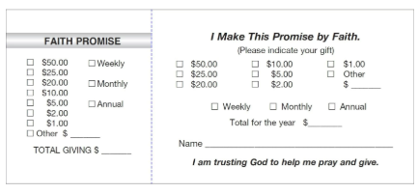

11. Easter and Thanksgiving Offerings

The Easter and Thanksgiving offerings are traditional opportunities to support the World Evangelism Fund. These offerings can help raise awareness of global missions and provide simple entry points for people who may not yet participate in Faith Promise.

Ideas for a strong offering emphasis
- Begin promotion several weeks early.
- Use a short missions video or story.
- Explain where the offering goes.
- Provide giving envelopes or clear online instructions.
- Report the result and say thank you.

QUICK WIN
Choose one Sunday before Easter or Thanksgiving to tell a short story of how Nazarene missions is making Christlike disciples in the nations.




12. Alabaster and Special Offerings

Alabaster helps provide ministry facilities and property around the world. Special offerings may also support district projects, missionary care, children's projects, disaster response, or other approved needs.

Best practices
- Make the purpose clear.
- Use a visual goal when possible.
- Connect the offering to prayer.
- Involve children and youth.
- Tell the church what happened after the offering.

TREASURER PARTNERSHIP
Always coordinate with the church treasurer and district instructions before receiving or sending funds. Use the required memo lines and payee names exactly as provided.
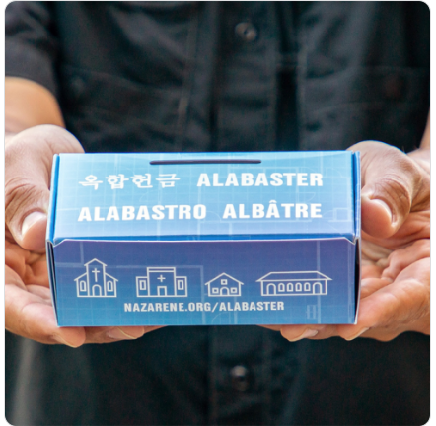

PART FOUR
Caring for Missionaries
GUIDING THOUGHT
Missionaries need more than offerings. They need prayer, hospitality, encouragement, and faithful churches.

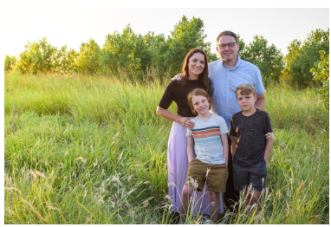
Kurt and Holly Johnson
Sweet Surrender Café
Poznan, Poland

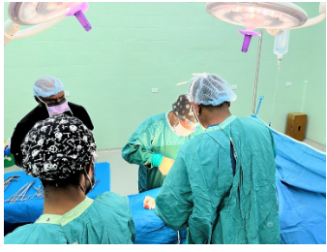

PNG Nazarene Hospital
Ben & Katherine Radcliffe


13. Links

Links is one of the Five Areas of Impact and is a strategic ministry that connects Nazarene missionaries with districts and local churches. Through Links, churches pray for assigned missionary families, communicate with them,
encourage them, and support them financially when appropriate.

What local churches can do
- Pray for Links missionaries regularly.
- Display their photo and basic assignment information.
- Send cards or messages of encouragement.
- Invite children and youth to learn about their area of service.
- Receive a Links offering when appropriate.
- Share updates with the congregation.

GIFTS AND SHIPPING
Avoid sending physical letters or packages unless the missionary has a specific need and requests items. International shipping can create expensive duties for missionaries. Ask before mailing anything.

Sending financial gifts
Follow current SWO and Global NMI instructions. Use the correct payee, mailing address, and memo line. Do not make checks payable directly to the missionary when district or denominational guidelines instruct otherwise.

RESTRICTED INFORMATION
Do not publish sensitive missionary names, locations, or photos online. If a missionary or assignment is marked restricted, use only the district-approved wording and distribution method.

2026-2027 LINKS Missionaries

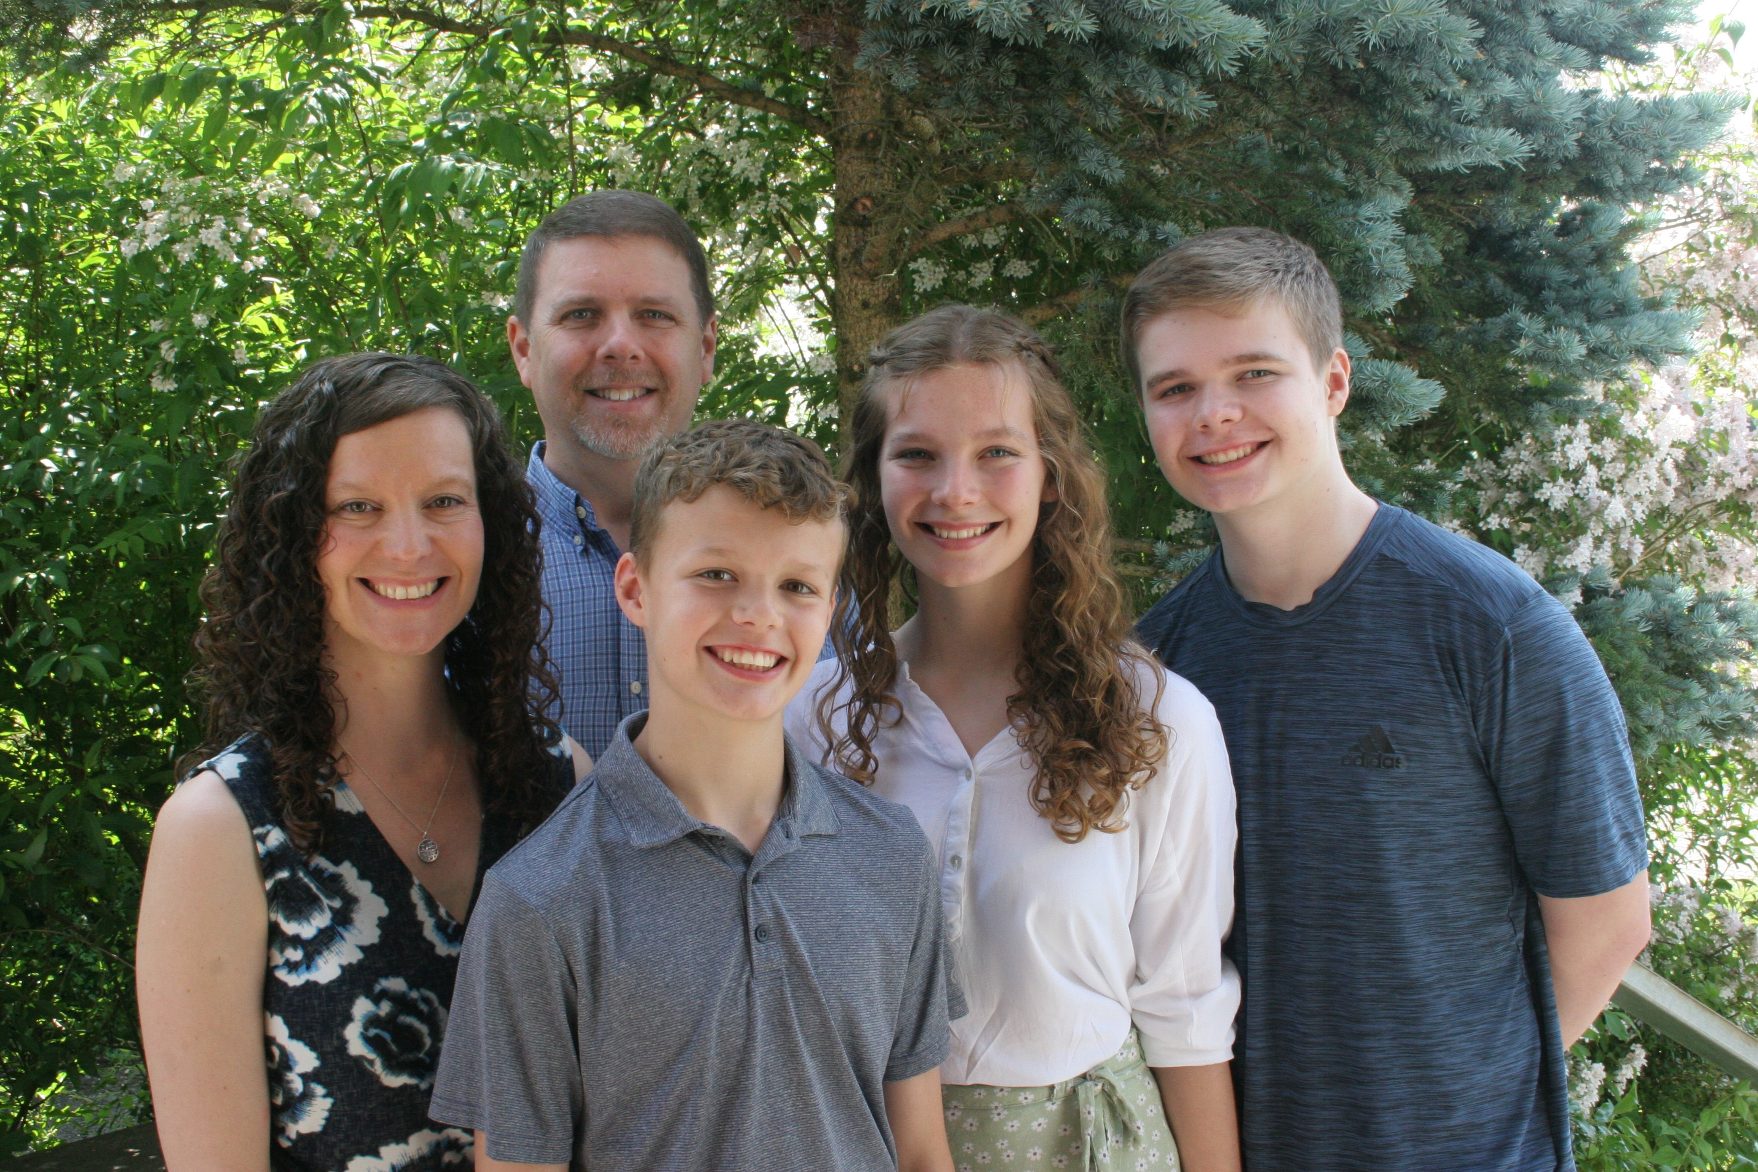
Douglas & Jennifer Mann (rpc@eurasiaregion.org)

Having been missionaries for over 20 years, we have now lived in “Switzermanny” for 9 years (enclave of Germany inside of Switzerland called Buesingen am Hochrhein. Doug and I (mostly!) enjoy our responsibilities for the Eurasia Region and certainly are fulfilled in supporting the missions efforts across our 41 countries with Nazarene presence and beyond!

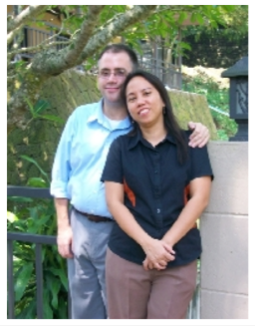
Mitchel & Marnie Modine (mmodine@apnts.edu.ph)

The Modines serve on the Asia-Pacific region. Mitchel is professor of Old
Testament at Asia-Pacific Nazarene Theological Seminary. Marnie serves in the Asia-Pacific regional office. Her responsibilities are statistics and other regional records.
Mitchel and Marnie met in the Philippines and were married in July 2009. Mitchel earned a PhD in Old Testament in 2006 while Marnie completed an MBA in 2009. Marnie enjoys cooking, and Mitchel enjoys eating Marnie’s cooking.

SWO District Missionaries
Laura & Taylor Myatt Ben & Katherine Radcliffe Matt & Faye Wagner
Papua New Guinea, Asia Pacific Papua New Guinea, Asia Pacific Guatemala, Mesoamerica
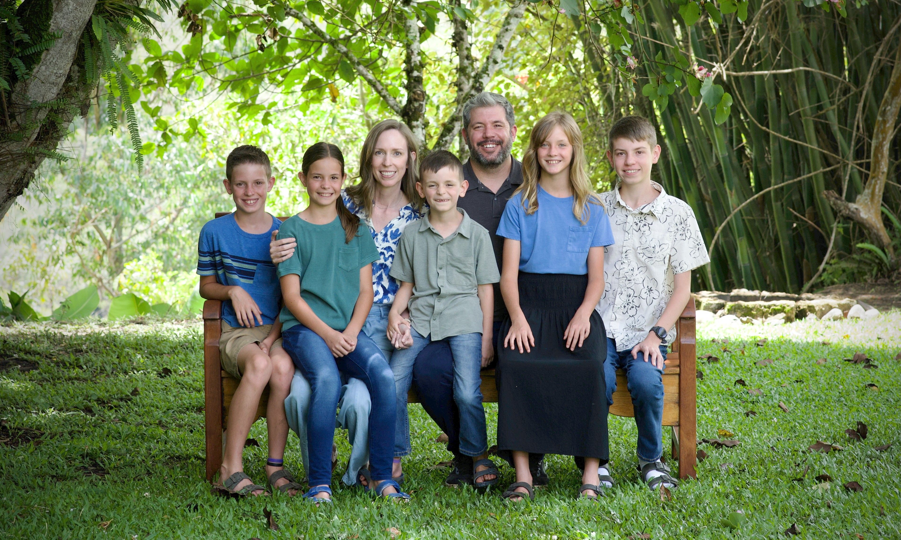
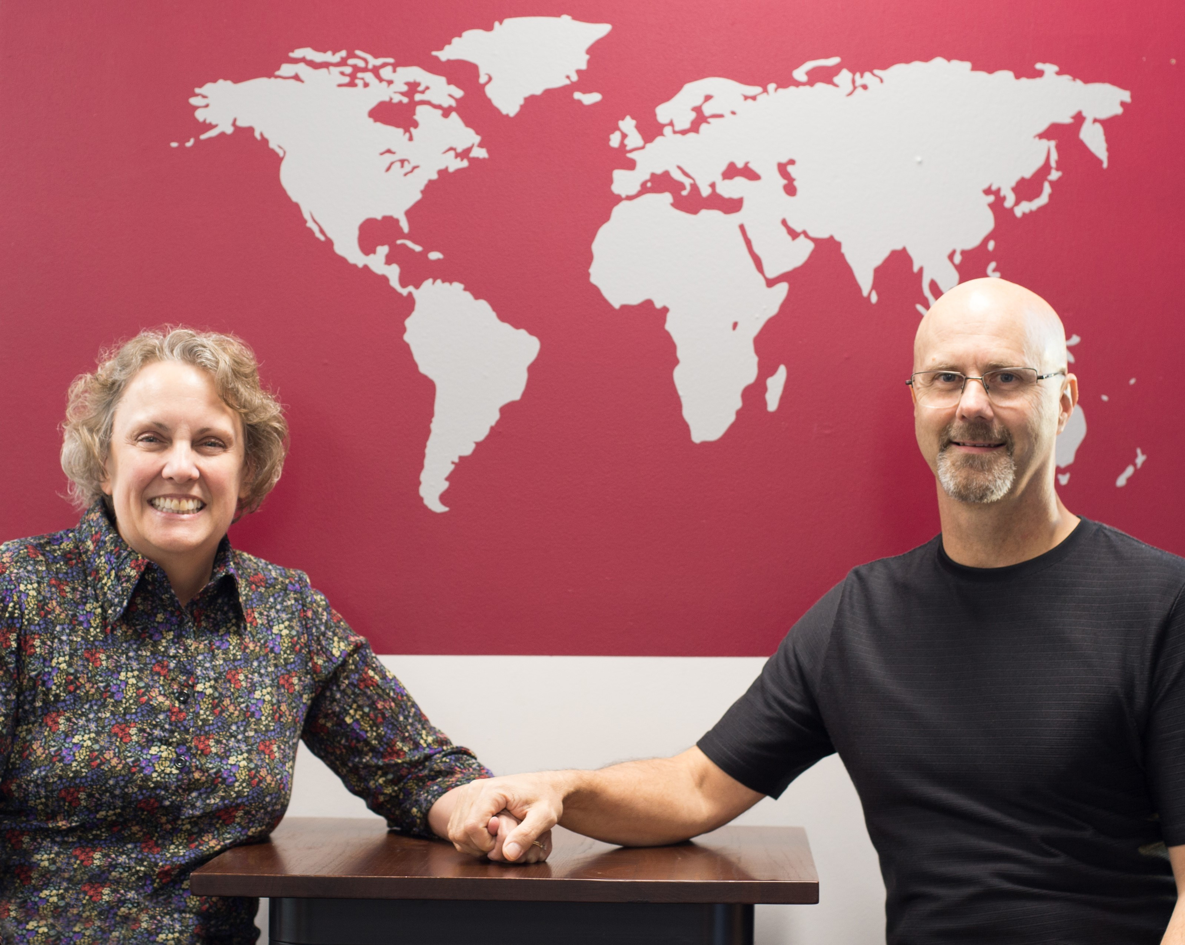
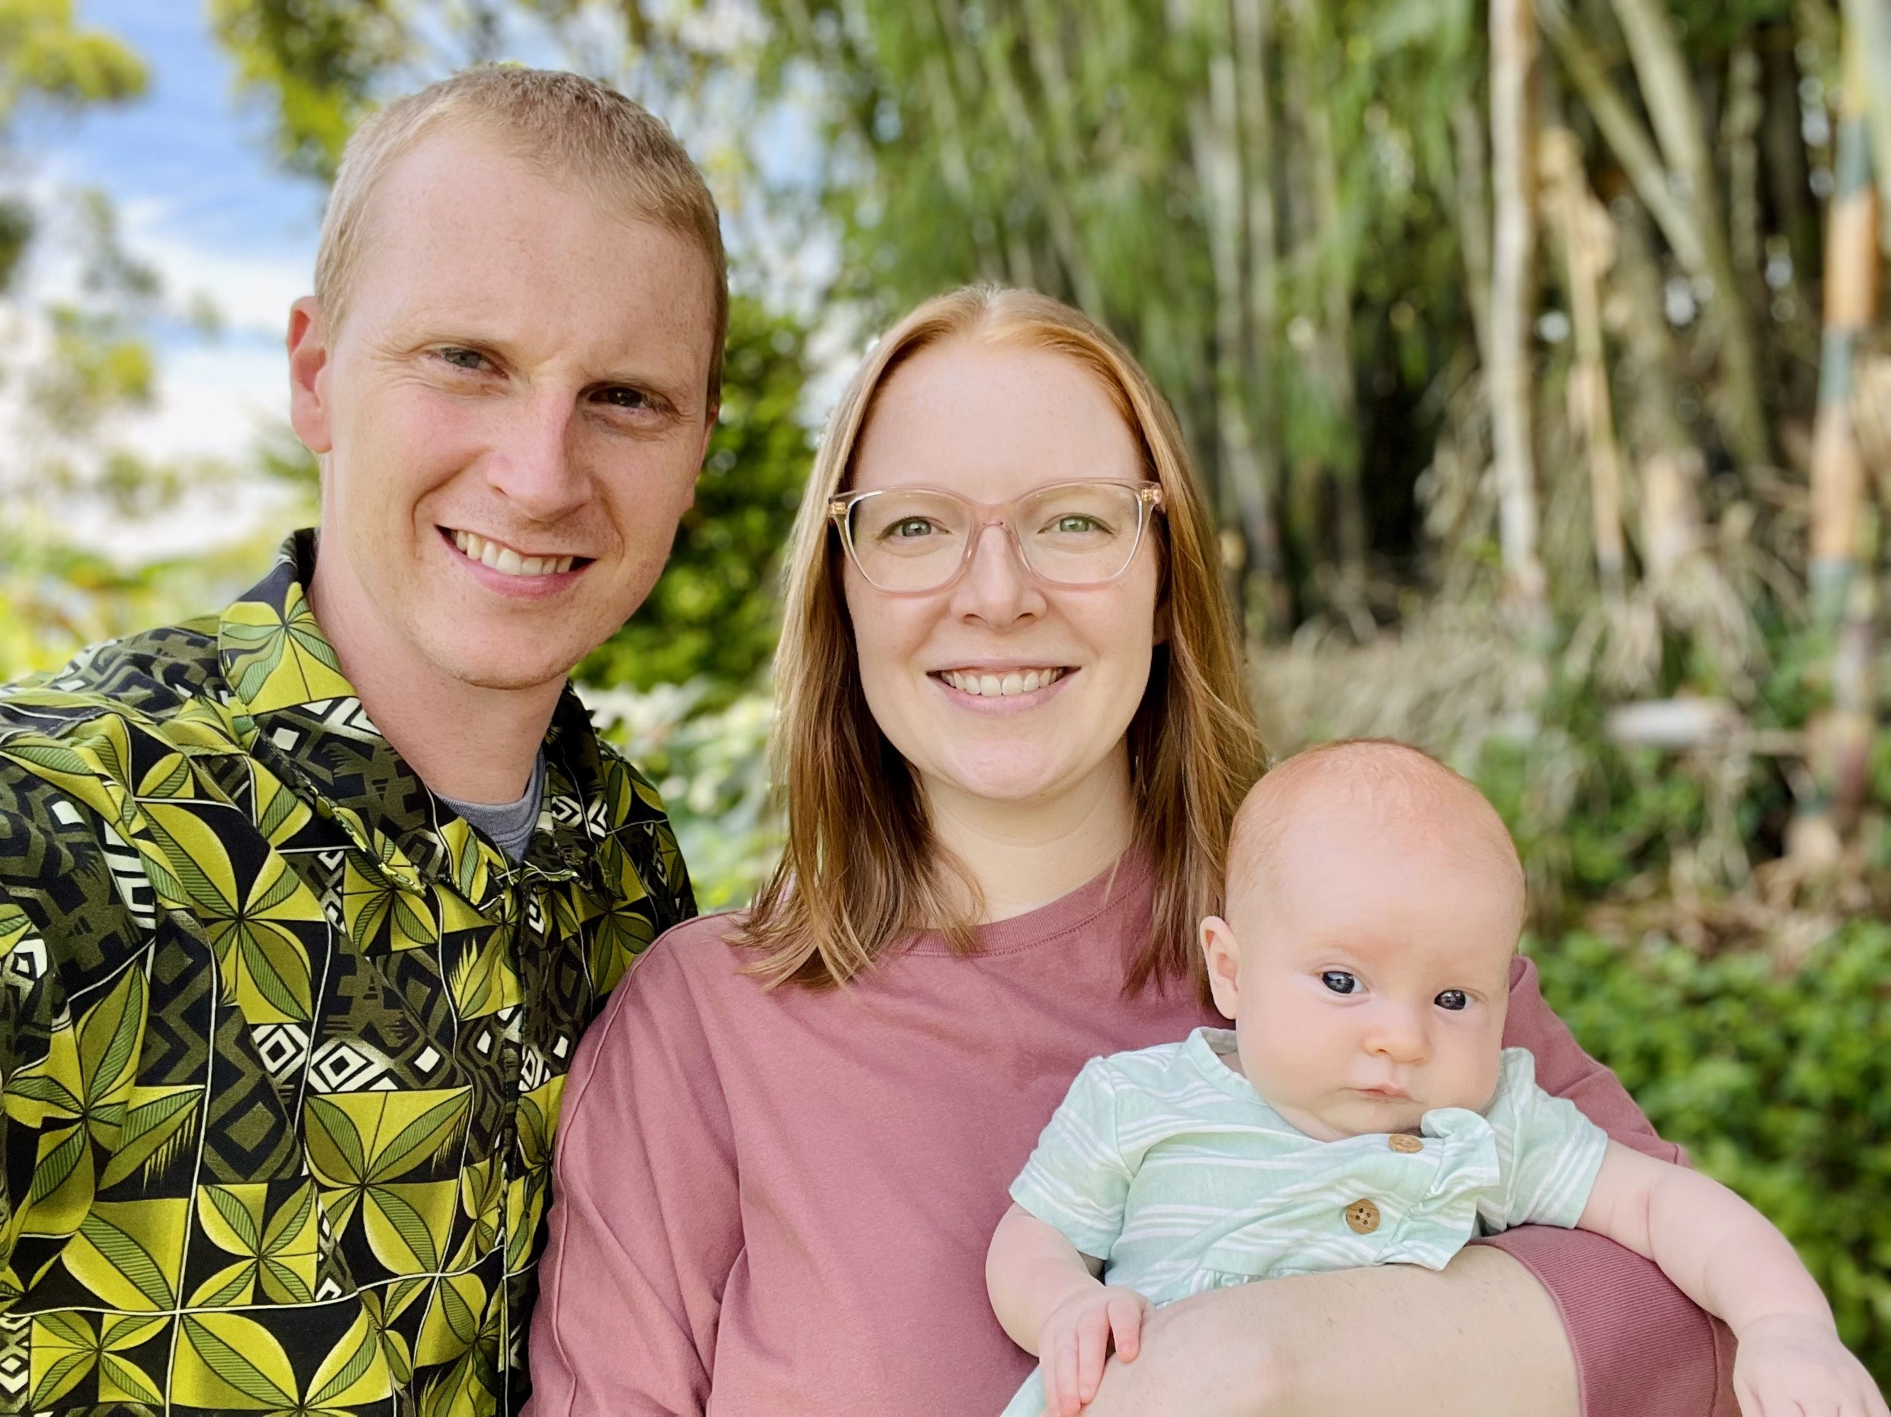

Not pictured: The Wheatleys from a Creative Access Area
Retired District Missionaries
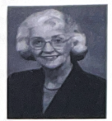
Jim & Kathy Radcliffe Wanda Terry
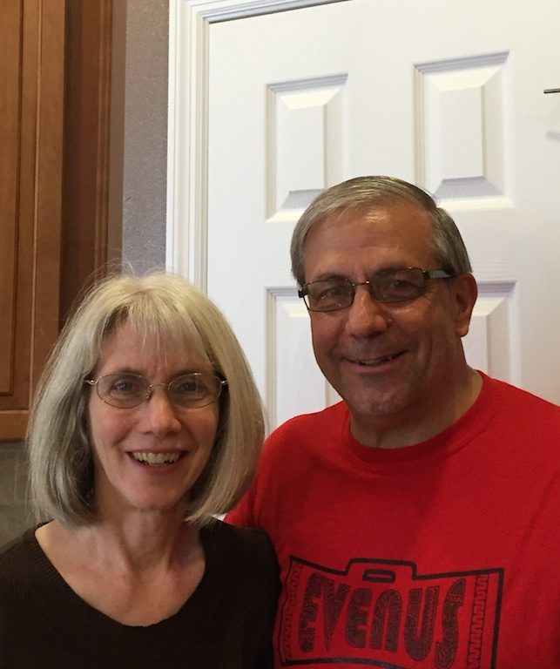

14. Hosting Missionaries and Deputation

When a missionary visits your church for deputation, Faith Promise, or a mission emphasis, your preparation helps the missionary serve well and helps your congregation connect personally with the global mission of the Church.

Before the visit
- Pray for the missionary and ask for specific prayer requests.
- Confirm date, time, location, format, and length of presentation.
- Ask about technology needs.
- Clarify transportation, lodging, meals, and dietary needs.
- Ask what can be published online or streamed.
- Promote the visit early.

During the visit
- Introduce the missionary warmly.
- Help them connect with children, youth, small groups, and people discerning a call.
- Receive a deputation offering after the missionary shares.
- Provide meals and lodging with hospitality and sensitivity.

Four common ways to give deputation support
- Check payable to “Global Treasury Services” with: ‘Missionary Name(s) Deputation’ in the memo line. Mail to: Global Treasury Services, P.O. Box 843116, Kansas City, MO 64184-3116.
- Use the Funding the Mission online giving site: www.fundingthemission.org with: ‘Missionary Name(s) Deputation’ in the memo.
- Use the missionary profile site: www.nazarene.org/missionary-profiles.
Select the missionary and click on GIVE NOW.
- Check payable to SWO District NMI with missionary name and local church name in the memo. Send to NMI Treasurer: Vickie Rocheleau, 316 Macready Ave, Monroe, OH 45050.

15. Missionary Health Care, Awards, and Memorial Roll

NMI helps churches honor faithful service and support missionary health care through established recognition programs. These are meaningful ways to encourage people while also blessing missionaries.

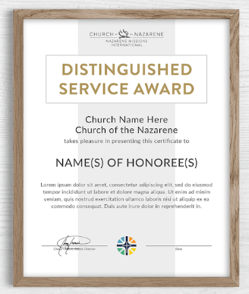
Distinguished Service Award
The Distinguished Service Award is a tribute to living church members or participants who have served faithfully. It may be given through NMI even when the person's service is not specifically in missions.

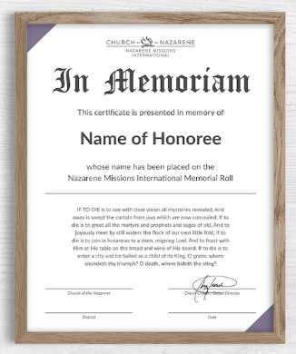
A picture of the "How We Fund Missions" brochure available for purchase from the foundry publishing. Memorial Roll
The Memorial Roll honors deceased friends and loved ones. Gifts connected to the Memorial Roll help offset missionary health care costs and free World Evangelism Fund donations for global ministry uses.

CURRENT AMOUNTS
The Distinguished Service Award is $125. The Memorial Roll is $75.

Suggested Memorial Roll letter
Dear [Name],
Please accept our sincere condolences at the passing of your loved one, [Name].
The Church of the Nazarene has a program called the Memorial Roll, a record of people who have been memorialized by gifts to the Missionary Health Care Plan. It is a meaningful way to honor the deceased and to support Nazarene missionaries globally.
Our local NMI council has honored [Name] by ordering a Memorial Roll certificate in [his/her/their] memory. Enclosed is the certificate from the global Church of the Nazarene. Please know that this gift helps provide health care assistance for Nazarene missionaries around the world.
May God's richest blessings be yours,

PART FIVE
Serving Beyond Your Church
GUIDING THOUGHT
District ministries give every church practical ways to serve, give, and go.

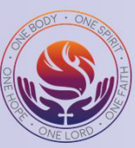
16. District Ministries

The Southwestern Ohio District provides ministries and projects that allow local churches to participate beyond their own congregation. The following chapters and the contact table in Chapter 21 introduce current district opportunities and the people who lead them.

17. Children's Project

The district Children's Project gives children and local churches a focused way to participate in a specific missions need each year.

2026-2027 Junior Project: Sweet Surrender Cafe - Poznan, Poland
This year's Junior Project supports the Sweet Surrender Cafe in Poznan, Poland - the coffee-house ministry led by Nazarene missionaries Kurt and Holly Johnson. Sweet Surrender is a real, working coffee house that serves as a non-threatening entry point into the community, where people who might never walk into a traditional church find a warm welcome, genuine friendship, and the love of Christ. The first Sweet Surrender opened in Gdansk in 2008, and the Poznan cafe followed in 2010.
When war came to Ukraine, the Poznan cafe became a refuge. Sweet Surrender has served Ukrainian families fleeing the conflict - offering Polish-language classes, art therapy, women's fellowship groups, children's programs, and a place of trauma recovery and hope.
- Give: Sweet Surrender Cafe - Approved Mission Special #154046
- Online: give.nazarene.org/donate/154046
- District Junior Project goal: $3,000

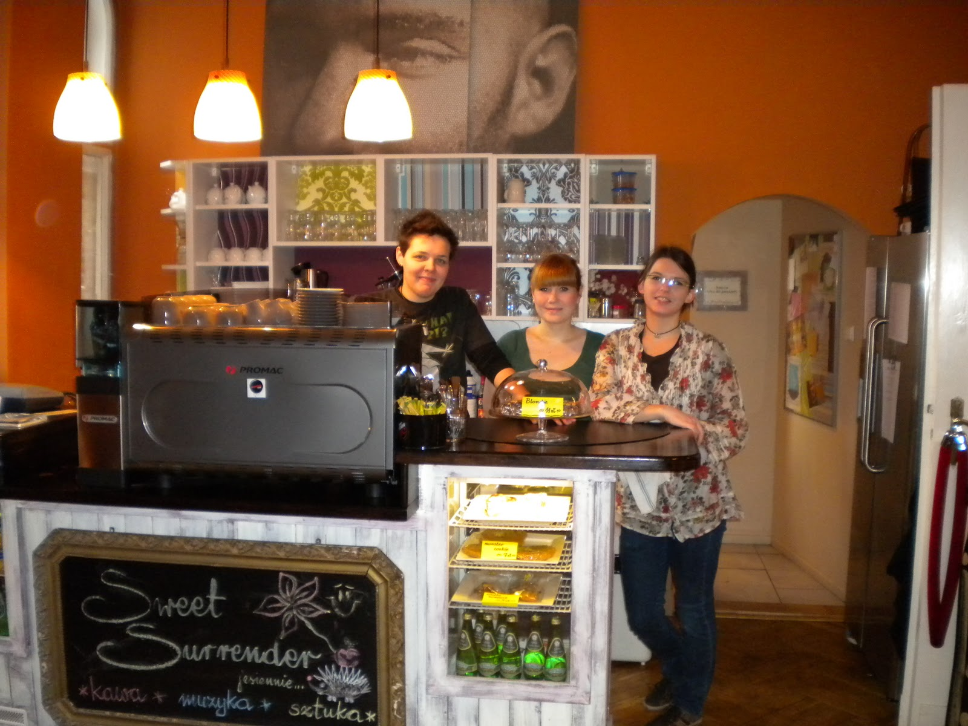
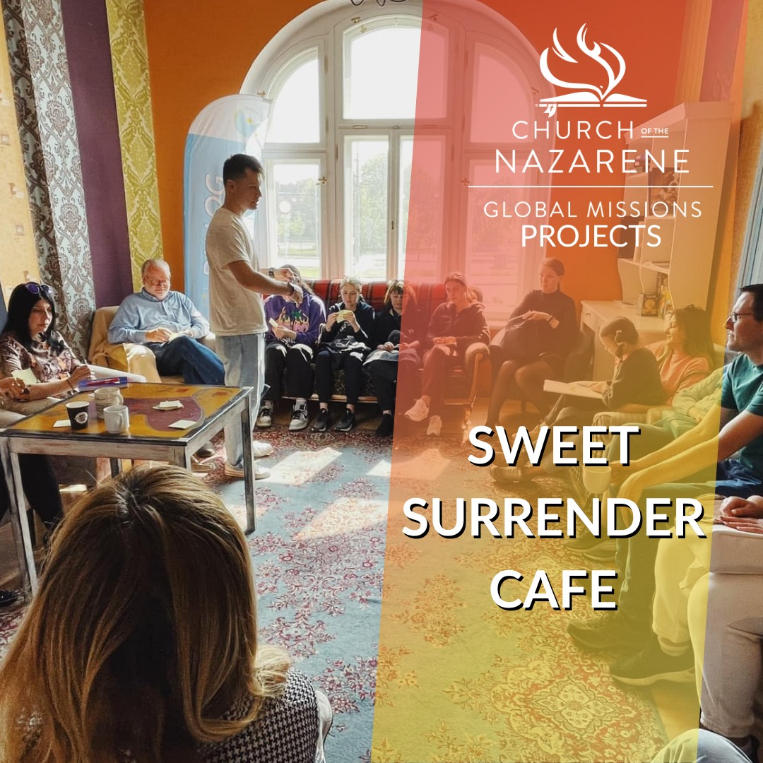
- Coordinator: Elizabeth Bennington - ebennington2004@gmail.com


How to lead the Children's Project
- Present the project in a way children can understand.
- Use a visual goal tracker.
- Invite children to pray for the people served by the project.
- Give families a simple way to participate.
- Celebrate progress and thank the children publicly.

18. Compassionate Ministries and Disaster Response

Compassionate ministries help churches demonstrate the love of Christ through practical care. District ministries include child sponsorship, Crisis Care Kits and School Pal Paks, Blessings From Above / Dress a Girl, Nazarene Missions Teams, and SWORD disaster response.

Blessings From Above / Dress a Girl
Blessings From Above includes Dress a Girl ministry efforts that sew dresses and provide them through mission trips and other distribution channels. Churches can participate by sewing, ironing, cutting, organizing, packaging, donating supplies, or requesting dresses for mission projects.
2025-2026 highlights: More than 17,300 dresses have now been sent to 18+ locations around the world plus four Appalachia locations in the U.S. - including 7,100+ dresses placed in Operation Christmas Child boxes - along with more than 2,000 hygiene bags and 1,800 fleece blankets. Teams served women's recovery centers in Scioto County, OH and Inez, KY, and partnered with Appalachia Reach Out to bless two Portsmouth, OH schools with blankets, socks, hygiene products, toys, and dresses. This fall the ministry begins supporting an elementary school in Wyoming County, WV. Churches going on mission trips or packing Operation Christmas Child boxes may request dresses.

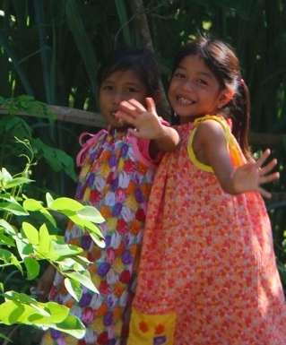

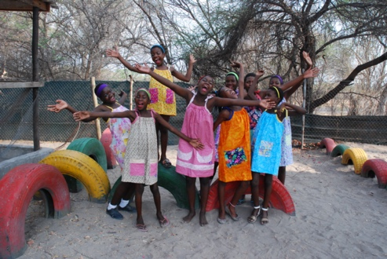

CONTACT
Judy Donley - judysjumpers@gmail.com - (513) 478-3468


Child Sponsorship
Child sponsorship connects churches and individuals with ongoing compassionate ministry for children. Contact the district coordinator for the current brochure and giving information.

CONTACT
Carol Webster - (513) 884-2075 - cswebster@hotmail.com

Nazarene Missions Teams
Nazarene Missions Teams includes mission trip opportunities and broader participation in compassion, work and witness, emergency response, evangelism, education, sports, technology, and medical ministry.
This year's Work & Witness: West Carrollton Nazarene sent a 10-member team to the Villa Caoba Church in the Dominican Republic (May 7-14, 2026), completing work on the church building begun in 2023. Xenia Nazarene took part in several mission projects, including two Disaster Relief trips.
Upcoming trips:
- Appalachia Reach Out - Scioto County, OH - August 1-7, 2026. About $450 per person (lodging, meals, materials). Contact: Rev. Dwayne Mills - dwayne.p.mills@gmail.com - (606) 298-7470 - appalachiareachout.com
- Rest Stop Ministries - Lebanon, TN - October 4-10, 2026. Women's anti-human-trafficking ministry; painting the residential home. Contact: Jody Scott - jodyscott@reststopministries.org - (615) 427-2229
- Jamaica Hurricane Recovery & Evangelistic Ministry - January 26 - February 6, 2027. Planning is in the early stages. Contact: Lionel Brown - RevLBrown@hotmail.com - (876) 886-2985
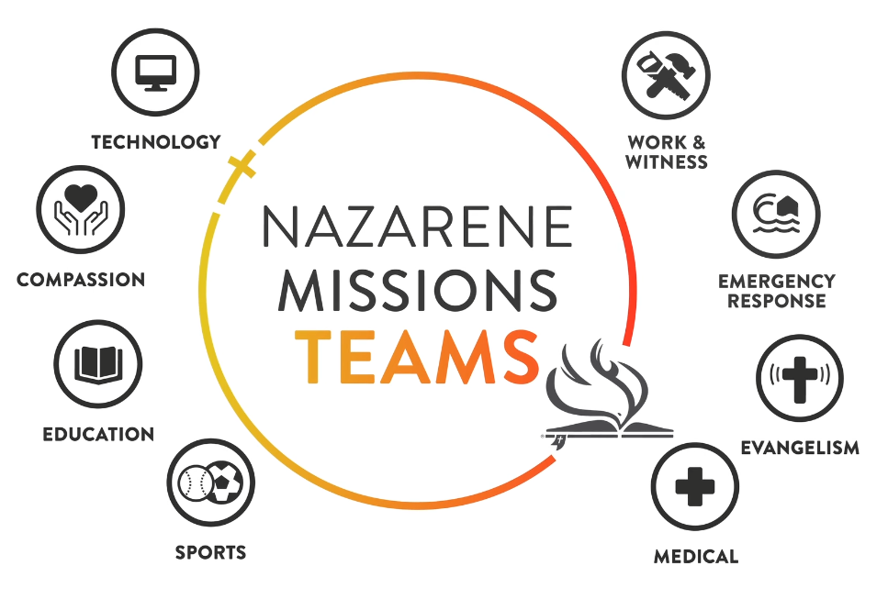
CONTACT
Jeremy Bowden - Work & Witness Coordinator - (513) 255-6310 - jeremy_bowden@yahoo.com


Crisis Care Kits and Pal Packs
When collecting kits, churches should follow the exact current packing list and shipping instructions. Deviating from the approved list can cause shipments to be rejected. Use only current-year instructions from Nazarene Compassionate Ministries or the district coordinator.

FALL 2026 CRISIS CARE KIT PICKUP SCHEDULE
Friday, September 25, 2026: Sardinia, 6:00-7:00 PM.
Saturday, September 26, 2026: West Chester, 9:00-10:00 AM; Xenia, 12:00-1:00 PM.
Contacts: Sarah Crouch and Carol Webster.

SWORD Disaster Response
SWORD is a SWO-NMI disaster response ministry that communicates with Nazarene Compassionate Ministries, local churches, government agencies, disaster coordinators, and others in impacted areas to offer assistance. The ministry includes volunteer response, furniture delivery, food and clothing collection, and practical support for disaster-impacted communities.
2025-2026 highlights: After Hurricane Melissa devastated western Jamaica, SWORD's leader joined a national rapid-response team in Frome, Jamaica (December 2025), clearing the Mt. Shiloh Church of the Nazarene so rebuilding could begin. In March 2026 a district team of seven adults and three teenagers returned and installed a new metal roof on the Burnt Savannah Church of the Nazarene. At home, the furniture ministry made deliveries on 14 occasions to the Lost Creek Fire Department (Hazard, KY) and Appalachia Reach Out (Inez, KY and Wheelersburg, OH), and continues to support other district ministries.
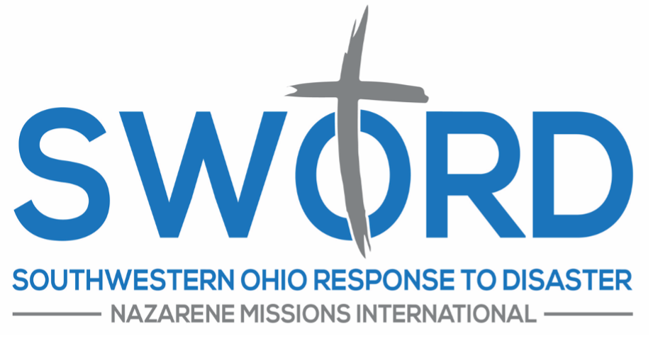
CONTACT
Ed Dyer - SWO Disaster Response Coordinator - sworddisasterresponse@gmail.com edyer927@gmail.com - (513) 615-4659 - facebook.com/SWORDdisasterresponse

PART SIX
Finishing the Year Well
GUIDING THOUGHT
Good reporting is easier when good notes are kept all year long.

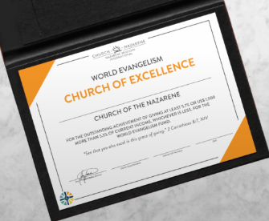
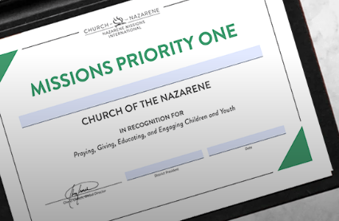

19. End-of-Year Reports

The Local NMI President is responsible for completing the Local NMI President's Report at the end of the church year. Many questions are based on Global NMI priorities, while district questions may ask about outreach activity, giving, teaching, membership, and awards.

REPORT DEADLINES
Report forms are sent to local presidents by May 31. Completed reports are due June 20.

Track throughout the year
- Mission offerings and goals.
- Missionary speakers and deputation offerings.
- Links participation.
- Alabaster participation.
- Children and youth missions involvement.
- Compassionate ministry projects.
- Mission trips or teams.
- Memorial Roll and Distinguished Service Award recipients.
- Local outreach and community service.

Report Preparation Checklist
☐ Find last year's report.
☐ Ask the treasurer for mission giving totals.
☐ Ask ministry leaders for outreach participation.
☐ Confirm award recipient names.
☐ Review the Five Areas of Impact.
☐ Submit the report before the deadline.
☐ Save a copy for next year.

20. Convention, Delegates, and Awards

District NMI Convention celebrates what God has done, elects or recognizes leadership, receives reports, and encourages local churches to continue growing in missions.

Delegates
Delegates must be church members age 15 or older. Each local church of 25 members or fewer may send two delegates, plus one additional delegate for each additional 25 members.

Automatic delegates
- Incoming and outgoing local NMI presidents.
- Retired pastors and missionaries.
- Senior and associate pastors.
- Missionaries on home assignment.
- District superintendent.
- District NMI Council members.
- Lay members of the District Advisory Board.

Awards
The district recognizes churches at annual convention. Churches are encouraged to become Mission Priority One Churches and World Evangelism Churches of Excellence. These awards are connected to the Five Areas of Impact and faithful World Evangelism Fund participation. In 2025-2026, 28 SWO churches were recognized as Mission Priority One and 23 as WEF Churches of Excellence.
Mission Priority One Church = Church has embraced the Five Areas of Impact of NMI: Prayer, World Evangelism Fund (full payment), Alabaster, Engaging Children and Youth, and LINKS.
WEF Church of Excellence = Church has given at least 5.7% or $1500 or more beyond 5.5%, whichever is less, to the World Evangelism Fund.

PART SEVEN
Resources
GUIDING THOUGHT
Keep contacts and links together so annual updates are simple.



21. Contacts (Council Members)

Name | Role | Email | Phone / Notes
Pam Carroll | District NMI President | pamcarroll1021@gmail.com | (513) 382-3706
Sarah Crouch | Vice President (+ NCM) | smkeeton86@gmail.com | (423) 400-4501
Stephanie Wagers | Secretary | stephaniewagers24@yahoo.com | (513) 328-8953  8254 Lyness Dr Cincinnati, OH 45239
Vickie Rocheleau | Treasurer | swonmivr@outlook.com | (513) 276-7333  316 Macready Ave Monroe, OH 45050
Jeremy Bowden | Work & Witness Coordinator | jeremy_bowden@yahoo.com | (513) 255-6310  6693 Red Pine Dr Liberty Twp, OH 45044
Donis Williams | Work & Witness Liaison | iliv2wrshp@gmail.com | (614) 506-3616
Bonita Gordon | LINKS Coordinator/ Alabaster/SW Zone Chair | bonitaraegordon217@icloud.com | (513) 236-8214
Carol Webster | Nazarene Compassionate Ministries | cswebster@hotmail.com | (513) 884-2075
Elizabeth Bennington | Children | ebennington2004@gmail.com | (937) 820-1237
Ed Dyer | Disaster Response | sworddisasterresponse@gmail.com | (513) 615-4659
Judy Donley | Outreach (Blessings From Above / Dress a Girl) | judysjumpers@gmail.com | (513) 478-3468
Carolyn Hamilton | NE Zone Chair | chteach123@yahoo.com
(vacant) | NW Zone Chair |  | position open
Venita Milburn | SE Zone Chair | milb705@yahoo.com | (513) 304-2523

22. Useful Web Links

SWO District: swonaz.org
Nazarene Headquarters: nazarene.org
Nazarene Missions International: nazarene.org/nmi
Funding the Mission: fundingthemission.org
NMI Central: nazarene.org/nmi/nmi-central
Nazarene Missions Teams: nazarene.org/teams
Missionary Profiles: nazarene.org/missionary-profiles
Compassionate Ministries: ncm.org
Jesus Film Harvest Partners: jfhp.org
World Mission Broadcast: nazarene.org/wmb
Dress a Girl: dressagirlaroundtheworld.com
Crisis Care Kit Info: fawngrovecompassioncenter.org/crisis-care-kit/
Pal Pak Info: fawngrovecompassioncenter.org/school-pal-paks/

APPENDICES
Practical Tools
GUIDING THOUGHT
Use these pages in council meetings and annual planning.



Appendix A. Missionary Visit Checklist

Six Months to Three Months Before
☐ Confirm date and event format.
☐ Clarify who is responsible for travel, lodging, meals, and honorarium or offering.
☐ Ask about technology needs.
☐ Ask what may be published online.
☐ Reserve rooms and add the event to the church calendar.

One Month Before
☐ Begin promotion.
☐ Collect prayer requests from the missionary.
☐ Plan children and youth connections.
☐ Prepare offering instructions.
☐ Assign hospitality responsibilities.

Week of Visit
☐ Confirm arrival time and contact phone number.
☐ Test technology.
☐ Prepare lodging and meals.
☐ Prepare introduction and offering explanation.
☐ Pray as a council.

After the Visit
☐ Send offering promptly according to instructions.
☐ Send a thank-you note.
☐ Report offering total to the church.
☐ Save contact information for future updates.

Appendix B. Faith Promise Planning Timeline

Four to Six Months Before
☐ Meet with pastor.
☐ Choose date and format.
☐ Invite speaker.
☐ Set giving goal.
☐ Plan children/youth involvement.

Two Months Before
☐ Begin communication plan.
☐ Prepare bulletin inserts or cards.
☐ Gather videos or missionary stories.
☐ Train ushers or leaders on commitment card process.

Two Weeks Before
☐ Promote in worship and newsletters.
☐ Pray publicly for the emphasis.
☐ Confirm all technology and hospitality details.

Day of Emphasis
☐ Explain Faith Promise clearly.
☐ Receive commitments prayerfully.
☐ Thank participants.
☐ Avoid pressure tactics.

Afterward
☐ Report commitment total.
☐ Thank the church.
☐ Track giving throughout the year.
☐ Share progress quarterly.

Appendix C. Council Meeting Agenda Template

Sample agenda
- Opening prayer for missionaries and mission needs.
- Review previous action items.
- Five Areas of Impact check-in.
- Calendar review.
- Treasurer / giving update.
- Upcoming missionary visits or district projects.
- Children and youth involvement.
- Communication plan for the next month.
- Assignments and due dates.
- Closing prayer.

Appendix D. Year-End Tracking Worksheet

Use this worksheet throughout the year so reporting is not stressful in May and June.
Category | What to Track | Notes
Prayer | Mission prayer moments, prayer cards, prayer meetings
WEF | Goal, amount given, offering dates
Alabaster | Offering dates and amounts
Links | Updates shared, gifts sent, communication
Children/Youth | Lessons, projects, offerings, mission moments
Missionary Visits | Dates, names, offering totals
Compassionate Ministry | Collections, trips, service projects
Awards | Memorial Roll, DSA, other recognition
Convention | Delegates, registration, attendance

Remember Why

People may not remember every report, offering total, or meeting agenda. But they will remember when their church prayed for a missionary by name, when a child discovered missions for the first time, when a visiting missionary helped them see the world differently, or when their generosity became part of something larger than themselves.
Thank you for helping your church look outward. Thank you for telling the stories. Thank you for making room for children and youth. Thank you for caring for missionaries. Thank you for saying yes.

FINAL ENCOURAGEMENT
Your faithfulness helps local churches participate in making Christlike disciples in the nations.



