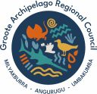

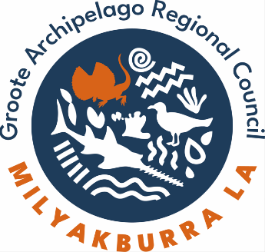
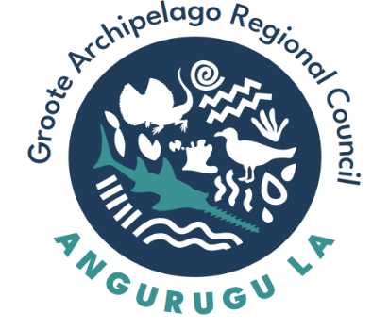
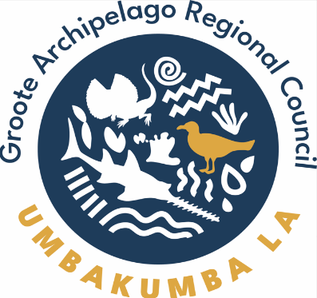

Local Authority Nomination Form

What is a Local Authority?
Local Authorities are the "voice" of the community and together make recommendations to Council based on the Regional Plan. A Regional Plan is a 'wish list' for your area. A local authority can only make recommendations to the Council to consider at its next Ordinary Council Meeting. Community Members are paid for their involvement in the Local Authorities.
Council’s Local Authority Policy details how the three local authorities will operate (functions, membership, payments etc.). It is available on the Council’s website. Members of the local authorities must abide certain Council policies as well, such as the Code of Conduct.
Groote Archipelago Regional Council is seeking nominations for membership of the Local Authority in each of the areas of Angurugu, Umbakumba and Milyakburra.
Nominations Open – 22 August 2025
Nominations Close – 12 September 2025
The nominations will be assessed by the Council at its next Ordinary Council Meeting on 29 September 2025. The nomination form can be handed directly to Council Office or e-mailed to governance@groote.nt.gov.au.

  - Details of Nomination
Full Name and Sign
Residential Address
Phone Number
E-Mail Address
Choose the area nominating for:
☐ Angurugu
☐ Umbakumba
☐ Milyakburra
- What is your connection to the area you are nominating for?
Note: You must live in the area or have sufficient connection to the community you are nominating for

- What do you hope to achieve as a Local Authority member?

Disclaimer: Council may not consider your form if you have not answered the above questionnaire or if it is missing the details requested.

