
Chug Springs Butchery
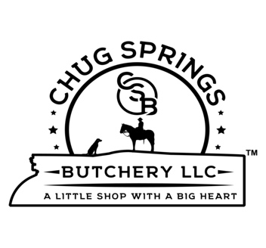
Custom / USDA
180 S. Chugwater Hwy.
Chugwater Wy 82210
307-365-4338

Name____________________________ PH.#__________________________
Email:______________________________
Ear tag. ________ CSB. Lot # ___________ ⚪ WHOLE ⚪ HALF ⚪ Quarters

Burger: 1 / 1.5 / 2 Lb. pkgs. Steak Thickness Roasts: 2-3 or 3-4 lb. pkgs.
¾” / 1” / 1 ¼” / 1 ½”

Front Shoulder: Hind Quarter:

Chuck Roast: Y / N Sirloin Tip Roast: Y / N

Chuck Steak: Y / N Sirloin Tip Steak: Y / N

Arm Roast: Y / N Top Round Roast: Y / N

Brisket: Y / N ( Half / Whole ) Top Round Steak: Y / N ( Tenderized: Y / N )

Skirt Steak: Y / N Bottom Round Roast: Y / N

Flank Steak: Y / N Cube Steak: Y / N

Short Ribs: Y / N Eye Roast: Y / N

Ribeye Steak: Y / N Eye Steak: Y / N

Ribeye Roast: Y / N ( 3 Rib / Whole ) Stew Meat: Y / N Lbs._____

Soup Bones: Y / N
Sirloin Steak: Y / N

Filet Mignon: Y / N

T-Bone Steak: Y / N OR Strip Steak: Y / N (Beef over 30 months will be Strip steaks.)

$25 per half for 1 steak per package requests except on USDA.

Offal:

Tongue: Y / N Heart: Y / N Liver: Y / N Ox Tail: Y / N Fat: Y / N

NOTES:______________________________________________________________
By signing below, you agree that fat products from your animal may be donated and used in other Chug Springs Butchery customer products and fat products from other Chug Springs Butchery customers may be used in your products. And acknowledge the selection on this cut sheet.

Signature_____________________________________________ Date:______/_______/20______

