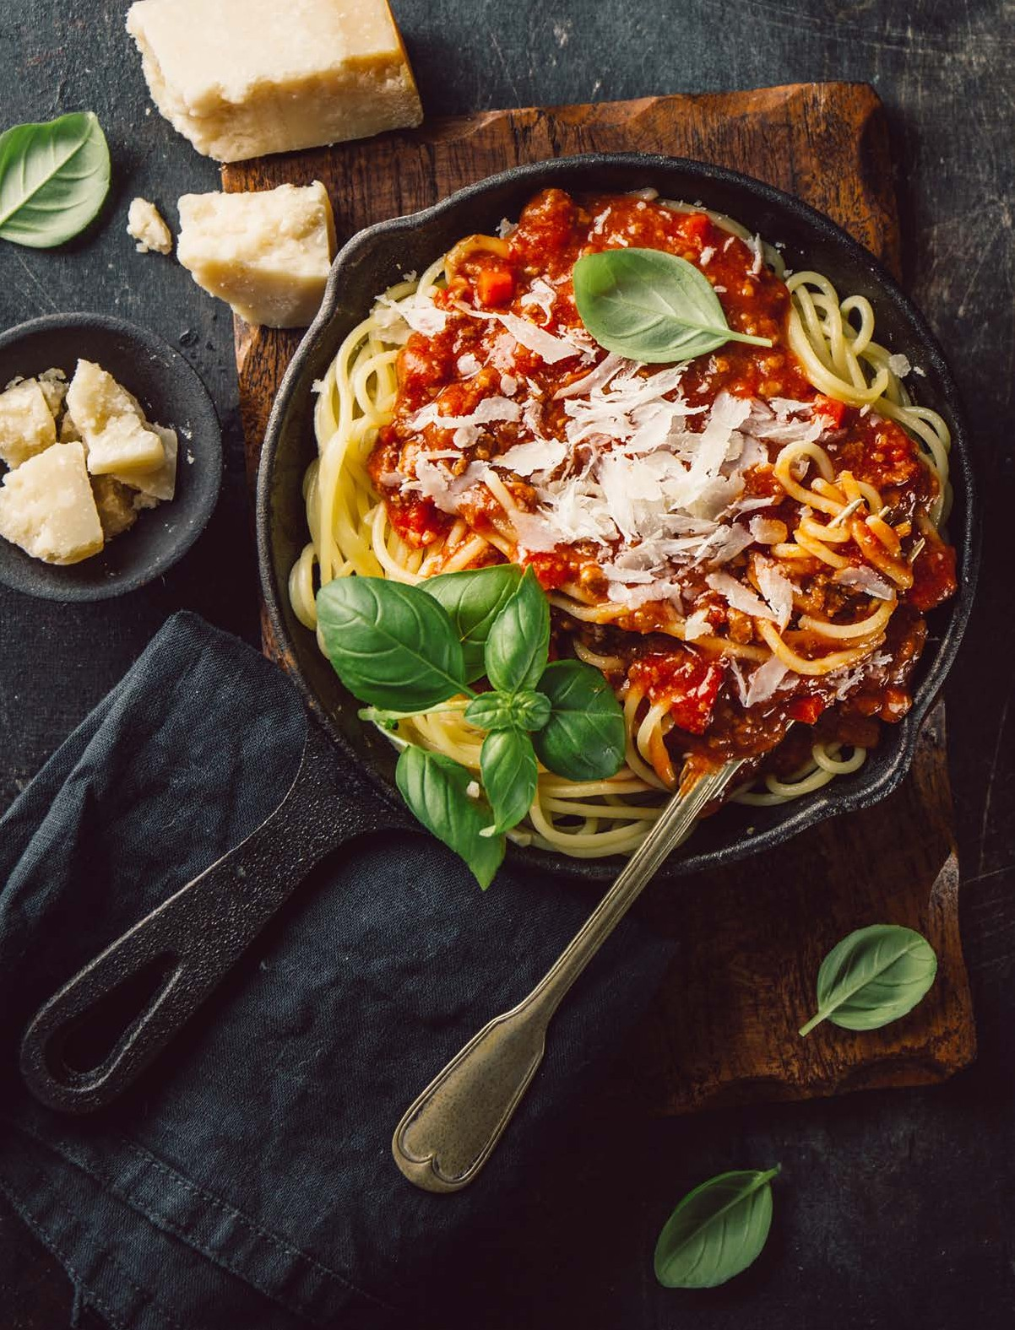



AVI CATERING INSPIRATIONS

Welcome to our AVI Catering Menu and Services Meet, Eat and Enjoy!
AVI’s catering team members are ready to make your catered event a success!

ORDERING INFORMATION
A 48 hour notice is preferred.
All items in this guide are priced to be served on disposables. China is available at an additional cost.
Please include the following information when placing an order:

- Event name
- Your name, e-mail and phone number
- Date of event
- Location of event
- Time of service
- Menu selections
- Guest count
- Pick-up or delivery

Please contact your local AVI representative for more details.

Stephanie Myers
foodservice@tiffin.edu
5672686099

Thank you for the opportunity to serve you!

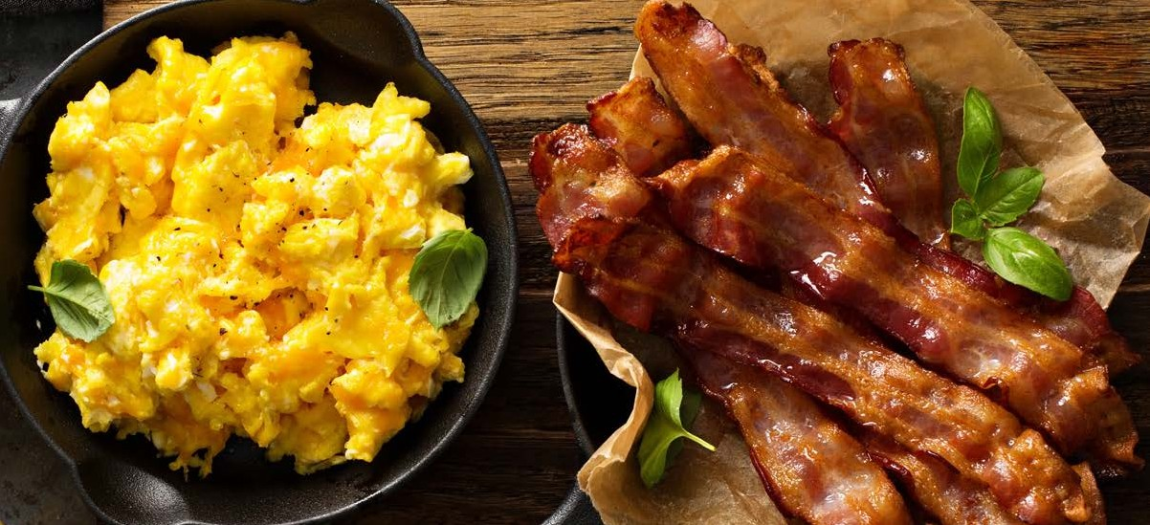
HOT BREAKFAST

Breakfast Buffets Include Freshly Brewed Coffee, Hot Water and Iced Water

Express Continental
Fresh Fruit Display, Muffins or Pastries
Includes Freshly Brewed Coffee, Hot Water and Iced Water

Executive Dragon
Fresh Fruit Display, Breakfast Pastries, Scrambled Eggs and Breakfast Potatoes, Choice of Vanilla Cinnamon French Toast or Buttermilk Pancakes,
Choice of Bacon, Sausage or Turkey Sausage.
Includes Freshly Brewed Coffee, Hot Water and Iced Water

Enhance Your Experience
Yogurt Bar Add-On
Roasted Vegetable Quiche
Breakfast A la Cart
Pastries and Muffins
Bagels with Cream Cheese
Fresh Fruit Display
Whole Fruit
Donut Holes
Gourmet Donuts
Cake Donuts
Granola Bars
Kind Bars


Priced person unless otherwise noted

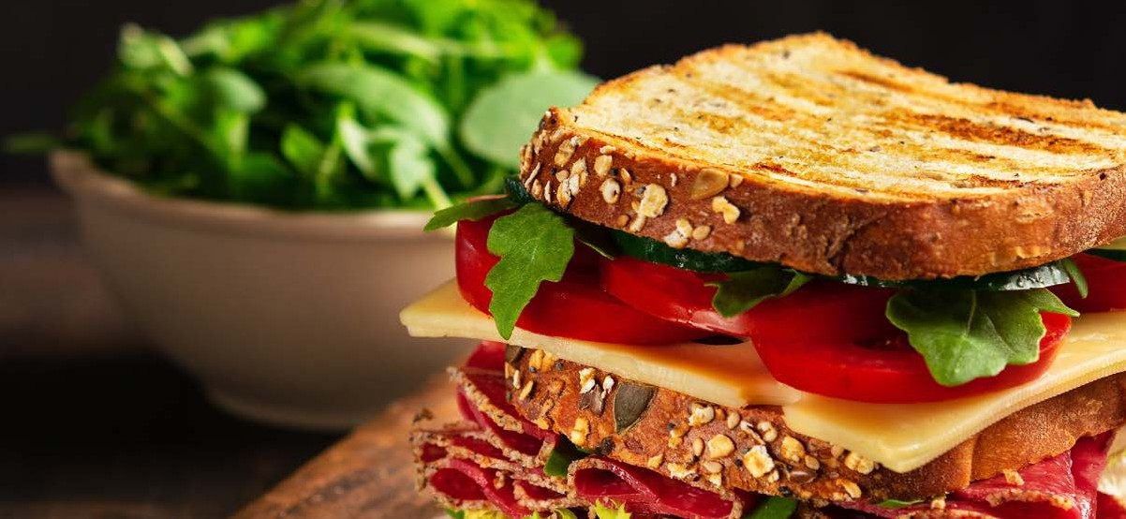
SANDWICHES

Box Lunches
Includes Bagged Chips, Cookies, Whole Fruit and Bottled Water
Choose Two
Roast Beef and Cheddar Smoked Turkey and Provolone Ham and Swiss
Chicken Salad Tuna Salad
Roasted Vegetable Wrap

Add Pasta Salad for 2.00 a person

Signature Sandwich Buffet
Includes House Chips, Cookies and Brownies, Iced Water, Choice of Iced Tea or Lemonade Choice of Quinoa Salad, Pasta Salad or Garden Salad (Italian and Ranch Dressing)
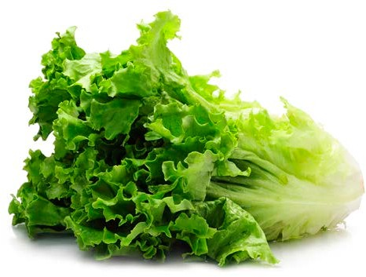
Choose Two
Roast Beef and Cheddar Sandwich or Wrap
Smoked Turkey and Provolone Sandwich or Wrap
Chicken Caesar Wrap
Chipotle Chicken Wrap
Ham and Swiss Sandwich or Wrap
Tuna Salad Sandwich or Wrap
Chicken Salad Sandwich or Wrap
Grilled Vegetable Wrap
Caprese Wrap

Additional Sandwich Choices 2.19 Per Selection

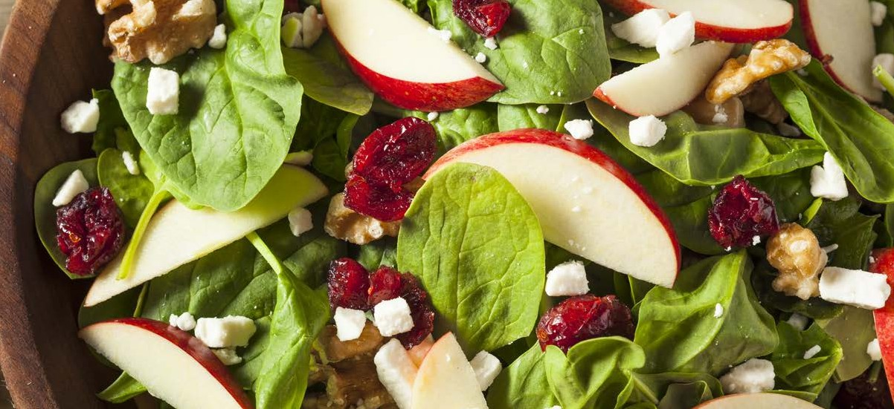
SALADS

Salad Buffet
Includes Choice of 2 Salads Rolls, Butter, Choice of Cookies or Brownies, Iced Water, Choice of Iced Tea or Lemonade

Add Tofu 1.99 Per Person
Add Chicken 2.99 Per Person
Add Salmon 4.99 Per Person

Greek Salad
Fresh Greens, Kalamata Olives, Grape Tomatoes, Cucumbers, Red Onions and Feta Cheese with Red Wine Vinaigrette

Chef Salad
Fresh Greens, Grape Tomatoes, Chopped Eggs, Cucumbers, Smoked Turkey, Smoked Ham, Cheddar Cheese and Swiss Cheese with Choice of Dressing


Caesar Salad
Fresh Romaine, Herb Croutons, Grape Tomatoes and Shaved Parmesan Cheese with Caesar Dressing

Cobb Salad
Fresh Romaine, Bacon, Grape Tomatoes, Hard-Boiled Eggs, Cheddar Cheese and Bleu Cheese with Ranch Dressing

Berry Salad
Fresh Greens, Summer Berries, Dried Cranberries, Mandarin Oranges, Pickled Red Onions, Candied Walnuts and Goat Cheese with Raspberry Vinaigrette

ENTRÉE SALADS
ENTRÉE SALADS

Entrée Salads Chicken / Steak
Includes Choice Salad Rolls, Butter, Choice of Dessert, Iced Water

Cobb Salad
Mixed Organic Greens, Egg, Bacon, Crumbled Blue Cheese, Tomato, Cucumber, Croutons, with Pesto Buttermilk Ranch

Santa Fe

Mixed Organic Greens, Black Beans, Roasted Corn, Tomato, Red and Yellow Pepper, Crispy Tortilla Strips with Avocado Buttermilk Ranch

Tuscan
Mixed Organic Greens, Fresh Mozzarella, Cucumber, Heirloom Tomato, Artichoke Hearts with Basil Balsamic Vinaigrette

Asian
Mixed Organic Greens, Edamame, Mandarin Oranges, Strawberries, Cucumber, Crispy Wontons with Miso Soy Vinaigrette

Power Bowl
Spinach, Mixed Organic Greens, Quinoa, Garbanzo Beans, Edamame, Cucumber, Half Hard-Boiled Egg, Red Pepper Hummus, with Sun Dried Tomato Vinaigrette and Balsamic Drizzle

Blackberry Salad
Spinach, Blackberries, Avocado, Red Onion, Cucumber, Toasted Walnuts, Feta Cheese with Blackberry Vinaigrette

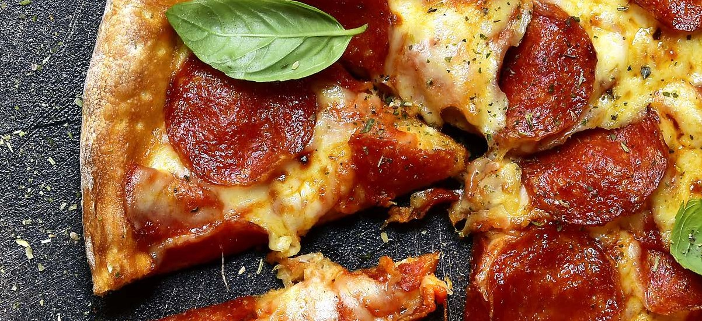
PIZZA

Pizza Buffet (16” Pizza)
Includes Breadsticks, Iced Water and Choice of Iced Tea or Lemonade

Choose 1 Salad
Garden Salad (Italian and Ranch Dressing)
Caesar Salad

Choose Pizza
Cheese Pizza + One Topping
Cheese Pizza

Dessert
Chocolate Chip Cookies

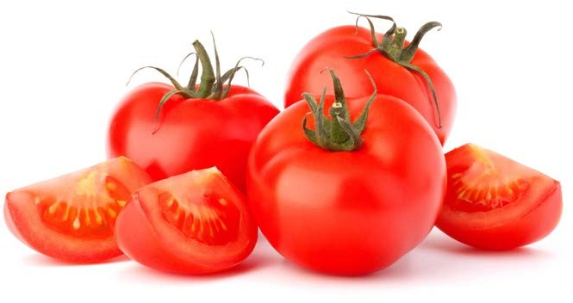
A la Carte (Pick-Up)
Cheese Pizza
Gluten-Free Cheese Pizza (7 inch)
Veggie Pizza
Meat Lovers Pizza
Supreme Pizza
Add Toppings for 1.79 each for A la Carte or Buffet

Pepperoni, Sausage, Bacon, Ham, Tomato, Onion, Black Olives, Banana Pepper, Green Pepper, and Extra Cheese

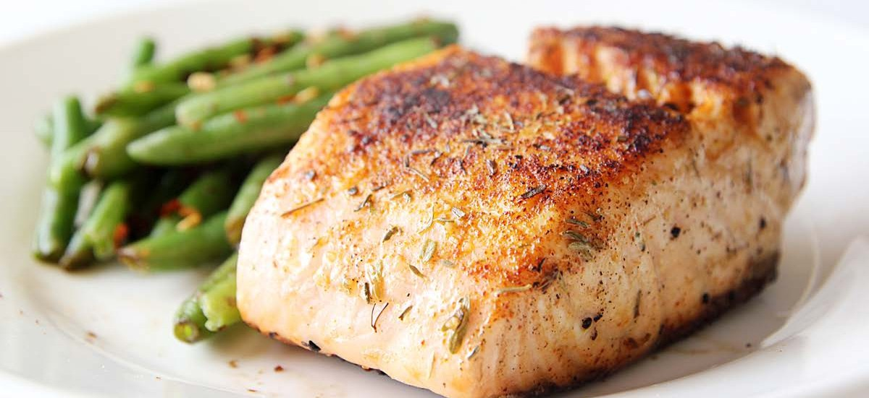
BUFFETS

Dragon Buffet (Minimum 25 people)
Includes Rolls, Butter, Water Choice of Iced Tea or Lemonade
Salad Dressings: Ranch, Balsamic, Italian, Caesar, Honey Mustard, Raspberry Vinaigrette (Choose 2)
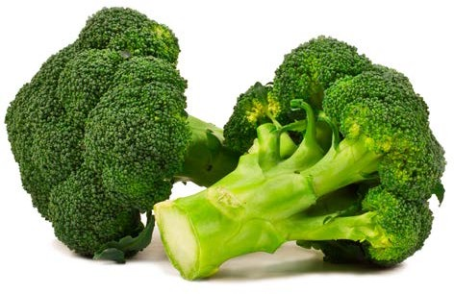
Choose 1 Salad | Choose 2 Entrees | Choose 1 Accompaniment
Garden Salad | Chicken with Smoked Gouda Cheese Sauce | Garlic Mashed Potatoes
Quinoa Salad | Rosemary Roast Beef | Roasted Red Skin Potatoes
Caesar Salad | Tortellini Primavera | Smoked Gouda Mashed Potatoes
Spinach Salad | Whole Grain Mustard Roasted Pork | Wild Rice Pilaf
 | Stuffed Portabella Mushroom | 3 Cheese Mac and Cheese
 | Tarragon Chicken

Choose 1 Vegetable | Choose 1 Dessert
Roasted Seasonal Vegetables | New York Cheese Cake with Assorted Sauces
Green Bean Almondine | Layer Carrot Cake with Cream Cheese Frosting
Baby Carrots | Double Chocolate Layer Cake
Garlic Green Beans
Steamed Broccoli

Single Entrée Buffet per person

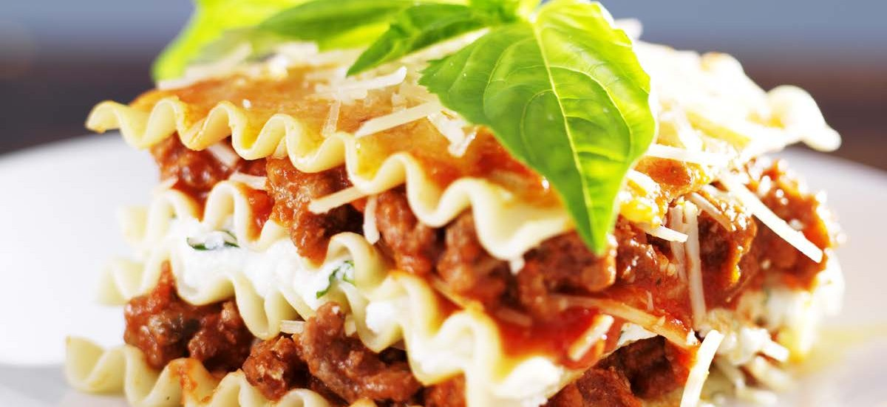
BUFFETS

Italian Buffet (Minimum 25 people)
Includes Breadsticks, Iced Water Choice of Iced Tea or Lemonade
Salad Dressings: Ranch, Balsamic, Italian, Caesar, Honey Mustard, Raspberry Vinaigrette (Choose 2)

Choose 1 Salad | Choose 1 Entrees | Choose 1 Accompaniment
Garden Salad | Chicken Parmesan | Pasta  (Marinara, Alfredo, or Basil Pesto)
Quinoa Salad | Chicken Marsala | Roasted Seasonal Vegetables
Caesar Salad | Lemon Rosemary Chicken | Green Bean Almondine
Spinach Salad | Meat Lasagna | Garlic Green Beans
 | Eggplant Parmesan | Wild Rice Pilaf

Choose 1 Dessert
New York Cheese Cake with Assorted Sauces
Layer Carrot Cake with Cream Cheese Frosting
Double Chocolate Layer Cake
New York Cheese Cake with Assorted Sauces
Assorted Dessert Bars

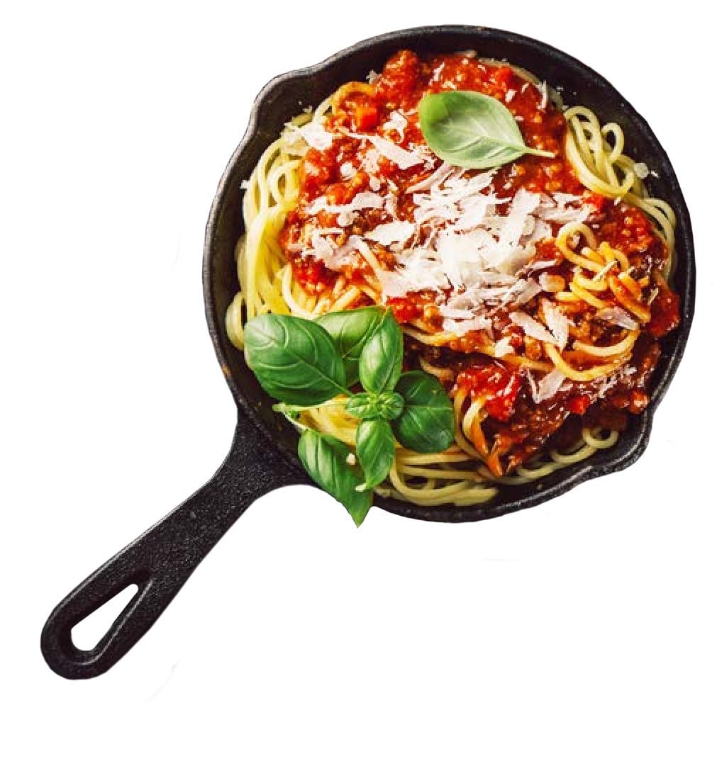

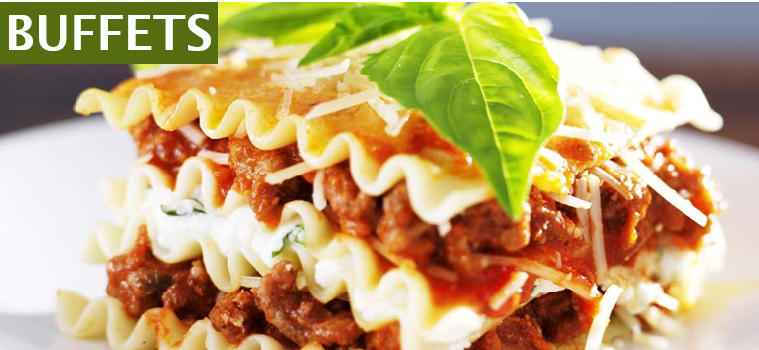

Pasta Buffet (Minimum 25 people)
Chicken, Breadstick, Water Choice of Iced Tea or Lemonade
Salad Dressings: Ranch, Balsamic, Italian, Caesar, Honey Mustard, Raspberry Vinaigrette (Choose 2)

Choose 1 Salad | Choose 1 Pasta | Choose 2 Sauces
Garden Salad | Penne | Marinara
Quinoa Salad | Spaghetti | Alfredo
Caesar Salad | Ziti | Tomato Basil Cream
Spinach Salad |  | Vodka Sauce
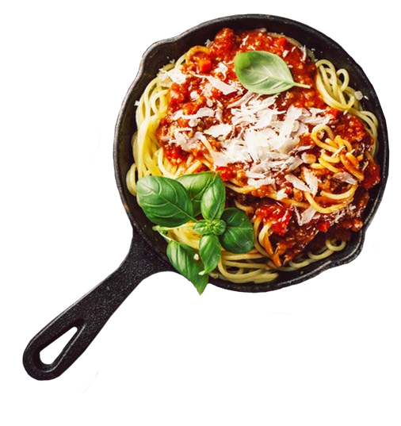

Choose 1 Dessert
New York Cheese Cake with Assorted Sauces
Layer Carrot Cake with Cream Cheese Frosting
Double Chocolate Layer Cake
New York Cheese Cake with Assorted Sauces
Assorted Dessert Bars

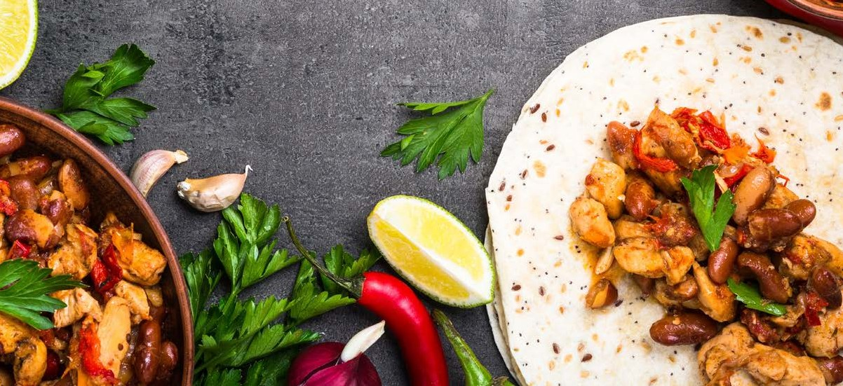
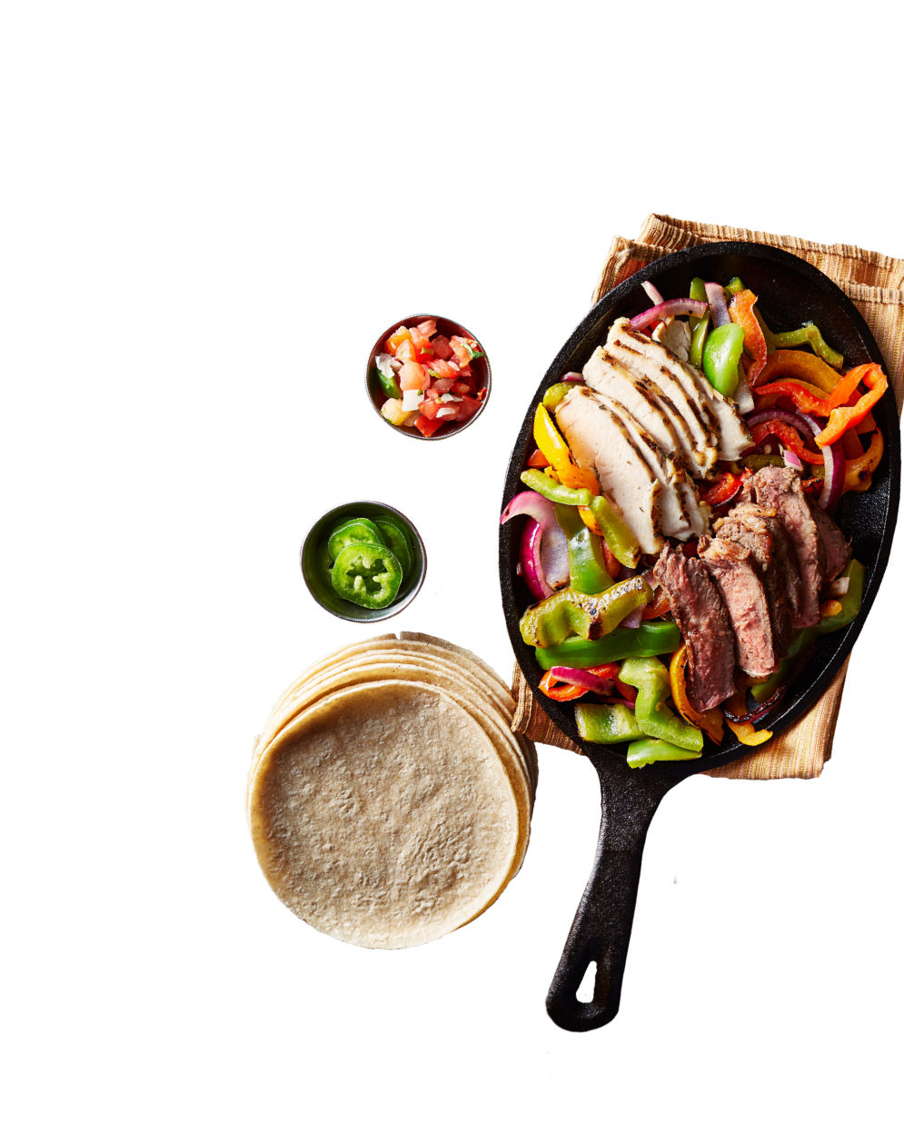
BUFFETS

Mexican Buffet (Minimum 25 people)
Includes Housemade Tortilla Chips, Pico De Gallo, Salsa, Tortillas, Sour Cream, Cheddar Cheese, Lettuce, Tomato, Black Olives, Jalapenos, Iced Water, Choice of Iced Tea and Lemonade

Choose 1 Salad | Choose 2 Entrees
Mixed Green Salad | Veggie Crumbles
Choice of 2 Dressings | Seasoned Taco Meat
Ranch, Italian, Avocado Lime, | Blackened Chicken
or Balsamic Dressing | Cilantro Lime Fried Tofu

Choose 1 Accompaniment | Choose 1 Dessert
Spanish Rice | Cookies
Cilantro Lime Rice | Brownies
Fajita Peppers and Onions | Cinnamon Sugar Churros
Refried Beans

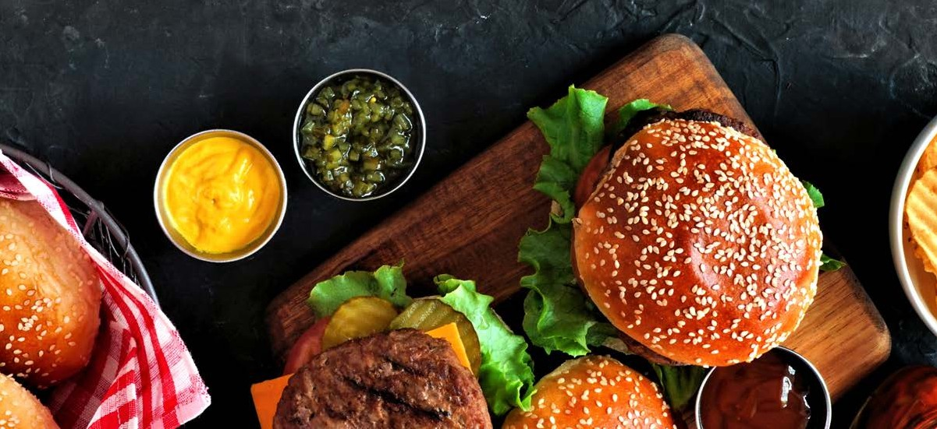
BUFFETS

Backyard BBQ (Minimum 25 people)
Includes Buns (Slider or Classic) Condiments, Iced Water, Choice of Iced Tea and Lemonade

Choose 2 Accompaniments | Choose 2 Entrees
Cole Slaw | All Beef Hot Dogs
3 Cheese Mac and Cheese | Black Bean Burger
Potato Salad | Shredded Chicken
Pasta Salad | Shredded Pork
Housemade Chips | Bratwurst
Smokehouse Potato Salad

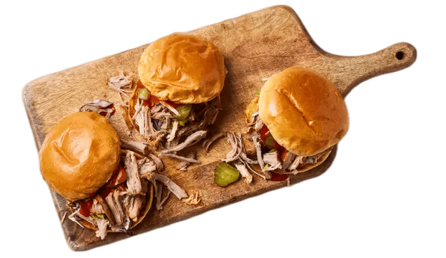
Choose 1 Accompaniments
Fresh Baked Cookies
Brownies
Rice Krispies

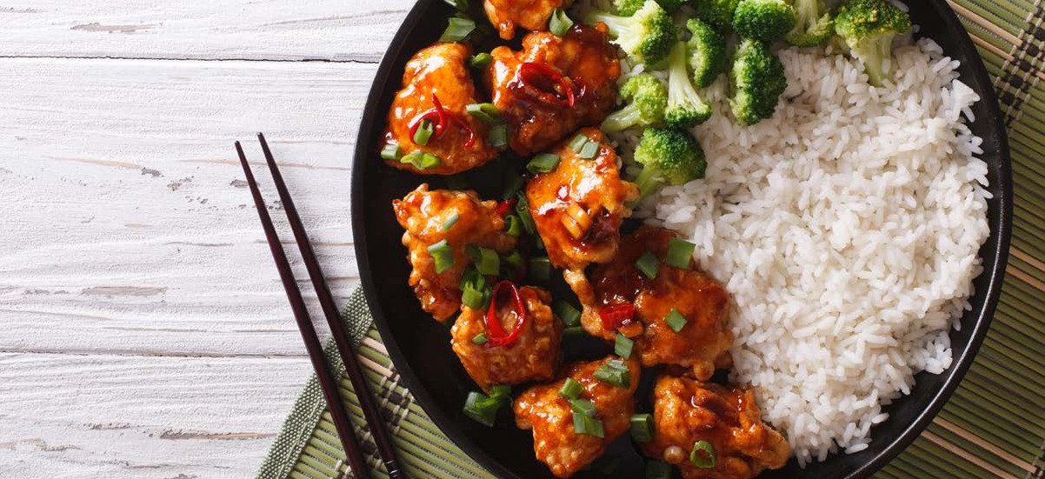
BUFFETS

Asian Buffet (Minimum 25 people)
Includes Stir Fried Vegetables, Iced Water, Choice of Iced Tea and Lemonade

Choose 1 Salad | Choose 2 Proteins | Choose 2 Accompaniment
Asian Chopped Salad | Chicken Breast | Vegetable Fried Rice
Asian Noodle Salad | Pork Loin | Steamed Brown Rice
 | Crispy Tofu | Steamed White Rice
 | Pepper Steak | Steamed Broccoli
 |  | Rice Noodles

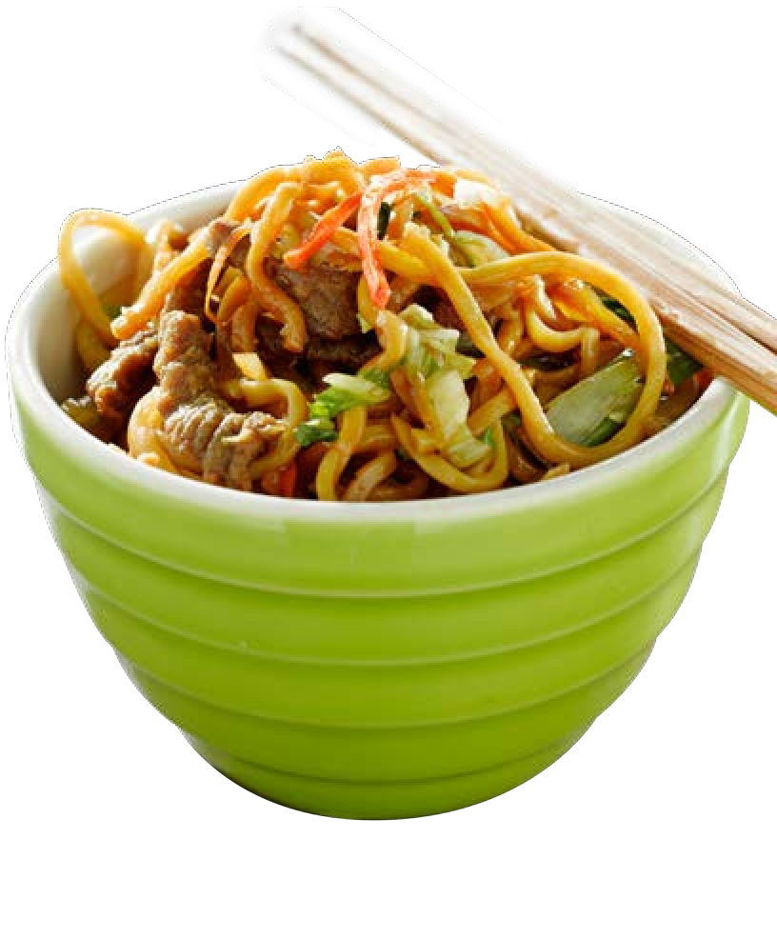
Choose 2 Sauces | Choose 1 Dessert
General Tso | Cookies
Teriyaki | Brownies
Sweet and Sour | Fortune Cookies
Miso Glaze

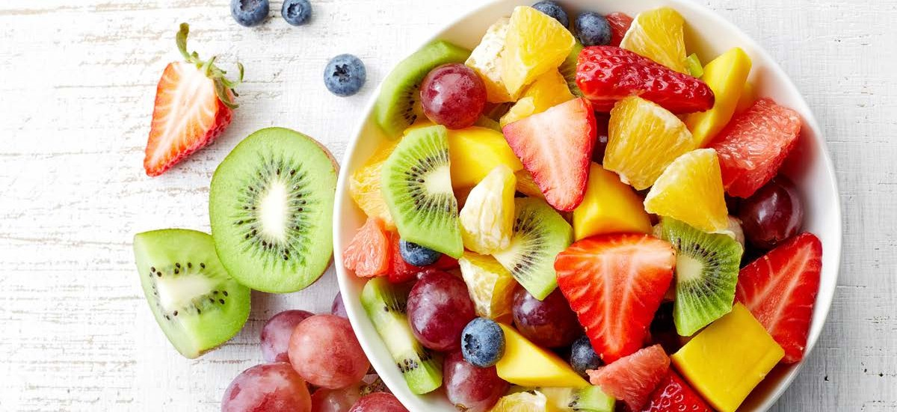
CLASSIC APPETIZERS

Fresh Fruit Platter

Vegetable Tray with Ranch

Simply Cheese

Cube Cheddar, Swiss and Pepper Jack

Artisanal Cheese Tray

Charcuterie Board

Hummus and Pita
Add Vegetables

Chips and Salsa
Add Guacamole

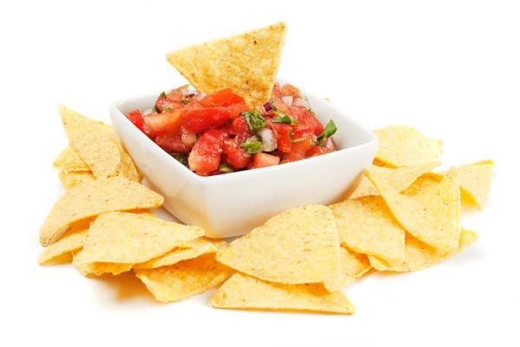

Minimum Order for 25 People
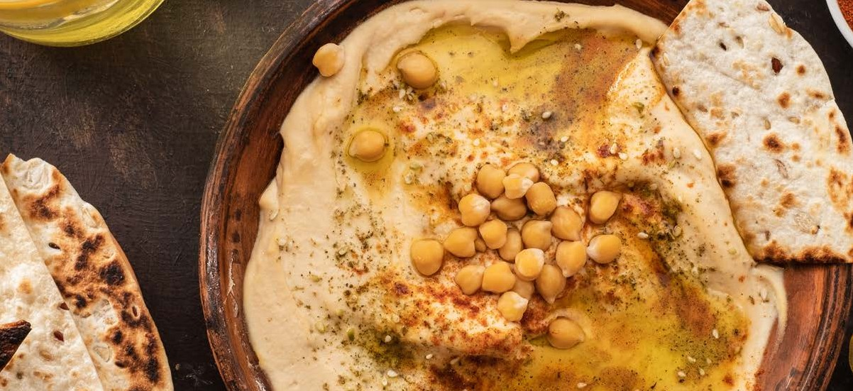
HORS D’OEUVRES

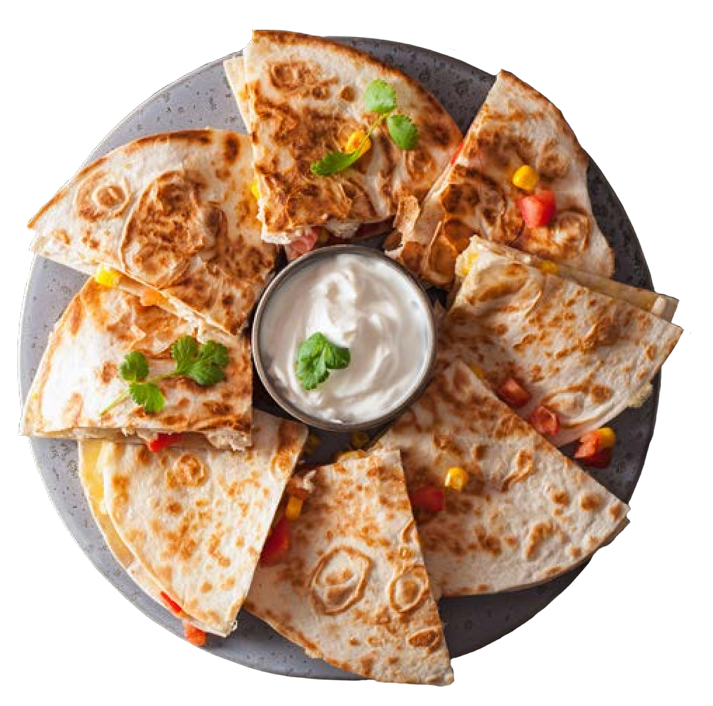
Priced individually unless otherwise noted
Hot Hors D’oeuvres
Sausage Stuffed Mushrooms
Swedish Meatballs
Chicken Pot Stickers
Chicken Quesadillas
Cheese Quesadillas
Spanakopita
Petite Quiche
Vegetable Spring Rolls
Spinach Artichoke Dip (Serves 25)
Mini Crab Cakes
Fried Cheese Curds
Thai Chicken Satay
Thai Beef Satay
Cold Hors D’oeuvres
Southwest Veggie Pinwheel Wraps
Roma Tomato & Garlic Bruschetta
Goat Cheese Crostini
Boursin Cheese and Tomato Bacon Jam Phyllo Cups
Pesto Chicken Antipasto Skewer
Tomato, Mozzarella, Basil Skewers

Priced individually unless otherwise noted

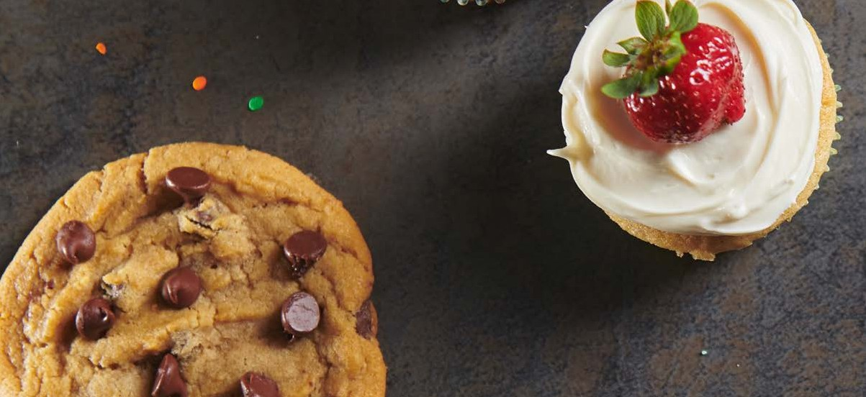
DESSERTS
AND BEVERAGES

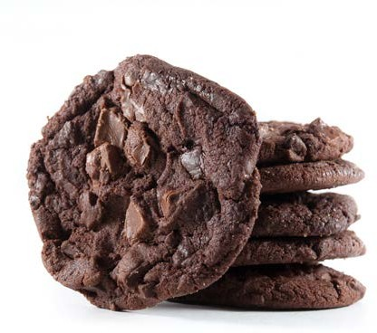
Desserts
Fudge Brownies Per Dozen
Assorted Dessert Bars Per Dozen
Cupcakes 18.99 Per Dozen
Chocolate or Vanilla
TU Cookies Per Dozen
Fresh Baked Assorted Cookies Per Dozen
Assorted Mini Cheesecakes Per Dozen
Sundae Bar Per Person
Chocolate, Strawberry and Vanilla Ice Cream (Choose 2)
Toppings Include: Whipped Cream, Nuts, Cherries, Chocolate Syrup,
Sprinkles, Caramel Toppings

Beverages
Coffee Airpot
Hot Chocolate Airpot
Bottled Water each
Canned Soda each
Bottled Juice each
Orange Juice Dispenser
Iced Tea Bottle
Water Dispenser
Iced Tea, Fruit Punch or Lemonade Dispenser
Infused Water Dispenser


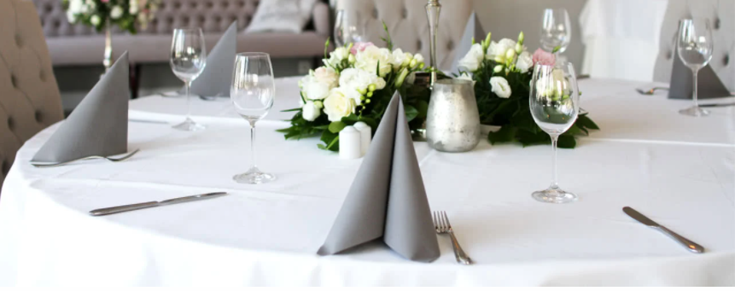
LINEN

Linen Rental
90” x 156” Floor Length Rectangle Linen
85” x 85” Square Linen for Round Linen
52” x 52” Accent Overlay for Rectangle and Rounds
120” Round for High Top Tables and Floor Length Round Tables
Napkins

- Linen Color and Size Availability are shown below. We place our linen orders on Monday for Wednesday delivery. Please plan accordingly. We keep a very limited amount of linen on hand if not needed for events.
- Full dinners have linen included in the buffet price for the buffet, beverages and seating tables. All other linen is additional this includes high tops for receptions.

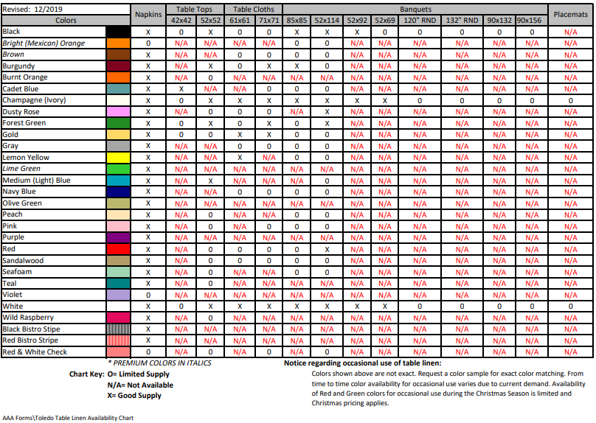



17

