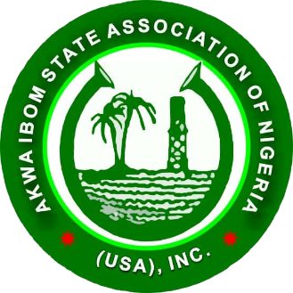
Akwa Ibom State Association of Nigeria (USA), Inc. (AKISAN)
NATIONAL SECRETARIAT HEADQUARTERS

San Diego, California Phone: 720-933-5375 Website: www.akisan.org AKISAN USA INC
A registered 501C3 Non-Profit Organization

2025 AKISAN USA BEAUTY PAGEANT: LETTER OF ATTESTATION FROM (INSERT CHAPTER NAME) CHAPTER

I, __________________________________________, President of the __________________ Chapter, hereby attests to the following:

The _____________________ Chapter has thoroughly vetted and officially endorsed ________________________________________ ("the contestant") to participate in the 2025 Miss & Mr. Akwa Ibom USA Pageant.
The vetting process includes, but is not limited to:
- Reviewing the contestant’s social media presence,
- Ensuring they uphold strong moral values,
- Conducting a criminal background check, and
- Reporting all findings to the AKISAN Beauty Pageant Committee.

The ______________________ Chapter understands that if any false information is provided by the chapter and/or the contestant—either during the pageant process or after winning—the contestant will forfeit their crown and title.

Signed: __________________________ Date____________________
(Chapter president name)
_________________________________

