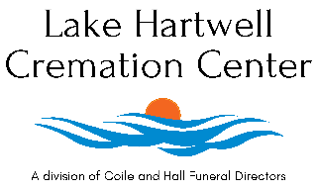
Obituary Template
As a courtesy we will publish a family generated obituary to our website and social media. We have provided a template to assist you in preparing the obituary.

Mr./ Mrs. [loved one’s name], age [#] of [City], [state] passed away on [Month Day, year] at [place of death]. Born in [City of Birth, State] he/she was the son/daughter of the late [fathers name] and [mothers name with maiden name] . [loved one’s name] was a lover of [insert hobbies, interest, military information or work history].
In addition to his/ her parents [loved one’s name] is preceded in death by his/ her [ any additional family members who have passed away names and relationship].

[loved one’s name] is survived by his/her [insert family members starting with spouse, children, siblings, grandchildren, great grandchildren etc.]

A celebration of life will be held on [ date and time of service] at [location of service]. Or

There are no formal services scheduled at this time.

Lake Hartwell Cremation Center is honored to serve the family of [insert loved one’s name].

Upon completion, please email obituary to care@cremationctr.com along with a photo of your loved one.

