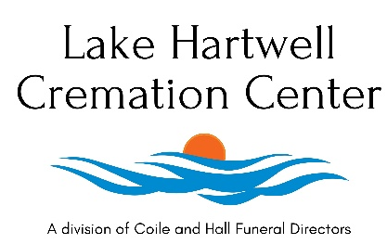
GENERAL PRICE LIST

Complete Simple Cremation Total within 75 Miles …………..………… $950.00
Limited Basic Services of the Funeral Director and Staff…………………… $600.00
Our fee for the limited services of the Funeral Director and Staff includes, but is not limited to, our staff responding to the initial request for service. Assisting families with online arrangement process. Filing all necessary paperwork. Publishing a family prepared obituary on our website. A shared cost of administrative, secretarial, and overhead expenses. This fee includes the cremation fee as well.
Transfer of Remains to our facility ……………………………………………….………$350.00
Our fee for transferring your loved one into our care from the residence, hospital, coroner or medical examiner office, or other place of death. This fee covers the first 75 miles. $2.95 per mile will be outside this radius.
-------------------------------------------------------------------------------------------------------------------------------
Preparation of Body for ID Viewing ………………………………………………….…. $300.00
Our fee is for preparing the loved one for an ID viewing for the immediate family only. This viewing is limited to 10 people and is allotted for 30 minutes.

Mailing of Cremated Remains ……………………………………………….………$100.00
Hand Delivery of Cremated Remains ……………………………………………….………$150.00
- Georgia Death Certificates are $25.00 for the first copy and $5.00 for each addition copy

- Death which occurs in the State of South Carolina may incur a Coroners Cremation Permit Fee. This is subject to the county in which the loved one died.

** It is our desire to keep our costs as modest and economical for the families we serve, to continue to provide the safest and most dignified transfer for your loved one and our staff an additional $200 may apply in certain cases to provide additional equipment, staff, and logistics when a loved one is over 375 lbs. **

