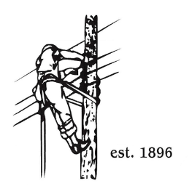
TOWN OF LYNDON
MEETING OF THE ELECTRIC BOARD OF COMMISSIONERS
August 26, 2024

Location: Lyndonville Police Station Building, Conference Room, 316 Main Street
Time: 5:30pm

Join Zoom Meeting
https://us02web.zoom.us/j/85623393997?pwd=Tzcvcm00TXpSdysvQWNPYXVtMWlKdz09
Meeting ID: 856 2339 3997
Passcode: 742759
Dial by your location
+1 646876 9923 US (New York)
+1 301715 8592 US (Washington DC)
AGENDA

- Changes/Modifications to Agenda
- Minutes Review/Approval August 12, 2024
- Public Comment
- Financial Report
- Line of Credit Request
- 2024 Rate Case Update
- Other Business
- Adjourn

