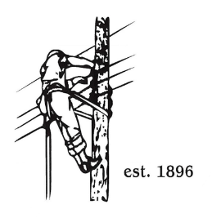
TOWN OF LYNDON
THE ELECTRIC BOARD OF COMMISSIONERS
September 22nd, 2025

Location: Municipal Building, Conference Room, 119 Park Avenue
Time: 5:30pm

Join Zoom Meeting
https://us02web.zoom.us/j/88345988927
Meeting ID: 883 4598 8927
Passcode: 108702
Dial by your location
+1 646876 9923 US (New York)
+1 301715 8592 US (Washington DC)
AGENDA

- Changes/Modifications to Agenda
- Public Comment
- Approve minutes from the August 25th meeting.
- Discuss attending joint AMI meeting with Barton and Orleans Trustees for AMI update by VPPSA on October 27th.
- Grid Grant update / discussion, approval
- GM Updates
- Garage Floor Drains
- Burke Transformer Fan Update
- Staffing update
- Twinstate Phone Upgrade update
- Other Business
- Adjourn

