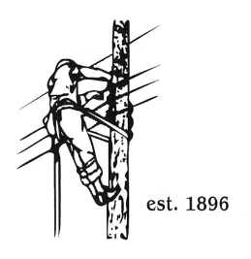**TOWN OF LYNDON**

**THE ELECTRIC BOARD OF COMMISSIONERS**

August 25th, 2025

Location: Municipal Building, Conference Room, 119 Park Avenue

Time: 5:30pm

Join Zoom Meeting

[https://us02web.zoom.us/j/88345988927](https://nam10.safelinks.protection.outlook.com/?url=https%3A%2F%2Fus02web.zoom.us%2Fj%2F88345988927&data=05%7C02%7Cjelwell%40lyndonelectric.com%7Caab1911ede1a4941777008dd3a3f8859%7Cf1d7bf4fb27e49ea8ea7795094bce33c%7C0%7C0%7C638730766722187931%7CUnknown%7CTWFpbGZsb3d8eyJFbXB0eU1hcGkiOnRydWUsIlYiOiIwLjAuMDAwMCIsIlAiOiJXaW4zMiIsIkFOIjoiTWFpbCIsIldUIjoyfQ%3D%3D%7C0%7C%7C%7C&sdata=XUx0JsOY0inr4f1Kd58Hsj4vlNZUd0g8M2dX9XJXcDw%3D&reserved=0)

Meeting ID: 883 4598 8927

Passcode: 108702

Dial by your location

+1 646876 9923 US (New York)

+1 301715 8592 US (Washington DC)

AGENDA

1. Changes/Modifications to Agenda
2. Public Comment
3. Approved minutes from the August 8th meeting.
4. Discussion / Decision on using VPPSA to finance the remainder of the AMI project.
5. 2025 VT Transco Equity reoffering discussion / decision.
6. General Mgrs. Report
7. Vail Hydro Update
8. Great Falls Hydro Update
9. Rate Case Update
10. Other Business
11. Adjourn