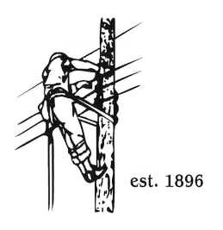**TOWN OF LYNDON**

**SPECIAL MEETING OF THE ELECTRIC BOARD OF COMMISSIONERS**

July 14th, 2025

Location: Municipal Building, Conference Room, 119 Park Avenue

Time: 5:30pm

Join Zoom Meeting

[https://us02web.zoom.us/j/88345988927](https://nam10.safelinks.protection.outlook.com/?url=https%3A%2F%2Fus02web.zoom.us%2Fj%2F88345988927&data=05%7C02%7Cjelwell%40lyndonelectric.com%7Caab1911ede1a4941777008dd3a3f8859%7Cf1d7bf4fb27e49ea8ea7795094bce33c%7C0%7C0%7C638730766722187931%7CUnknown%7CTWFpbGZsb3d8eyJFbXB0eU1hcGkiOnRydWUsIlYiOiIwLjAuMDAwMCIsIlAiOiJXaW4zMiIsIkFOIjoiTWFpbCIsIldUIjoyfQ%3D%3D%7C0%7C%7C%7C&sdata=XUx0JsOY0inr4f1Kd58Hsj4vlNZUd0g8M2dX9XJXcDw%3D&reserved=0)

Meeting ID: 883 4598 8927

Passcode: 108702

Dial by your location

+1 646876 9923 US (New York)

+1 301715 8592 US (Washington DC)

AGENDA

1. Changes/Modifications to Agenda
2. Public Comment
3. Approve minutes from prior meeting, June 9th, 2025
4. Budget analysis by Financial Manager Erica Welton
5. Remove Jonathan Elwell’s name from the Town of Lyndon Electric Department Money Purchase Pension Plan and add Jason Lefebvre.
6. Approval of Town of Lyndon Electric Dept. procurement / conflict of interest policy.
7. General Managers report:
   1. Update on Burke Substation Transformer fan installation.
   2. Update on switch 843.
   3. Update on Recreational Management Plan for Great Falls.
   4. Update on Dell Computer installs.
   5. Update on phone system upgrade.
8. Other Business
9. Adjourn