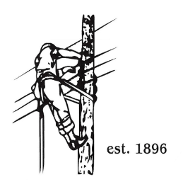
TOWN OF LYNDON
THE ELECTRIC BOARD OF COMMISSIONERS
Monday October 27th, 2025

The Town of Lyndon Electric Department Board of Commissioners’ meeting will be a joint meeting with Barton and Orleans trustees in Orleans at the Municipal Building. The address is below for those wishing to attend. The meeting will be on Zoom, click on the link below using the meeting code and password or dial in via phone with the number below.

Location: Orleans Municipal Bldg., 1 Memorial Square, Orleans, VT
Time: 6:00pm

Join Zoom Meeting
Join the meeting now
Meeting ID: 236 324 432 852 4
Passcode: dz3gh3Uz
Dial in by phone
+1 469-965-2602,,367140635# United States, Northlake
Find a local number
Phone conference ID: 367 140 635#

AGENDA

- Call meeting to order
- VPPSA presentation on AMI project and Power Supply.
- Adjournment

