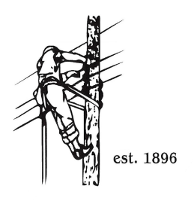
TOWN OF LYNDON
THE ELECTRIC BOARD OF COMMISSIONERS
Tuesday October 14th, 2025

Location: Municipal Building, Conference Room, 119 Park Avenue
Time: 5:30pm

Join Zoom Meeting
https://us02web.zoom.us/j/88345988927
Meeting ID: 883 4598 8927
Passcode: 108702
Dial by your location
+1 646876 9923 US (New York)
+1 301715 8592 US (Washington DC)
AGENDA

- Changes/Modifications to Agenda
- Public Comment
- Approve minutes from the September 22nd, 2025, meeting.
- Budget analysis from Erica Welton through August 2025.
- Joint Board of Commissioners meeting with Barton and Orleans Trustees on Monday October 27th for AMI and power supply update by Ken Nolan of VPPSA.
- GM Updates
- Grid Resiliency Grant
- Twinstate Phone Upgrade
- Software Update
- Great Falls Hydro
- Other Business
- Adjourn

