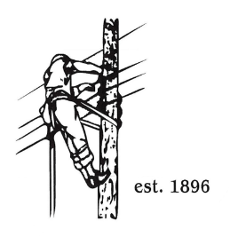
TOWN OF LYNDON
THE ELECTRIC BOARD OF COMMISSIONERS
Monday January 12th, 2026

Location: Municipal Building, Conference Room, 119 Park Avenue
Time: 10:00AM

Join Zoom Meeting
https://us02web.zoom.us/j/88345988927
Meeting ID: 883 4598 8927
Passcode: 108702
Dial by your location
+1 646876 9923 US (New York)
+1 301715 8592 US (Washington DC)
AGENDA

- Changes/Modifications to Agenda
- Public Comment
- Approve minutes from the December 22nd, 2025, meeting.
- Ken Mason as alternate VPPSA Board Director for Orleans
- Joint Board meeting with Orleans and Barton on January 26th.
- Presentation of 2026 draft budget to board by Erica Welton.
- Non-union tiered wage/salary and adjustment.
- Other Business
- Adjourn

