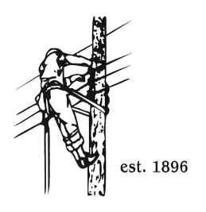
TOWN OF LYNDON
THE ELECTRIC BOARD OF COMMISSIONERS
Monday June 8th, 2026

Location: Municipal Building, Conference Room, 119 Park Avenue
Time: 5:30pm

Join Zoom Meeting
https://us02web.zoom.us/j/88345988927
Meeting ID: 883 4598 8927
Passcode: 108702
Dial by your location
+1 646876 9923 US (New York)
+1 301715 8592 US (Washington DC)
AGENDA

- Changes/Modifications to Agenda
- Public Comment
- Approve minutes from the May 11th, 2026, meeting. (May 25th, 2026, meeting was cancelled.)
- Review submitted proposals for Truck 17 purchase. (Action Item)
- Transco Equity Offer. (action Item)
- NISC Update, timeline.
- GM Updates:
- Great Falls Signage / Kiosk
- SQRP Penalty
- SCADA update
- Other Business
- Adjourn

