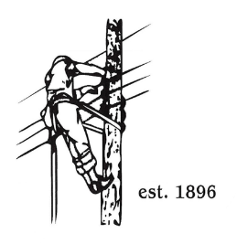
TOWN OF LYNDON
THE ELECTRIC BOARD OF COMMISSIONERS
Monday April 13th, 2026

Location: Municipal Building, Conference Room, 119 Park Avenue
Time: 5:30pm

Join Zoom Meeting
https://us02web.zoom.us/j/88345988927
Meeting ID: 883 4598 8927
Passcode: 108702
Dial by your location
+1 646876 9923 US (New York)
+1 301715 8592 US (Washington DC)
AGENDA

- Changes/Modifications to Agenda
- Public Comment
- Approve minutes from the meeting.
- Budget Analysis by Erica Welton for January and February of 2026.
- Approval of revised NISC proposal.
- 2026 1st quarter SQRP
- GM Updates
- AMI
- Great Falls License
- Other Business
- Adjourn

