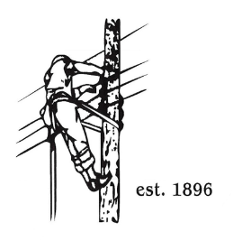
TOWN OF LYNDON
THE ELECTRIC BOARD OF COMMISSIONERS
Monday March 23rd, 2026

Location: Municipal Building, Conference Room, 119 Park Avenue
Time: 5:30pm

Join Zoom Meeting
https://us02web.zoom.us/j/88345988927
Meeting ID: 883 4598 8927
Passcode: 108702
Dial by your location
+1 646876 9923 US (New York)
+1 301715 8592 US (Washington DC)
AGENDA

- Changes/Modifications to Agenda
- Public Comment
- Approve minutes from the February 23rd, 2026, meeting. The Meeting for March 9th, 2026, was cancelled.
- Executive Session
- to discuss software upgrade with non-disclosure agreement
- to discuss employee matter
- Proposal / Approval of software upgrade
- GM Update
- Great Falls Headgate update
- AMI update
- Truck 17 update
- St. Patty Day storm update
- March 31st extended lunch break for informational insurance meeting
- Other Business
- Adjourn

