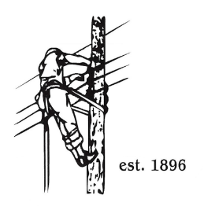
TOWN OF LYNDON
THE ELECTRIC BOARD OF COMMISSIONERS
Monday February 9th, 2025

Location: Municipal Building, Conference Room, 119 Park Avenue
Time: 5:30pm

Join Zoom Meeting
https://us02web.zoom.us/j/88345988927
Meeting ID: 883 4598 8927
Passcode: 108702
Dial by your location
+1 646876 9923 US (New York)
+1 301715 8592 US (Washington DC)
AGENDA

- Changes/Modifications to Agenda
- Public Comment
- Approve minutes from the January 26th,2026 board meeting.
- Joint board meeting with Barton and Orleans is to be held on Monday February 23rd in Lyndon.
- Power Supply Update, December 2025 to February 2026
- SQRP for 2025
- GM Updates:
- Meter Reader Position
- Great Falls Head Gates
- AMI
- Other Business
- Adjournment

