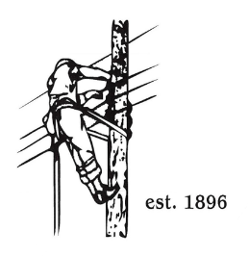
TOWN OF LYNDON
THE ELECTRIC BOARD OF COMMISSIONERS
Monday February 23rd, 2026

Location: Municipal Building, Conference Room, 119 Park Avenue
Time: 5:30pm

Join Zoom Meeting
https://us02web.zoom.us/j/88345988927
Meeting ID: 883 4598 8927
Passcode: 108702
Dial by your location
+1 646876 9923 US (New York)
+1 301715 8592 US (Washington DC)
AGENDA

- Changes/Modifications to Agenda
- Public Comment
- Approve minutes from the February 9th, 2026 meeting.
- Joint portion of meeting with Barton and Orleans to discuss:
- Purchased power discussion with VPPSA.
- Feasibility of Orleans, Barton and Lyndon exploring opportunities to work together to increase efficiency.
- December 2025 budget analysis by Erica Welton.
- Presentation of 2026 LED budget.
- Other Business
- Adjourn

