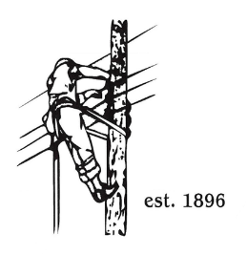
TOWN OF LYNDON
THE ELECTRIC BOARD OF COMMISSIONERS
Monday January 26th, 2026

Location: Municipal Building, Conference Room, 119 Park Avenue
Time: 5:30pm

Join Zoom Meeting
https://us02web.zoom.us/j/88345988927
Meeting ID: 883 4598 8927
Passcode: 108702
Dial by your location
+1 646876 9923 US (New York)
+1 301715 8592 US (Washington DC)
AGENDA

- Changes/Modifications to Agenda
- Public Comment
- Approve minutes from the January 12th meeting.
- Budget Analysis for November by Financial Manger Erica Welton
- Barton and Orleans Trustees were scheduled to attend the January 26th meeting with the Lyndon Board of Commissioners; this will now take place at the February 9th meeting in Lyndon due to the inclement weather forecast for Monday night.
- General Manager Updates:
- Meter Reader Hiring update.
- 5 year forecast update.
- Great Falls headgates, Management plan update.
- Burke 34.5kv OH line / Substation update.
- Other Business
- Adjourn

