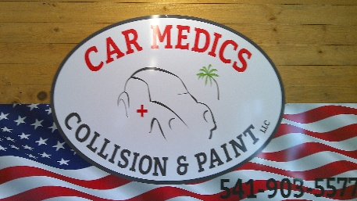
TAX ID:32-2227772
AUTHORIZATION TO REPAIR FORM
DATE:_______________ CLAIM NO:_________________

NAME_______________________________________

YEAR:_______MAKE:_____________MODEL:__________

By signing this form, I understand and agree to the following terms and authorize Car Medics Collision & Paint. To repair the above mentioned vehicles. Car Medics Collision & Paint is also authorized to act as my agent for the purpose of negotiation on my behalf with the insurer for the cost of the repairs, Including damage not listed or visible at the time the initial insurance appraisal was done.
I authorize the employees of Car Medics Collision & Paint to operate my vehicle for the purpose of testing the vehicle, Delivery of the vehicle or for inspection of the vehicle by my insurance company.
I understand Car Medics Collision & Paint will order parts for my vehicle as soon as possible. I also understand that Car Medics Collision & Paint will start the work performance as soon as possible once the insurer has photographed the vehicle and assessed the damages.
In the event the vehicle is not repaired I understand there may be charges, including but not limited to the following, Towing, Storage, Administrative Fees, Appraisal Fees, Parts Restocking Fees, Labor charges, Legal & Recovery Fees. I also understand that any charges not paid by the insurer are my responsibility, Including but not limited to the following, Towing, Deductibles, Betterments or for additional work requested. I also understand that those charges are due upon Pickup/Delivery of my vehicle.
Unless prior arrangements have been made I agree to pick up my vehicle unless I have informed Car Medics Collision & repair of prior commitments, Otherwise a $25.00 per day storage fee may be added to the total cost repair bill. In the event I do not pay the charges owed necessary to remove my vehicle from Car Medics Collision & Paint I understand that I will be responsible for any and all legal fees incurred.
Car Medics Collision & Paint will not be held responsible for loss or damage to vehicle or articles left in vehicles in case of Fire, Theft, Accident or any other cause beyond your control. An express garage keeper’s lien is acknowledged on the vehicle to secure the amount of repairs thereto. I understand Car Medics Collision & Paint is not responsible for any personal items left in the vehicle.
I understand that Car Medics Collision & Paint will repair my vehicle as specified in the appraisal written by my Insurance Company. I understand that my Insurance Company’s appraisal also acts as the repair order for my vehicle. *please note “Car Medics Collision & Paint” Does NOT save old vehicle parts unless requested by customer at time of drop off*
**When my vehicle is complete the total amount (which includes deductible) of $__________.____ will be paid to Car Medics Collision & Paint, I agree to pay this amount in full or my vehicle will not be released.**
OWNER/DEIGNEE SIGNATURE X____________
DATE:_____________

DIRECTION TO PAY: APPRAISAL, SUPPLEMENTS AND TO BILL.
The undersigned hereby directs the insurance company to pay Car Medics Collision & Paint directly.

OWNER/DESIGNEE SIGNATURE X_________________
DATE:_________________
By signing this form under the direction to pay plan portion, I understand that if any payments come to myself in error, I will forthwith that payment to Car Medics Collision & Paint immediately.

