State EPA: CAL000429011

Bar # ARD-311832

355 E Manchester Ave.

Work Order# _________

Los Angeles, CA 90003

Tel: 323 308- 0554

Fax: 855 201 1922

|  |  |  |  |  |  |  |  |  |  |  |  |  |  |  |  |  |  |  |  |  |  |  |  |  |  |  |  |  |  |
| --- | --- | --- | --- | --- | --- | --- | --- | --- | --- | --- | --- | --- | --- | --- | --- | --- | --- | --- | --- | --- | --- | --- | --- | --- | --- | --- | --- | --- | --- |
| Client Name | | |  | | | | | | | | | | | | | | Date and Time Veh. Came In | | | | |  | | | | | | | |
| Home Address | | |  | | | | | | | | | | | | | | Insurance Company | | | | |  | | | | | | | |
| City, State, Zip | | |  | | | | | | | | | | | | | | Policy Number | | | | |  | | | | | | | |
| Email Address | | |  | | | | | | | | | | | | | | Adjuster’s name | | | | |  | | | | | | | |
| Name Of Person Dropping Vehicle | | |  | | | | | | | | | | | | | | Adjuster Tel. # | | | | |  | | | | | | | |
| Cell Phone # | | |  | | | | | | | | | | | | | | Adjuster’s Email | | | | |  | | | | | | | |
| Home Phone # | | |  | | | | | | | | | | | | | | Claim # | | | | |  | | | | | | | |
|  | | |  | | | | | | | | | | | | | |  | | | | |  | | | | | | | |
| VEHICLE INFORMATION | | | | | | | | | | | | | | | | | | | | | | | | | | | | | |
| VIN |  |  | |  |  | |  |  | |  | |  |  | | |  | |  |  | |  | |  | |  |  |  |  |
| Year |  | | | | | Prod Date | | |  | | | | | | Checked in by Employee: | | | | | | | | |  | | | | | |
| Make |  | | | | | Mileage In | | | | |  | | | | | | | | |  | | | | | | | | | |
| Model |  | | | | | Color / Code | | | | |  | | | | | | | | |
| Lic. Plate |  | | | | | Fuel (Circle) | | | | | E----1/4----1/2--3/4----F | | | | | | | | |
| Vehicle was (Circle One) Towed In / Driven in / Other | | | | | | | | | | | | | |

|  |  |
| --- | --- |
| Office Use Only  Accident Related Damage Non-Accident Related Damage | |
| **(Initials)**________________  **Date**____________________ | **(Initials)______________**  **Date**___________________ |

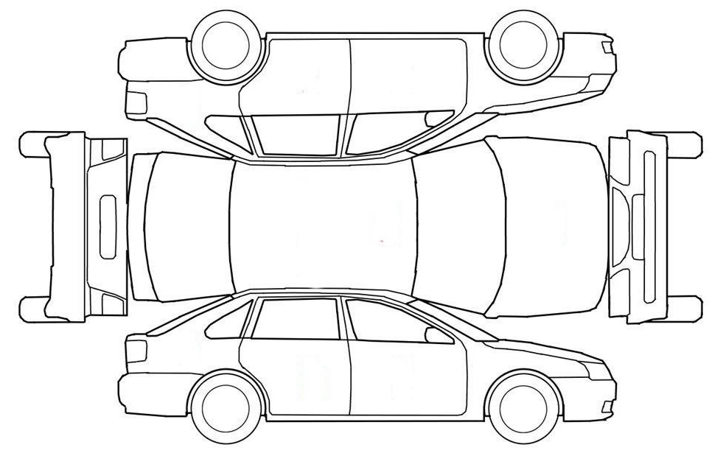

**Dash Lights on After Accident**

**Interior Damages**

|  |
| --- |
| Acknowledgement of Payment Policy |
| You are responsible for FULL payment upon pick up UNLESS your insurance carrier pays us directly. Deductible must be paid in full upon pick up. Forms of payment accepted are Debit and Credit Card, Cash, Cashiers Checks. We DO NOT accept Credit and/or Debit card transactions over $1000. Non-repaired vehicle are subject to cash method of payment only. **There will be a 2.5% Fee on top of Credit and Debit Transactions**.    **Deductible:** $_______________________ **Signature** _________________________________________________________ |
|  |

|  |
| --- |
| Repair Authorization (In Person) |
| Repair as per attached (Ins Co/323 Auto Collision Center)  Amount:___________________________________ Insurance Claim #_____________________________________________________  Print Name & Sign:_____________________________________________________________ Dated:_____________________________ |

|  |
| --- |
| Supplement Authorization (Verbal) |
| I authorize the following amount in addition to the original amount previously authorized by me.  Amount $_______________________________________ Authorized By:____________________________________________________________  Date and Time Called:_________________________________________________ Phone Number Called:_____________________________________________ |

RO:_____________

|  |
| --- |
| Acknowledgement of Notice & Consent – Delivery Section (Upon Completion of repair only) |
| I acknowledge notice and oral approval of increase / decrease in the original estimate price, Delivery of vehicle and RECEIPT of Itemized final bill invoice from 323 Auto Collision Center.  Signature of Customer:_______________________________________________________ Date:________________________________ |

|  |
| --- |
| Repair Authorization (Verbal) |
| Repair as per attached (Ins Co 323 Collision Center)  Amount:_____________________ Ins. Claim#_______________________________ Authorized By:__________________________Drivers Lic#:____________________________  Date & Time Called:_______________________________________________ Phone Number Called:___________________________________________________________ |

|  |
| --- |
| Direction To Pay |
| The Undersigned, herein after called “Customer” for the consideration of repairs made to “Customer’s” automobile does hereby grant to above mentioned repair facility. “Customer’s” power of attorney to sign or endorse any checks, and/or drafts made payable to “Customer” and any releases thereto, as settlement for “Customer’s” claim for damages of the above referenced vehicle.  **Authorized Signature x**_____________________________________________________________________________ **Date:**______________________ |

|  |
| --- |
| Ackowledgement of Shop Policy |
| Teardown consists of disassemble and/or possible photo vehicle damaged area to prepare for an estimate. Disassembly MAY prevent reassembly of vehicle to the original condition. Teardown charges will apply if repairs are not performed. Reassembly will take place within 30 days of the vehicle date shown at the top of this page if customer chooses to not furter authorize the services/repairs recommended. Lien could be put on vehicle after 2 days of completion of repairs or if repairs have been stopped & vehicle has not been removed. STORAGE and other applicable charges will apply on the vehicle upon arrival or after one day of completion of repairs, if vehicle has not been picked up. Storage fees and misc. fees will also apply if repairs were not completed & vehicle has not been removed from.  Storage Charges at the Rate of $250 per calendar day /Estimate fee of $275.000/ Advanced Charges :_________________________________  I Understand, act as an authorized person/Customer do hereby authorize a teardown.  **Authorized Signature x**___________________________________________________________________________ **Date:__________________________**  I ___________________________________ Authorize Repairs to Vehicle stated on Page 1 of Repair Order  **Authorized Signatre x_______________________________________** |