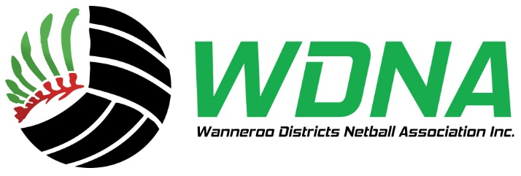

Dear Members
For 2026 we are streamlining as many of our processes as we can, starting with the Board nominations.
As per our By Laws:
- The nomination must include a statement by another member (nominator) in support of the nomination. The member can either be from the nominee’s club or another WDNA club.
- Any person nominating for the Board shall declare that they are not an undischarged bankrupt or one whose affairs are under insolvency law.
  - Have not been convicted with an offence involving fraud or dishonesty punishable on conviction by 3 months or more imprisonment and.
  - Have not been convicted of an offence in connection with the promotion, formation of management of a body corporate, including duties under the law.
- All nominations received within the timeframe stated shall be forwarded to the Nominations Committee to determine their suitability for the position nominating for. The Nominations Committee will provide their recommendations to the Board within 48 hours of the close of nominations.
Please find below the links to nominate for a 2026 Board position.
NOMINATOR
If you are nominating someone, please complete this link.
https://form.jotform.com/253287894841876

NOMINEE
If you are being nominated or wish to nominate yourself, please complete this link and ensure your nominator has also completed the correct link.
https://form.jotform.com/253168219839872

Nominations close on January 15th, 2026

