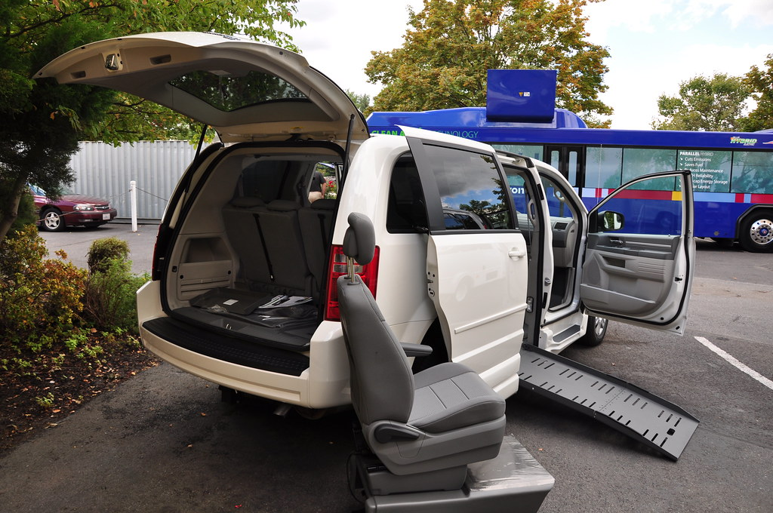  - VEHICLE / DRIVER HOURS OF OPERATION: 8:30 – 4:30 M-F  - RESERVE RIDE AT LEAST 24 HRS IN ADVANCE BY CALLING 438-2192 DURING BUSINESS HOURS. LEAVE A MESSAGE IF WE’RE OUT OF OFFICE FOR A RETURN CALL UPON OUR RETURN  - CANCELLATIONS NEED TO BE MADE ASAP OR A MINIMUM OF 2 HOURS PRIOR TO PICKUP TIME  - EVERY EFFORT WILL BE MADE TO ARRIVE AS CLOSE TO SCHEDULED PICKUP TIME AS POSSIBLE, PLEASE ALLOW A 15 MINUTE WINDOW. DRIVER WILL WAIT 5 MINUTES BEFORE LEAVING FOR NEXT PASSENGER  - WE RESERVE THE RIGHT TO DENY TRANSPORTATION FOR FAILURE TO PROVIDE ACCURATE INFORMATION OR FAILURE TO CANCEL  - IF MOBILITY DEVICES OR ASSISTANCE IS NEEDED; MAKE KNOWN AT TIME OF RIDE RESERVATION
  Who We Are
  PASSENGERS ARE THE MOST IMPORTANT PEOPLE IN OUR BUSINESS
  BCT IS PLEASED TO SERVE THE RESIDENTS OF BENSON COUNTY WITH PUBLIC TRANSIT THAT IS AVAILABE TO ALL AGES.
  RIDES ARE AVAILABLE FOR ANY PURPOSE
  UPTOWN MADDOCK RIDES AVAILABLE
  WITHIN BENSON COUNTY RIDES
  RIDES TO NEARBY TOWNS: DEVILS LAKE, HARVEY, RUGBY WEEKLY
  MEDICAL RIDES ANYWHERE IN ND
  Contact Us
  Phone: 701-438-2192 MONDAY -FRIDAY 8:30 AM TO 4:30 PM
  CHECK UPDATED SCHEDULING AT
  www.bensoncountytransportation.com
  
  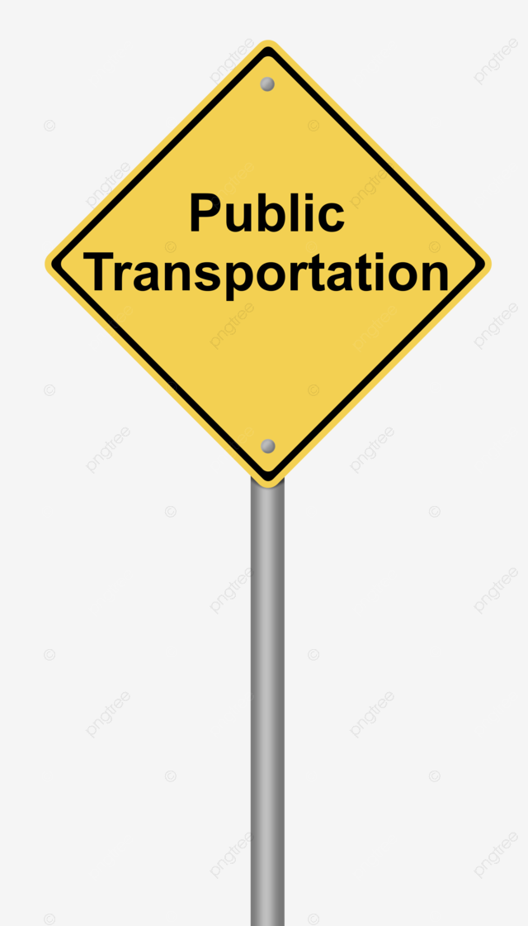
  438-2192
  Under Title VI of the Civils Rights Act of 1964 and its related statutes and regulations, no person or groups of persons shall be on the grounds of race color or national origin be excluded from participation in, be denied the benefits of or be otherwise subjected to discrimination under any and all programs or activities funded in whole or in part with Federal Funds.
  Benson County Transportation will consider every request for reasonable modifications from individuals with disabilities. Language assistance for persons with LEP is available free of charge. To request a reasonable modification or language assistance contact our office at 701-438-2192 or in writing to PO Box 306, Maddock, ND 58348

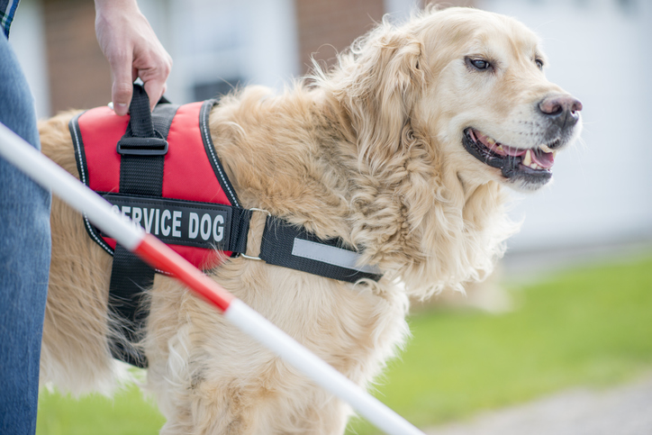  WE WELCOME SERVICE ANIMALS  A PERSONAL CARE ATTENDANT/ESCORT WHO IS DIRECTLY INVOLVED IN THE ASSISTANCE (HANDS ON CARE) OF THEIR ATTENDEE IS HIGHLY RECOMMENDED TO ACCOMANY YOU, IF YOU ARE IN A WHEELCHAIR OR USING A WALKER ETC AND NEED ASSISTANCE WALKING. IF YOU’RE HAVING SAME DAY SURGERY, (WITHIN OUR HOURS OF OPERATION) HAVE SOMEONE ACCOMPANY YOU.  OUR DRIVERS ARE NOT YOUR PERSONAL ASSISTANTS; AND CANNOT ACCOMPANY YOU INTO YOUR HOME OR INTO BUILDINGS FOR APPOINTMENTS |  |  | ALL PASSENGERS USING A MOBILITY DEVICE MUST ALLOW DRIVER TO SECURE THE DEVICE TO THE BEST OF HIS/HER ABILITY. AT DRIVERS’ DISCRETION WE WILL NOT ACCEPT THOSE DEVICES TOO LARGE TO BE SAFELY ACCOMODATED.  CALL TODAY TO RESERVE YOUR RIDE 438-2192 CLOSED HOLIDAYS  PLEASE SCHEDULE YOUR MEDICAL RIDE AS EARLY AS POSSIBLE BEFORE APPOINTMENT DAY FOR BEST SCHEDULING OPPORTUNITIES. WE DON’T WANT YOU TO HAVE TO RESCHEDULE EITHER. |  |  | RIDERSHIP RULES TO FOLLOW:  - ALL PASSENGERS REQUIRED TO WEAR SEAT BELTS  - NO SMOKING (E-CIGS) ON OR WITHIN 25 FT OF VEHICLE  - CELL PHONE RINGERS OFF  - NO FOOD EXCEPT BOTTLED WATER  - LAW PROHIBITS FIREARMS, KNIVES OR ANY OTHER WEAPONS ON VEHICLE  - NO RIDING WITH OPEN CONTAINERS OF ALCOHOL OR ILLEGAL DRUGS; WE RESERVE THE RIGHT TO ASK TO SEE CONTENTS OF PKG IF DRIVER SUSPECTS OPEN CONTAINER. WE WILL NOTIFY LAW ENFORCEMENT FOR ILLEGAL DRUGS  - NO RIDING UNDER THE INFLUENCE ANY PASSENGER UNDER THE INFLUENCE OF DRUG OR ALCOHOL MAY BE REFUSED SERVICE

