Women’s Guild
Membership Application
Name: Address: City: Zip: Phone: Cell Phone: Email: Seasonal Address:

New ____ SJA ___OLOL
Participation Interest:
Serve on a committee
I don’t have Internet access and need a “Phone Buddy”
Be a “Phone Buddy”
Need transportation to meetings
Provide transportation to meetings
Other (specify)
Please complete and mail to Carmella Alfano
2225 Herringbrook Road
Eastham, MA 02642

Mission Statement
To provide an opportunity for the women of St. Joan of Arc Parish to come together as a community to work for the betterment of the parish and to enrich our spiritual journey through friendship, prayer and service.

Guild Board
President Shelly Kennedy
President Elect Sue Koch
Past President Pattie Miller
Co-Secretary Carmella Alfano
Co-Secretary Anne Figurella
Co-Treasurer Karen McGorry Cross
Co-Treasurer Pam Vasilik

Standing Committee Representatives
Honor Guard Chair Nancy Rouillard Hospitality Co-Chair Terri Dolbec Hospitality Co-Chair Brenda Bourne Nominating Chair Katie Griffin Scholarship Chair Ellen Covell Thrift Shop Chair Karen Knight

St. Joan of Arc

Women’s Guild

2025-2026



St. Joan of Arc Church 61 Canal Road
Orleans, Massachusetts 02653
508-255-0170

Why Join?
- To participate in a community of women working for the betterment of the St. Joan of Arc Parish.
- To experience an enriching spiritual journey with the women of St. Joan of Arc Parish through friendship and prayer.
- To promote charity and friendship among the women of St. Joan of Arc Parish.
- To participate in interesting programs and projects with the women of St. Joan of Arc Parish.

Questions? Send email to: SJAGuild@joanarc.org
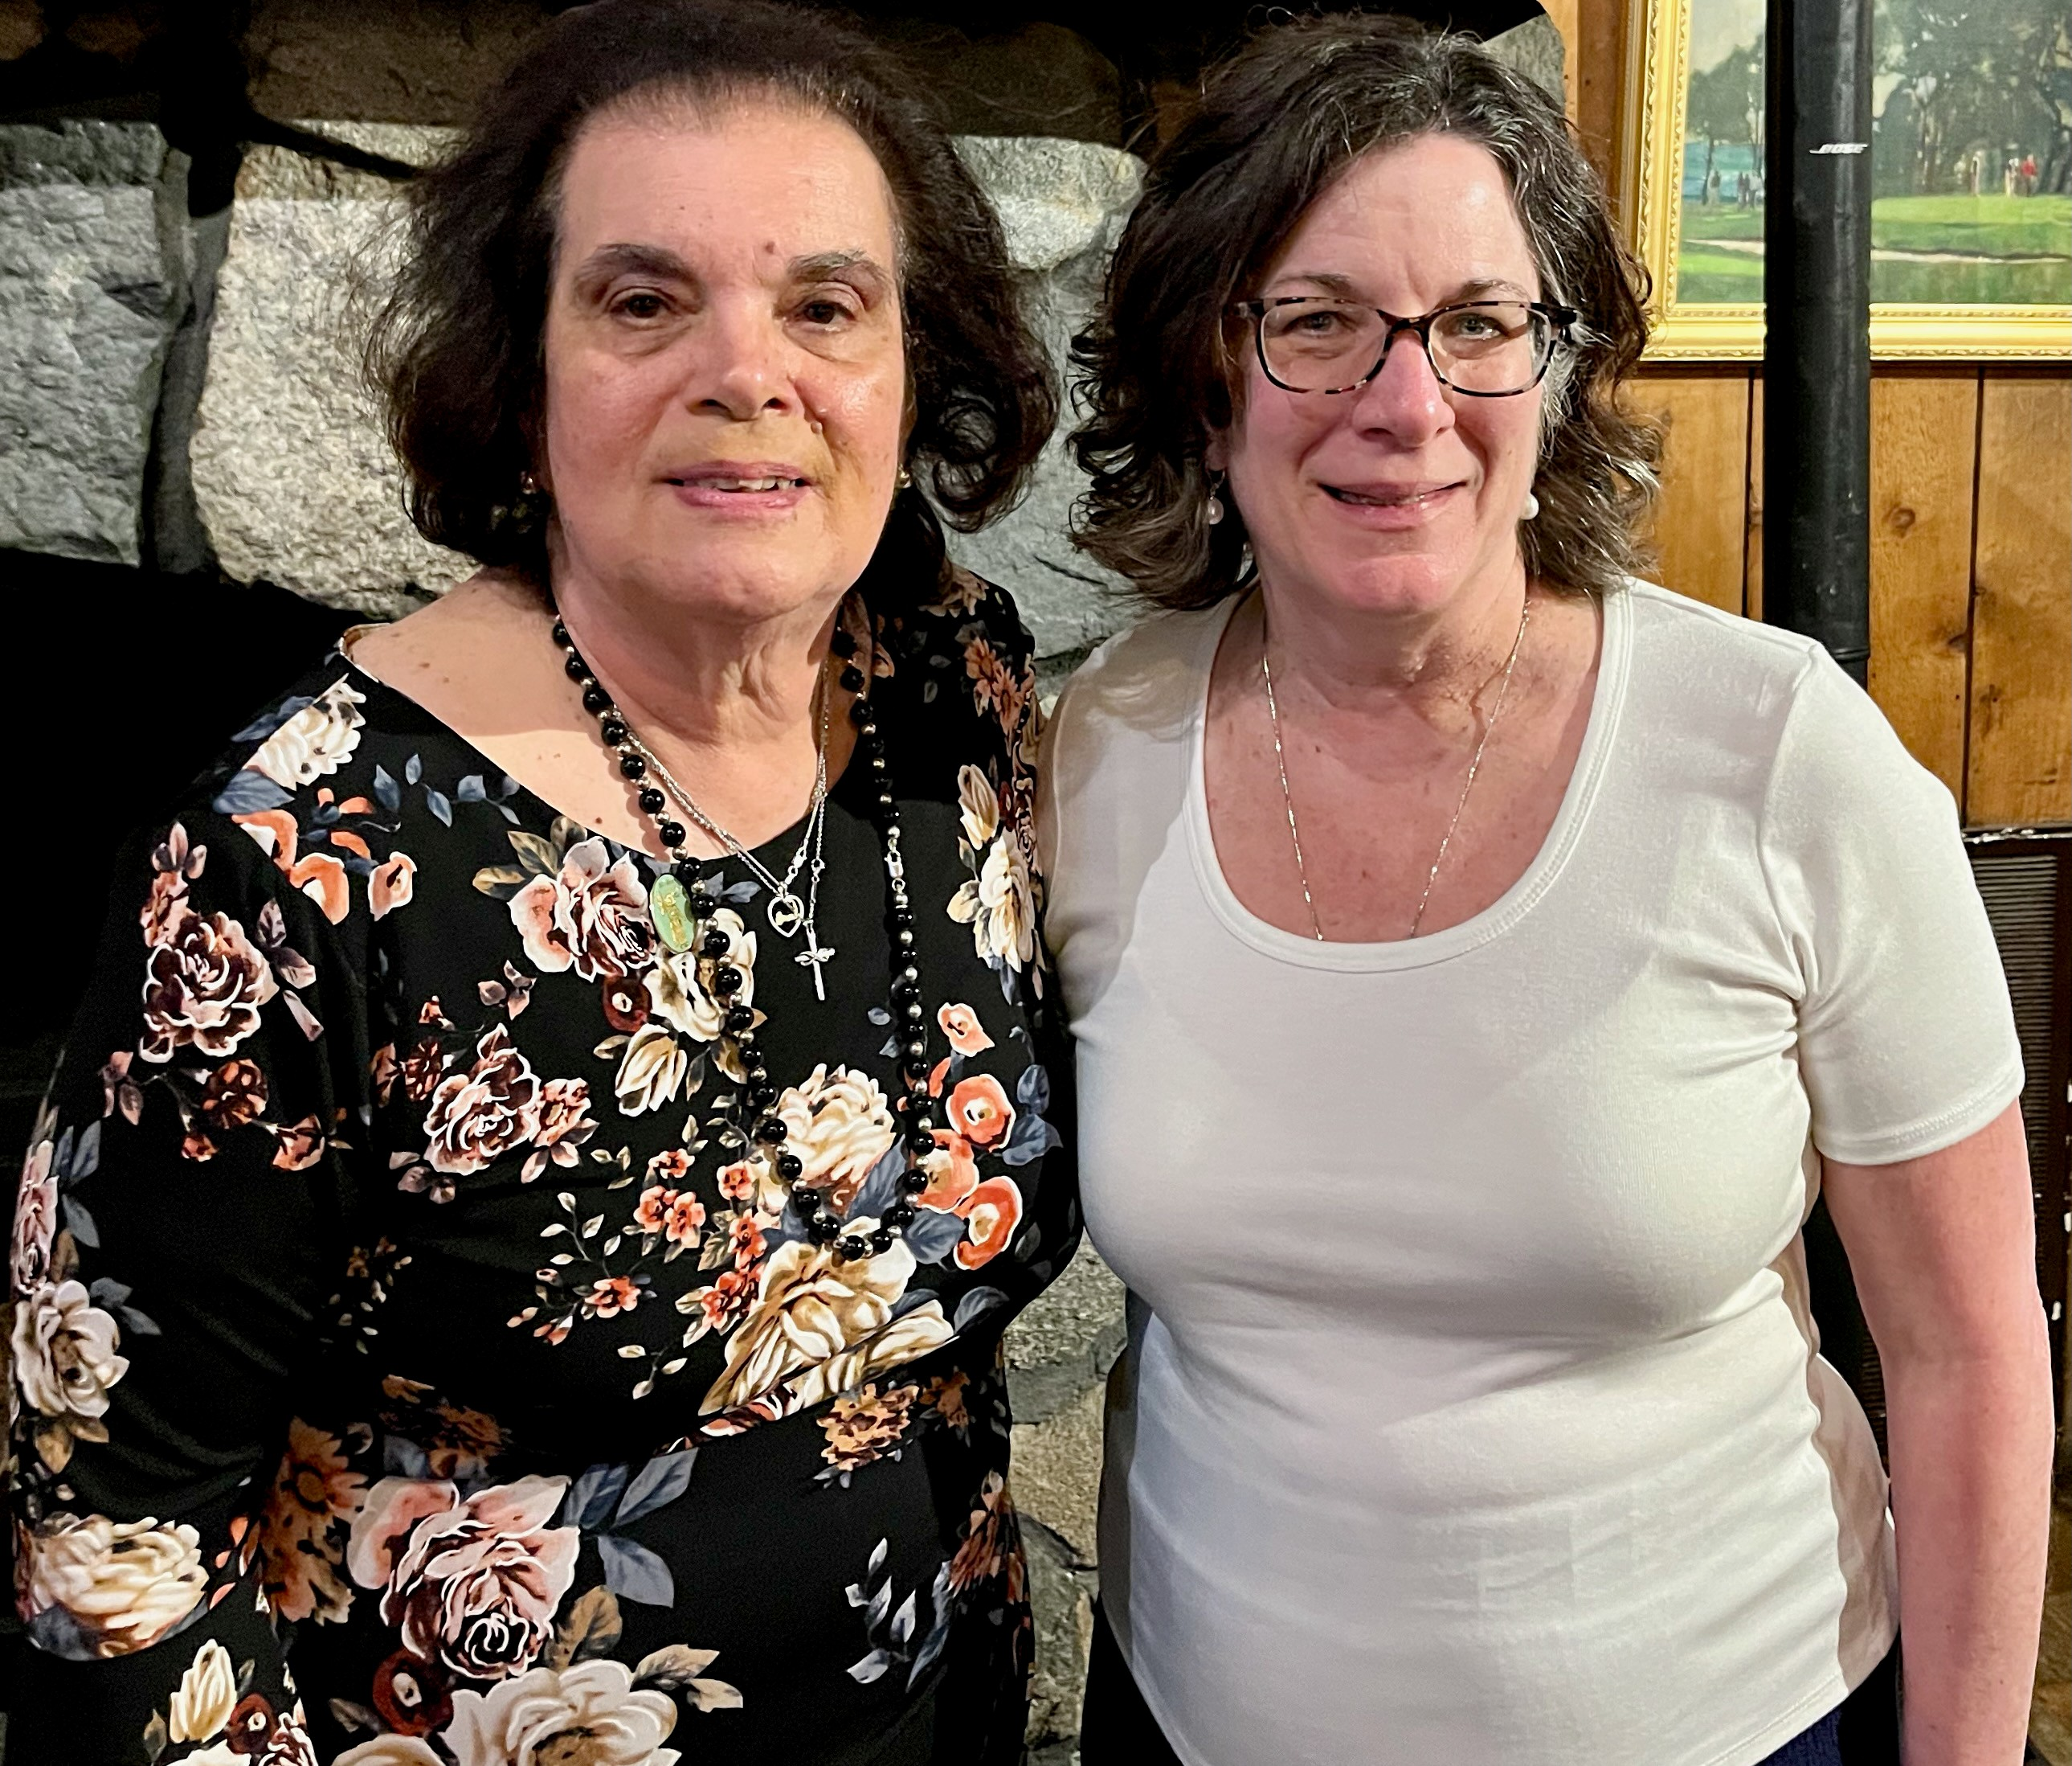

Past President Patricia Miller with President Shelly Kennedy

Monthly Meeting Schedule

September 9 7:00 PM Presentation by Father Peter:
“Why did Jesus Appear to Women First.”
October 18 5:00 PM Parish Picnic & Friendship Social with Knights of Columbus
November 19 (Wed) 11:00 AM Luncheon at the Hidden Cove Restaurant, Cape Cod Tech, Harwich
December 10 (Wed) 11:30 AM Christmas Luncheon at
Wequassett Resort and Golf Club

January 13 2:00 PM

Bingo
February 10 2:00 PM
Company of Books
Presentation by Freya Hemley

March 10 2:00 PM
Praying the Stations with Mary,
The Mother of Jesus - Lenten Program.

April 15 2:00 PM
Spring Tea and Fashion Show

May 12 2:00 PM
Mass & Rosary for Deceased Guild
Members and Thrift Shop Volunteers
June 9 11:30 AM
Spring Luncheon at Barley Neck Inn

St. Joan of Arc Thrift Shop
The Thrift Shop is the primary source of Guild income and funds earned provide scholarships for college-bound parishioners. Additionally, the funds support community outreach and are also used to supplement St. Joan of Arc Parish income.

Thrift Shop Hours
Monday 10 am - 4 pm
Tuesday 10 am - 1 pm
Wednesday 10 am - 4 pm
Thursday 10 am - 4 pm
Friday 10 am - 4 pm

Thrift Shop Phone: 508-255-4476

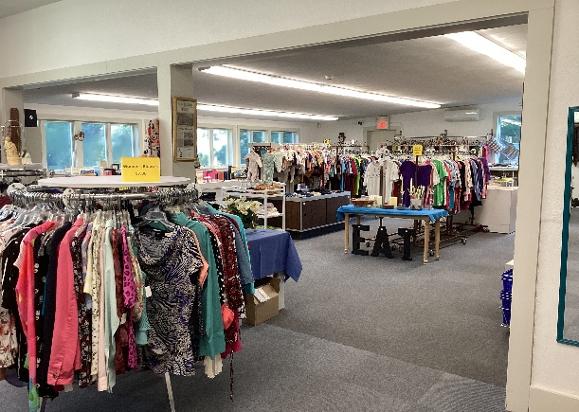

Donations are accepted during normal Thrift Shop Hours. (see above).

