Media Release
Click HERE for high resolution imagery
Kyrie Therapeutic Farm ‘Step Up For Recovery’ Charity Walk to take place at Malahide Castle on September 27th
Connection – Hope – Identity – Meaning - Empowerment
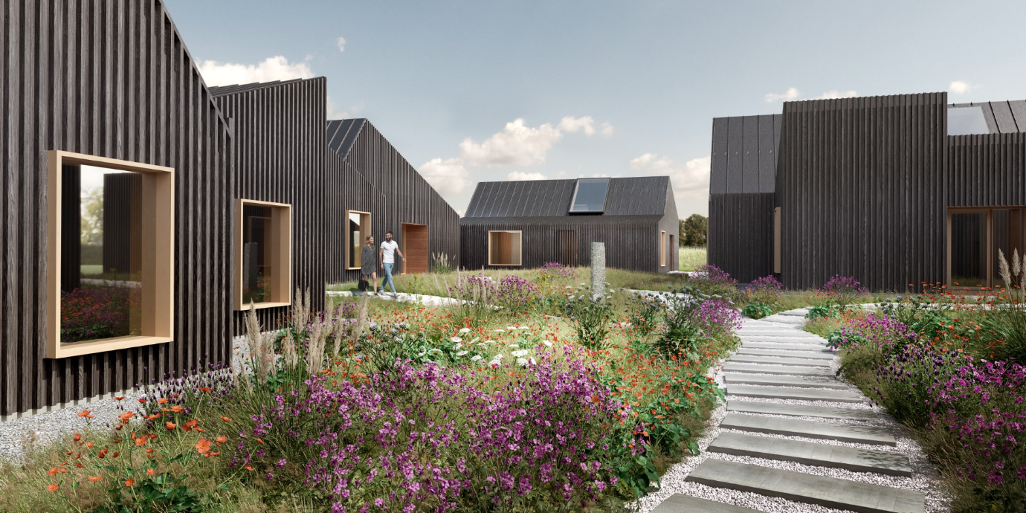
(CGI Image of Kyrie Therapeutic Farm)
On Saturday 27th September, Kyrie Therapeutic Farm will host the inaugural Step Up For Recovery Walk to highlight the issue of mental health in Ireland. The five kilometre walk in Malahide Castle (10am – 2pm) will be a ticketed event but people are encouraged to host their own walk and help raise much needed funds to build Ireland's first therapeutic farm. Kyrie Therapeutic Farm, a fifty seven acre former stud farm, is set to open in County Kildare in 2027 and will be Ireland’s first therapeutic farm for adults with serious mental health challenges. Inspired by the Gould Farm in America, it will provide residential, community, and nature-based care for up to forty adults (18+) at a time, offering meaningful work, therapeutic supports, and a pathway to recovery.
John McKeon of Kyrie Farm says the fundraising walk “is a walk for mental health awareness and solidarity”. John and his family lost their beloved son, aged 18, to suicide and their loss was the catalyst to find a new way of helping those who are in most urgent need of mental health supports and care. John and his family believe that a recovery orientated mental health support is what is needed in Ireland which is at one with Kyrie Farm pioneering community based approaches to care.
The five kilometre walk around the grounds of Malahide Castle will raise vital funds to build Kyrie Farm, which will be Ireland's first dedicated residential step-down farm for people recovering from serious mental health challenges. Each kilometre represents a theme of the CHIME framework - Connection, Hope, Identity, Meaning and Empowerment. However, people are encouraged to do their own five kilometre walk to raise funds in any part of the country on September 27th.

Eoin Galavan, Clinical Lead for Kyrie Farm, said today “Ireland’s mental health system is at breaking point. Too many are discharged too early, left without support, or turned away entirely due to lack of capacity. This walk is a moment to reflect, connect and stand together for a new model of care that supports real recovery beyond hospitals and medications in a not for profit, accessible way”.

A System in Crisis
Recent analysis published in The Irish Psychologist (August 2025) paints a stark picture of a system unable to meet demand:
· Ireland has only 23 public psychiatric beds per 100,000 people, less than one-third of the EU average and among the lowest in the Organisation for Economic Co-operation and Development (OECD).
· In 2024, the HSE spent €93 million outsourcing care to private providers, often abroad, disrupting continuity of care.
· Suicide remains the leading cause of death among 15–25 year-olds, highlighting the devastating human cost of gaps in the system.
· Despite commitments in Sharing the Vision (2020), only 9 out of 100 policy recommendations had been fully implemented by late 2024.
· Ireland spends just 5–6% of its health budget on mental health, compared to 10–12% in peer countries.
Experts and service users consistently warn that lives are being lost and communities stretched thin by this chronic underinvestment and over-reliance on hospital-based, biomedical care. The World Health Organization (WHO) and United Nations (UN) have urged a decisive shift toward community-led, rights-based recovery services.

John McKeon commented about the fundraiser “This is more than a fundraiser; it’s a call to action. Join us on 27th September to walk and talk for recovery, show solidarity with those living with mental health challenges, and call for reform that places dignity, connection, and empowerment at the heart of mental health care in Ireland”.

For more information, please visit www.kyriefarm.ie.

Instagram @kyriefarmie

Register now: https://donorbox.org/events/804458

-ENDS-

Notes to Editor

About Kyrie Therapeutic Farm

- Kyrie Therapeutic Farm is a registered charity (CHY 22704), Charities Regulatory Authority No. 20206028.
- Company Limited by Guarantee, CRO No. 673192.
- Kyrie Therapeutic Farm is a not-for-profit organisation with a voluntary board of directors.

For media/interview requests, please contact:
Joanne Byrne | Joannebyrne@presence.ie | 087 249 4668

