

**Homeless and Special Needs Housing**

**Application Instructions**

**Housing Trust Fund - Homeless Reduction Grant**

**Due Date: September 12, 2025 11:59pm**

Questions regarding program or application should be directed to:

Deserae Williams

(804) 965-4690

[deserae.williams@dhcd.virginia.gov](mailto:deserae.williams@dhcd.virginia.gov)

CAMS-related questions should be directed to:

CAMS HELP DESK

CamsHelp@dhcd.virginia.gov



**Homeless and Special Needs Housing HTF-HRG Application**

The Housing Trust Fund Homeless Reduction Grant is an individual application, where the preferred grantee will have ongoing responsibility of the project. Applicants must meet and adhere to all requirements set forth in the HSNH guidelines and ensure that the proposed project is housing related.

**Eligible Applicants**

Eligible applicants are units of local government and non-profit organizations.

Applicants must have a registered CAMS profile in order to apply. Proposed projects that will leverage multiple partners and subcontracts are allowable. The applicant is the entity responsible for compliance. Please contact DHCD if you have any questions.

DHCD may not enter into program grant agreements with any applicant with outstanding audit findings, IRS findings, DHCD monitoring findings or other compliance issues. Please note that DHCD will work with all interested parties toward the resolution of outstanding issues, where appropriate.

DHCD must verify project partner capacity and roles when evaluating applications and project feasibility. Applicants must be able to clearly articulate the relationship between all partners involved in the service provision, development, ownership, and/or property management of a project.

**Application Submission**

The Housing Trust Fund (HTF) Homeless Reduction Grant applications must be submitted through DHCD’s [Centralized Application and Management System](https://dmz1.dhcd.virginia.gov/camsportal/Login.aspx) (CAMS). Applicants should carefully follow all instructions for submission. Applications submitted with incorrect or missing information will be reviewed as is.

An applicant organization must have a registered CAMS organizational profile in order to apply for HTF funding. Once an organization has an approved profile, individual users may be given access to CAMS by the organization’s profile manager.

Applicants may submit applications at any time prior to the deadline. DHCD will only review applications submitted by the established deadline.

CAMS will send the applicant an email notification when an application has been submitted and received.

**Project Information**

The applicant must log into CAMS and select the Housing Trust Fund Homeless Reduction Grant Pool 2026 program, select the appropriate sub-program (HTF-HRG Rapid Rehousing, HTF-HRG Underserved Populations Innovation Projects, or HTF-HRG Permanent Supportive Housing) and click Apply. When the applicant clicks on Apply the system will ask for a Project Name. Please be careful to enter a project name that will help DHCD identify your project. The name of the development or the street where the project is located would be appropriate project names. Once the applicant hits Continue the project name cannot be edited. At this point CAMS will give the application a system-generated Application ID number.

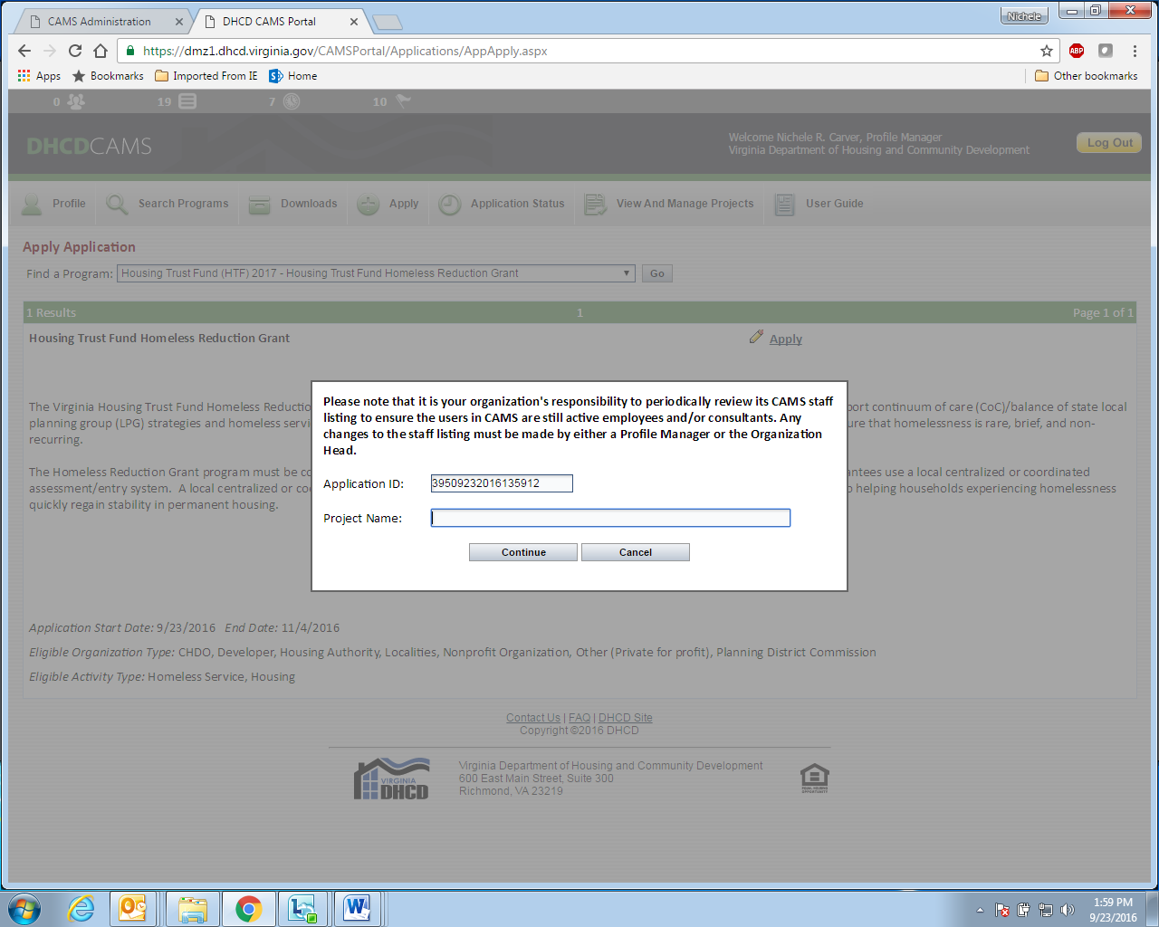

Select Continue and CAMS will take the applicant to the Project Information tab. On the project information tab the Organization Name will be pre-populated based on the organization’s profile. Please note, any errors or needed updates to the organizational profile must be made by the individual who is set up as a profile manager for your organization.

On the project information tab the applicant must enter the Project Primary Contact information. This is the name of the individual DHCD should contact with questions about the project and their contact information.

Place of Primary Performance is where that project will be located and the Primary Service Area is the locality(s) that the project is intended to target.

The page will display a ‘Print’ option at the top right-hand corner. The ‘Print’ function will produce a PDF that can be printed or saved. This will have any information that you have entered and saved in the application.

*Tip: To print an application that will display all the questions simply go into the “Narrative Information” tab and enter NA into each text box. This will allow you to have a copy of the application including all the narrative questions to work from outside of CAMS.*

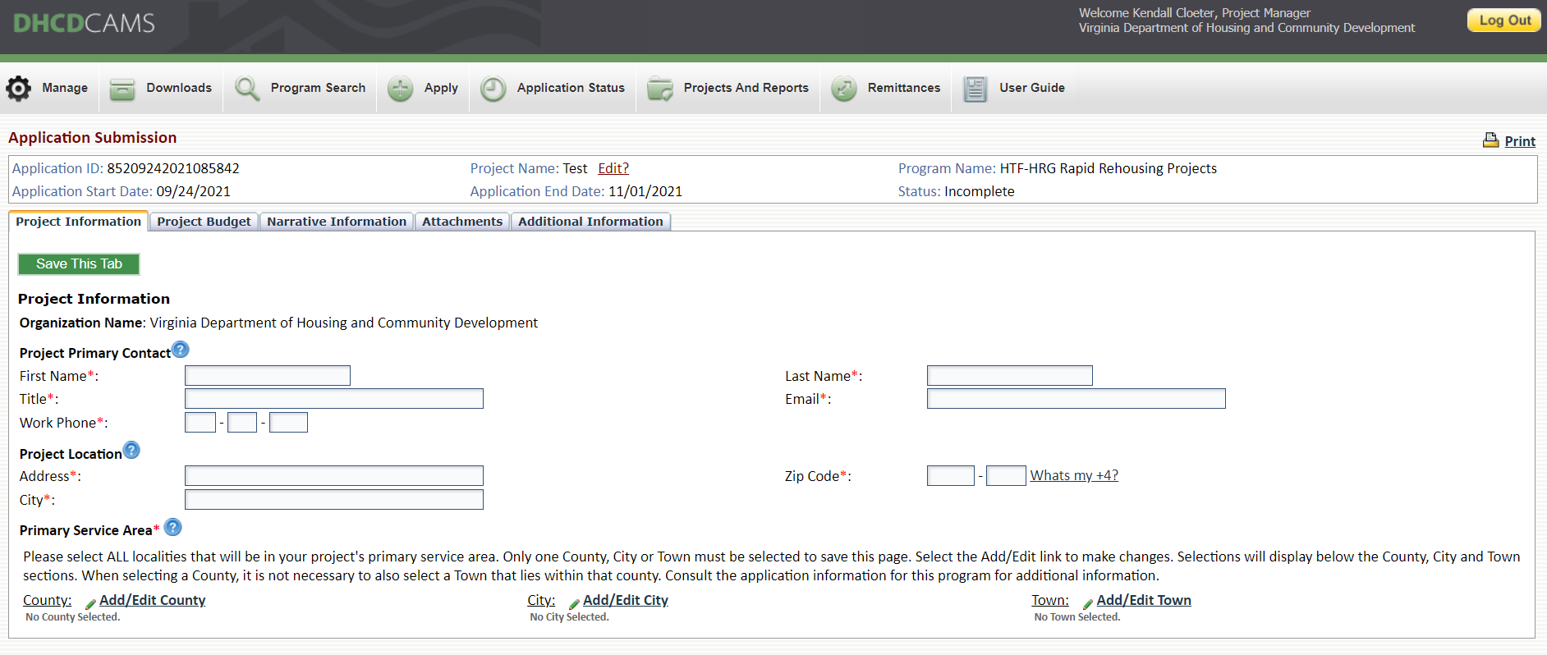

**Project Budget**

The next tab, Project Budget, requires basic budget information that corresponds to the requested amount and project type.

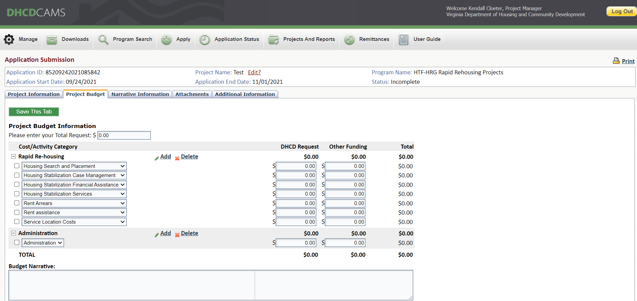

**Narrative Information**

The applicant will then go to the narrative questions. There are size limits to the text boxes. DHCD suggests that applicants work in Word and copy and paste into the CAMS text boxes. Word allows an applicant to spell check and check the size of the text prior to copying and saving in the text box. Once the narrative information is complete applicants should print the questions by clicking the Print tab at the top of the page and review them for completeness and accuracy. The applicant is able to edit this information up until the time the application is submitted for review.

The CAMS text box in this section will only accommodate text responses. Graphics, tables, and charts will appear as text only. The applicant may use the CAMS attachment section to provide any additional information not accommodated in the narrative text boxes.

**HSNH: Housing Trust Fund - Homeless Reduction Grant Application Narrative**

**Letter of Support - Local Coordination (All applicants)**

A letter of support for this application must be provided. The letter of support must be written and signed by the Continuum of Care or Local Planning Group Board Chairperson. In the event a letter of support cannot be obtained from the Continuum of Care or Local Planning Group Board chair, applicants must submit a letter providing a detailed explanation of their efforts to obtain the letter of support **and** information regarding how the project will coordinate with the existing programs within the Continuum of Care or Local Planning Group.

**Need, Approach, + Capacity (RRH Projects Only)**

Provide a clear and detailed description of the proposed project and how the project meets the requirements established in the HSNH-HTF-HRG Program Guidelines. All renewals and new applications must include details on project activities, target population, project outcomes, timeline for implementation, and hiring of staff (if applicable). If this project will used as supplement for other funding, please provide details of the additional funds.

Provide quantitative data including PIT, HMIS (or comparable systems) by name lists, etc, that demonstrates the community need for this project and describe how this data was used to inform the project design. If this is a new project and sufficient quantitative data is not available, qualitative data may be provided. If data was not used to inform this project design describe how the need for this project was identified.

Describe how the project works to ensure households facing language, mobility/transportation, and limited personal phone or internet access barriers will be able to access and engage with services through this project at program entry? Please be sure to provide a response to all four barriers.

Describe in detail how the organization implements a Housing First approach. Please provide organization and/or programmatic policies, procedures, and guidelines to demonstrate implementation of a housing first approach.

Provide quantitative data on disparities of historically marginalized populations within current services and program outcomes versus community census data. Qualitative data may also be used to supplement the information provided.  If current local data and research systems do not accurately identify these disparities, how can this project supplement or improve data collection? Provide details on how this project will address these disparities. Please provide data including PIT, HMIS (or comparable systems), by name lists, etc.

Describe how the local crisis response system will assess and provide referrals to your proposed project through your local coordinated entry.  How does the proposed project work in conjunction with existing permanent housing resources? Include how referrals are received through outreach/coordinated entry and steps taken for an eligible client to be permanently housed, which can include information about the operations of a by-names list and case conferencing.

Describe how persons with lived experience, community stakeholders, and other homeless service providers are involved in the development and implementation of this project. Please include specific examples of  homeless participation as defined on page 21 of the HSNH-HTF-HRG Guidelines.

Describe how the project will implement housing stabilization services and leverage mainstream resources to ensure that households are quickly moved into stable permanent housing. Provide examples of strategies and partnerships with other programs including details on Move On strategies, Voucher programs, and program exits that assist in transitioning households out of the PSH project and maintain housing stability.

How is your organization uniquely positioned to serve the target population and meet the community need for this project? Include specific organizational experience, staff skills, training, and partnerships as it required in HSNH-HTF guidelines.

How is your organization able to meet the requirements of this grant to include program reporting, and financial requirements? Include specific HMIS/VaData requirements, internal fiscal control policies, results of financial audits, timeliness of remitting, and how of the board reviews the financial budget/actual expenditures.

Has the agency’s programs been monitored by any state or federal funders in the past 5 years? Please detail any issues or concerns and if funds have been returned as a result of that monitoring. In addition, if your organization has returned or deobligated funds for any reason to DHCD in the past three (3) years, please provide detail on the circumstances for the return of funding.

Taking into consideration other programs, funding, and permanent housing opportunities, how will clients in the RRH project continue receiving services once the grant cycle / funding has ended.

**Need, Approach, + Capacity (PSH Projects Only)**

Provide a clear and detailed description of the proposed project and how the project meets the requirements established in the HSNH-HTF-HRG Program Guidelines. All renewals and new applications must include details on project activities, target population, project outcomes, case manager to client ratio (PSH projects), timeline for implementation, and hiring of staff (if applicable). If this project will used as supplement for other funding, please provide details of the additional funds.

Provide quantitative data including PIT, HMIS (or comparable systems) by name lists, etc, that demonstrates the community need for this project and describe how this data was used to inform the project design. If this is a new project and sufficient quantitative data is not available, qualitative data may be provided. If data was not used to inform this project design describe how the need for this project was identified.

Describe how the project works to ensure households facing language, mobility/transportation, and limited personal phone or internet access barriers will be able to access and engage with services through this project at program entry? Please be sure to provide a response to all four barriers.

Describe in detail how the organization implements a Housing First approach. Please provide organization and/or programmatic policies, procedures, and guidelines to demonstrate implementation of a housing first approach.

Provide quantitative data on disparities of historically marginalized populations within current services and program outcomes versus community census data. Qualitative data may also be used to supplement the information provided.  If current local data and research systems do not accurately identify these disparities, how can this project supplement or improve data collection? Provide details on how this project will address these disparities. Please provide data including PIT, HMIS (or comparable systems), by name lists, etc.

Describe how the local crisis response system will assess and provide referrals to your proposed project through your local coordinated entry.  How does the proposed project work in conjunction with existing permanent housing resources? Include how referrals are received through outreach/coordinated entry and steps taken for an eligible client to be permanently housed, which can include information about the operations of a by-names list and case conferencing.

Describe how persons with lived experience, community stakeholders, and other homeless service providers are involved in the development and implementation of this project. Please include specific examples of  homeless participation as defined on page 21 of the HSNH-HTF-HRG Guidelines.

Describe how the project will implement housing stabilization services and leverage mainstream resources to ensure that households are quickly moved into stable permanent housing. Provide examples of strategies and partnerships with other programs including details on Move On strategies, Voucher programs, and program exits that assist in transitioning households out of the PSH project and maintain housing stability.

How is your organization uniquely positioned to serve the target population and meet the community need for this project? Include specific organizational experience, staff skills, training, and partnerships as it required in HSNH-HTF guidelines.

How is your organization able to meet the requirements of this grant to include program reporting, and financial requirements? Include specific HMIS/VaData requirements, internal fiscal control policies, results of financial audits, timeliness of remitting, and how of the board reviews the financial budget/actual expenditures.

Has the agency’s programs been monitored by any state or federal funders in the past 5 years? Please detail any issues or concerns and if funds have been returned as a result of that monitoring. In addition, if your organization has returned or deobligated funds for any reason to DHCD in the past three (3) years, please provide detail on the circumstances for the return of funding.

Taking into consideration other programs, funding, and permanent housing opportunities, how will clients in the PSH project continue receiving services once the grant cycle / funding has ended.

**Need, Approach, + Capacity (Underserved Population Innovation Projects Only)**

**\*Underserved populations are defined by a lack of resources targeted towards providing culturally appropriate and trauma-informed services for a vulnerable population. Please note that all proposed HTF-HRG projects must be housing related.\***

Provide a clear and detailed description of the proposed project and how the project meets the requirements established in the HSNH-HTF-HRG Program Guidelines. All renewals and new applications must include details on project activities, target population, project outcomes, timeline for implementation, and hiring of staff (if applicable). If this project will used as supplement for other funding, please provide details of the additional funds. If this is intended to be a planning project only, please ensure this is clearly stated.

Provide a clear description of how this application meets at least one of the core components and a description of the required planning/coordinating body as stated on page 59 of the HSNH-HTF-HRG guidelines.

Provide quantitative data including PIT, HMIS (or comparable systems) by name lists, etc., that demonstrates the community need for this project and describe how this data was used to inform the project design. If this is a new project and; sufficient quantitative data is not available, qualitative data may be provided. If data was not used to inform this project design describe how the need for this project was identified.

Describe how the project works to ensure households facing language, mobility/transportation, and limited personal phone or internet access barriers; will be able to access and engage with services through this project at program entry? Please be sure to provide a response to all four barriers.

Identify specific barriers faced by the proposed targeted population to obtaining and/or maintaining permanent housing through existing programs and services within the community. How will this proposed project address these barriers?

Describe in detail how the organization implements a Housing First approach. Please provide specific organization and or programmatic policies, procedures, and guidelines to demonstrate implementation of a housing first approach.

Will the needs of historically marginalized populations be addressed through this proposed project? Do disparities exist in the incidence of homelessness, access to services, and outcomes of services? Provide quantitative and/or qualitative data in the response. How will the proposed project aim to address or reduce these disparities? Please provide data including PIT, HMIS (or comparable systems), by name lists in current programs and services etc.

Describe how the local crisis response system will assess and provide referrals to your proposed project through your local coordinated entry.  How does the proposed project work in conjunction with existing permanent housing resources? Include how referrals are received through outreach/CE, by name lists, and steps taken for a client to be permanently housed. If planning project-only, what efforts will be made to ensure any resulting programs or services are integrated within the local crisis response system?

Describe how persons with lived experience, community stakeholders, and other homeless service providers are involved in the development and implementation of this project.  Please include specific examples of  homeless participation as defined on page 60 of the HSNH-HTF-HRG Guidelines.

Detail how this project will produce a new model of service or inform best practices that can be replicated in other communities to serve the proposed target population.

Describe how the project will assist clients in maintaining housing stabilization who exit the program. Some examples include: Move on Strategies, Voucher programs, other local resources to stabilize proposed population.

How is your organization uniquely positioned to serve the target population and meet the community need for this project? Include specific organizational experience, staff skills, training, and partnerships as it relates to the expectations of the HSNH-HTF guidelines.

How is your organization able to meet the requirements of this grant to include program reporting, and financial requirements?

Has the agency’s programs been monitored by any state or federal funders in the past five years? Please detail any issues or concerns and if funds have been returned as a result of that monitoring. In addition, if your organization has returned or deobligated funds for any reason to DHCD in the past three (3) years, please provide detail on the circumstances for the return of funding.

Detail how the proposed project will be sustained and program services will continue once the grant cycle has ended. Planning Projects, please detail the next steps or the process for determining the continuation of the efforts initiated by this project.

**Attachments**

There are a number of attachments required for the Homeless Reduction Grant application. Some of these attachments require the use of a DHCD-provided template. The Certifications and Assurances is an example where the applicant will be required to download a template, complete, and upload the completed templates. All attachments are listed on the attachment tab. The attachments with required templates have a link next to the name of the attachment and instructions to download.

Some attachments do not require DHCD templates. Applicant Financials is an example of an attachment where the applicant will not be required to download and complete a DHCD template. In these cases the applicant would simply upload an electronic version of the document under the appropriate attachment.

Please see the [CAMS User Guide](http://devhome/CAMSPortal_TEST/ResourceDocs/CAMS%20User%20Guide%202021.pdf) for more detailed instructions (file types and size limits).

Required application attachments include the following:

|  |  |
| --- | --- |
| **Application Attachments** | |
| ***Name of Attachment*** | ***Requirement*** |
| Certifications and Assurances* | DHCD template; required for all projects |
| Applicant Financials | Required for all projects – current and prior year organizational budgets to include revenue sources and expenses |
| Letter of Support (signed by the CoC/LPG governing board chair) | Required for all projects. |
| CoC/LPG approved Homeless Services Flow Chart | Required for all projects |
| Job Descriptions | Required for projects proposing staff costs |
| MOUs | If applicable |
| Board of Directors | Required for non-profit applicants |
| Additional Attachments | Optional |

*DHCD required template

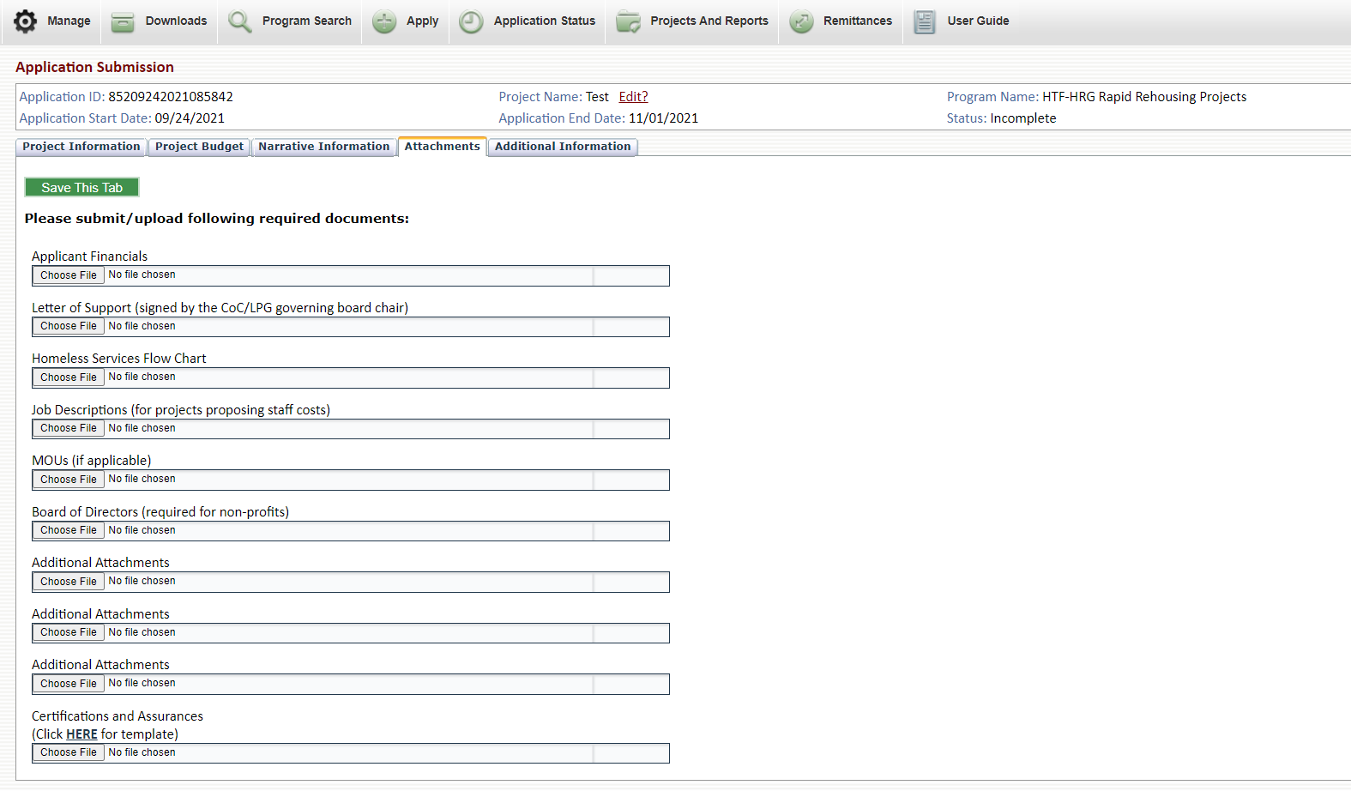

**Additional Information**

The Additional Information tab allows the applicant to provide additional information not previously requested in the other sections of the application.

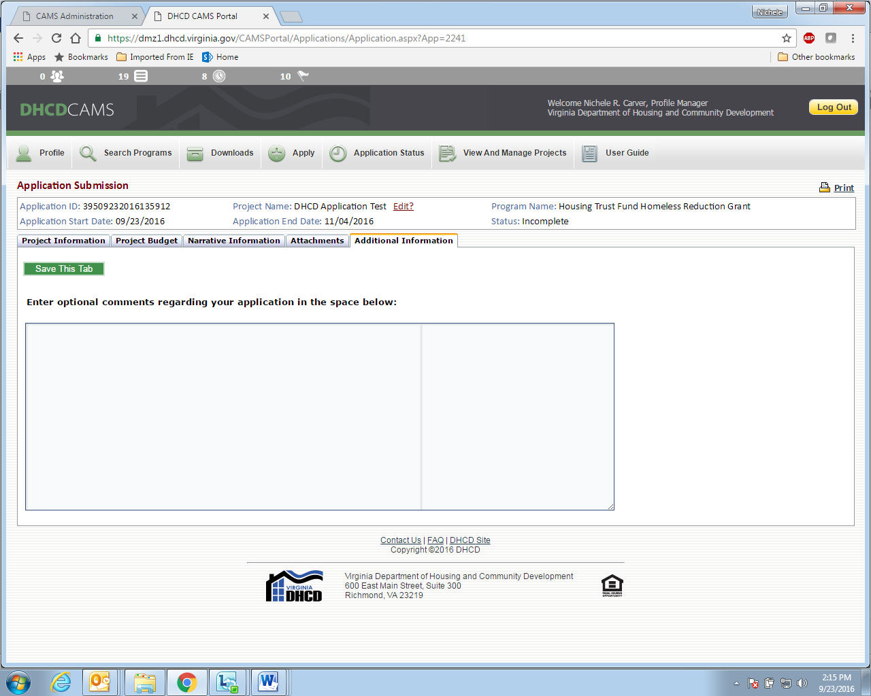

**Application Status**

Applicants may allow multiple users to edit and review application materials. Applicants are solely responsible for controlling security access to CAMS.

Once the applicant begins work on the application CAMS will save the application as Incomplete. The applicant may return repeatedly to CAMS to work on this application. Please be sure all work on the application is saved in CAMS. The application will remain as an incomplete application until the applicant chooses to submit the application. Once the application is submitted the status will change from Incomplete to Pending.

**DHCD Review Process**

Applicants with unresolved DHCD findings, audit findings, or other compliance issues will not be eligible for a funding commitment.

DHCD conducts panel reviews of all applications submitted by eligible applicants through CAMS.

Applications will be accepted on or before 11:59 PM, September 12, 2025 and ***must*** be submitted to DHCD through the online application and project management system, [CAMS](https://dmz1.dhcd.virginia.gov/camsportal/Login.aspx) (Centralized Application and Management System). Please allow up to two business days for responses to CAMS help desk requests.

Applications received by the deadline will be reviewed against established criteria to identify those projects best positioned to meet priority needs within Virginia.

Applications must meet minimum requirements including scoring at least 60 points in order to be considered for funding. Scoring criteria are need, approach, local coordination, and capacity.

Fifteen percent of the score will be based on Part I of the Homeless and Special Needs Housing 2024-2026 application.

Applications will be reviewed and scored by a panel. Offers will be extended to those applications scoring at least 60 points based on availability of funds. Any remaining balance of funds may be allocated through a subsequent application process.

Project applications selected through the Homeless Reduction Grant application process will receive funding notification in writing. Additional information and negotiations may be required prior to grant agreement execution. Applicant awards are tentative pending an executed grant agreement. Applicants are expected to respond in a timely manner to all information requests.

Additional information may be found in the HSNH Program Guidelines and during the How-to-Apply webinars. Information for accessing webinars may be found on the [DHCD website.](http://www.dhcd.virginia.gov/index.php/dhcd-resources/trainings-and-workshops.html)