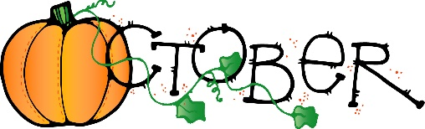
Town of Hundred Regular Council Meeting Minutes
October 21, 2024

The regular meeting of the Town Council of the Town of Hundred canceled due to Mayor Goff not being available.

