Greetings,

We are reaching out to you on behalf of the newly formed Rusk Area Youth Sports (formerly Ladysmith Summer Youth League). We are a 501(c)(3) nonprofit organization that is focused on enhancing our current youth baseball & softball programs, along with bringing more sports to Rusk County for our youth such as soccer, basketball, hockey, volleyball, flag football, archery & more! Our emphasis is on youth ages 5-14 years old.

Currently for Rusk County, any youth wanting to participate in sports such as soccer, basketball, flag football, etc. must travel to Eau Claire, Chippewa Falls or Rice Lake. One of our goals is to eliminate that necessity by offering more sports for our youth that live in the Rusk area including Bruce, Cornell, Flambeau, Holcombe & Ladysmith. To accomplish this, we are in need of funding in order to purchase equipment, batting cages, soccer goals & nets, scoreboards, field maintenance, upgrading current equipment, equipment maintenance, concession stands & so on!

We are inviting you to participate as a sponsor for 2026 to help the Rusk Area Youth Sports become successful & grow into something beneficial for our Rusk Area youth for years to come. Sponsorship levels are listed below. Sponsorship banners will be displayed at the Industrial Field Ballparks & Christman Softball Field. Please email a digital copy of your company logo to RuskAreaYouthSports@gmail.com.
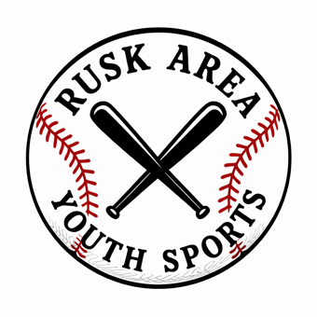
Thank you for considering investing in the future of our local youth sports!

Rusk Area Youth Sports

Jared Prokop - President (715-797-0918)
Tommy Rudack - Vice President
Jodi Robinson - Treasurer
Erika Mikunda - Secretary
Rachael Moser - Director

(Platinum)_____$1,500 & Above Sponsorship = 6’ x 10’ Banner displayed on dugout & recognition on sponsorship banner at Industrial Ballpark along with our social media platforms

(Gold)_____$1,000 Sponsorship = 6’ x 8’ Banner & recognition on sponsorship banner at Industrial Field Ballpark along with our social media platforms

(Silver)_____$500 Sponsorship = 3’ x 6’ Banner & recognition on sponsorship banner at Industrial Field Ballpark along with our social media platforms

(Bronze)_____$250 Sponsorship = 3’ x 4’ Banner & recognition on sponsorship banner at Industrial Field Ballpark along with our social media platforms

Anonymous Donor________Any other $ amount

Please mail sponsorship form & payment to:
Rusk Area Youth Sports
PO Box 207
Ladysmith, WI 54848

Contact Name:__________________Phone:_________________Email:___________________________

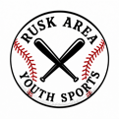
-----------------------------------------------------------------------------------------------------------------
(Keep for Records)
Rusk Area Youth Sports
Name_________________________________Business____________________________
Donation Amount_____________________Date___________________
Company logos to be used for banners can be emailed to: RuskAreaYouthSports@gmail.com

