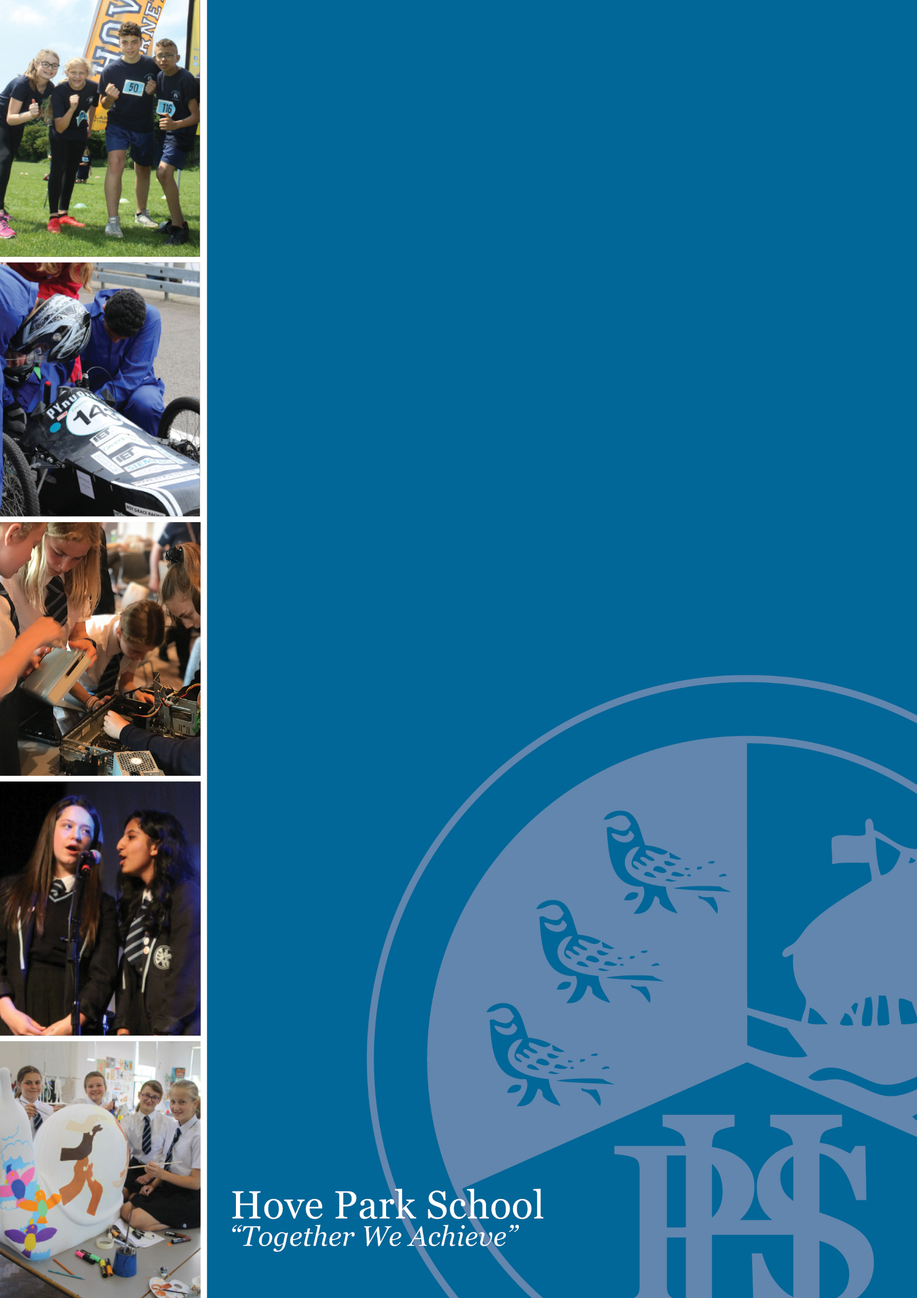
Position: Teacher of Music (0.6 FTE)
Salary: MPS/UPS

Closing Date: 1st May 2026
Interview Date: w/c 4th May 2026

Information Pack

Dear Colleague,
I am delighted that you are considering joining Hove Park School and Sixth Form. At Hove Park, we believe that our school is a place where a community develops and thrives; a place where we come together to support each other to achieve. This is an exciting opportunity to join the school in improving the outcomes and wellbeing of our students. At Hove Park School, there is a strong community ethos underpinned by positive relationships. Ofsted visited us in January 2026 and were hugely complimentary about our inclusive culture, acknowledging that our school is a place where every student is made to feel valued. They praised the exemplary behaviour of our pupils and were pleased to see that our students are achieving in line with national data, ensuring they are well-prepared and ready for their next steps.
Please take time to read this application pack and explore our website (www.hovepark.org.uk) to get a feel for Hove Park School and its community. If you have the passion and ambition to help the school make a difference in this role and feel you are a good fit, please consider applying.
To apply, please submit a completed teaching staff application form to recruitment@hovepark.org.uk. Applications for this vacancy must be received by 3:00pm on 1st May 2026. Please note that the school cannot accept CVs and that Hove Park School is committed to promoting the safeguarding and welfare of our students. We also expect all staff and volunteers to share this commitment.

Yours faithfully,

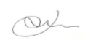

Jim Roberts
Headteacher

Teacher of Music

Contract Type: Permanent, Part-Time, 0.6 FTE
Commencing: 1st September 2026
Reports to: Head of Music

Hove Park School and Sixth Form is an ambitious and innovative place to work. We strive to help young people enjoy successful lives by giving them an inspirational, academic and enriching education, with a strong emphasis on independent learning and harnessing new technology. Ofsted visited us in March 2017 and we strongly held our status as a ‘Good’ school.

Our student body is multi lingual and drawn from a diverse community across Brighton and Hove.

The music team are committed to enabling all students to become independent, life-long learners of music.
The job provides an excellent opportunity for a highly motivated teacher who is looking to join an ambitious, supportive department. The successful candidate will be:

· Passionate about music and able to inspire students
· Willing to explore and embrace innovative technology
· Able to demonstrate a creative approach in the classroom
· Committed to raising attainment
· Willing to promote and contribute to the full range of extra-curricular activities
· Keen to share and promote the school's vision of high standards and success for all

Deadline for applications: 1st May 2026
Interview: w/c 4th May 2026

Hove Park School is committed to safeguarding and promoting the welfare of children and young people and expects all staff and volunteers to share this commitment. The successful candidate will be subject to an enhanced DBS check.
Information about this post and an application form can be downloaded from our website: www.hovepark.brighton-hove.sch.uk/vacancies

Hove Park School celebrates diversity and welcomes applications from all areas of our community as we aim to have a staff body that is representative of our socially, culturally and ethnically diverse student population.

Teacher of Music – Permanent – Part-Time, 0.6 FTE
Commencing – September 2026

Job Description

Student Outcomes
- To ensure that all assessment processes are accurate and credible by using appropriate moderation systems.
- To analyse and evaluate progress data and take swift and appropriate action in response to underachievement.

Developing Teaching and Learning

- To promote regular debate and discussion about the quality of teaching and learning and expectations for students’ achievements, encouraging the sharing and dissemination of good practice within the music team and with other areas.
- To ensure effective development of the use of new technologies in teaching and learning and music.
- To ensure the behaviour management procedures are implemented so that effective learning can take place.
- To ensure that schemes of work are followed.
- To ensure that regular and planned assessment opportunities are built into the scheme of work and that they support improved learning and progress.

Quality Assurance

- To enable, promote and encourage the sharing of good practice within the music team.
- To demonstrate excellence in classroom practice.

Communication

- To ensure effective communication/consultation as appropriate with the parents of students.
- To communicate the work and success of the art team to the rest of the school and to parents and the wider community.

- Employees will be expected to comply with any reasonable request from a manager to undertake work of a similar level that is not specified in this job description.

Hove Park School is committed to safeguarding and promoting the welfare of children and young people and expects all staff and volunteers to share this commitment. The successful candidate will be subject to an enhanced DBS check.

Person Specification

You are:
- Highly motivated and looking to join an ambitious, supportive department.
- Passionate about music and able to enthuse students.
- Willing to explore and embrace innovative technology able to demonstrate a creative approach in the classroom.
- Committed to raising attainment in music.
- Willing to promote and contribute to the full range of extra-curricular activities.
- Keen to share and promote the school's vision of high standards and success for all.

- Evidence of the following will be obtained through the Application process (A) and/or at Interview (I)

 | Essential | Desirable
Qualifications and Professional Development | - Good Degree in a relevant subject(A)  - Qualified Teacher Status (A)  - Evidence of commitment to own professional development (A) | - Recent CPD and/ or experience of leading a team of teachers (A/I)  - Experience or willingness to teach Philosophy and Ethics
Experience | - Recent successful teaching at KS3 and KS4 (A/I)  - Evidence of being a good or outstanding teacher (A/I)  - Successful track record of raising student progress | - Experience of subject evaluation and writing of improvement plans (A/I)
Skills and Knowledge | - An up to date knowledge of the curriculum in the relevant subject (A/I)  - The ability to create innovative resources and learning opportunities to engage learners (I)  - The ability to use progress data to inform teaching and learning (I)  - Knowledge of how to use Assessment for Learning to engage students in their learning (A/I)  - Excellent verbal and written communication skills (A/I)  - Good ICT skills to support teaching and learning and to analyse student progress (A/I)  - Effective manager of behaviour; clear boundaries for sanctions and rewards  - The capacity to meet deadlines (A/I)  - A team player (I) | - Good ICT skills/Digital Literacy (A/I)
Attributes and Qualities | - High professional and personal standards in both work and conduct (I)  - A commitment to a positive ethos (I)  - A commitment to safeguarding and promoting the general health, safety and welfare of young people (A/I)

The list of duties in the job description should not be regarded as exclusive or exhaustive. There will be other duties and requirements associated with your job and, in addition, as a term of your employment you may be required to undertake various other duties as may reasonably be required.

Your duties will be as set out in the above job description but please note that the Council reserves the right to update your job description, from time to time, to reflect changes in, or to, your job.

You will be consulted about any proposed changes.

Our Values and Ethos at Hove Park School and Sixth Form


A school is more than just a place where students come to learn. It is also a place where a community develops and thrives. It is a place where we come together to support each other achieve whether it is in the classroom learning, on the sports field competing or on the stage performing, we know that success comes from us all working together.
Student progress will always remain a key priority because outcomes so often dictate future pathways and opportunities for young people. Having been again judged by Ofsted as a ‘good’ school, we continue to reflect on the structures and routines that we expect to see in every lesson. Exploring the ways we teach to ensure we drive improvement and our ambition to be ‘outstanding’ at the next inspection.
Our early adoption of a digital device for every child has provided significant opportunities to innovate and explore digital pedagogy - both at Hove Park but also within our community and beyond. Our Wellbeing at School award demonstrates an ethos focused on ensuring all students feel cared for and supported throughout their time with us.
Our curriculum has been planned and developed to provide a whole education for all students. When we describe our curriculum we are not just talking about the sequencing of lessons and subjects across the Key Stages but also the half-termly curriculum enrichment days and extra-curricular provision that together enrich and broaden a student’s time at Hove Park. A learning journey that provides a traditional foundation at Key Stage 3 from which students can build on individual strengths. We are ambitious for all our students and expect them, where appropriate to retain a breadth to their studies through the study of EBACC subjects and the use of our Project days.
The final part of my vision for our school relates very much about the school experience each and every student will have. It is about identifying the skills, values and attributes that we believe students should develop during their time with us and the things they will see, hear, try and explore at KS3, KS4 and KS5.
It is an exciting time to be part of Hove Park School as we continue to shape our future and the way we support all students to grow and achieve.

