

**Hove Park School**

**Attendance Policy**

|  |  |  |
| --- | --- | --- |
|  | | |
| Date Ratified | Frequency of Review | Next Review Date |
| July 2025 | Yearly | July 2026 |
| Governor link | Staff link | Committee |
|  | Nansi Mellor |  |

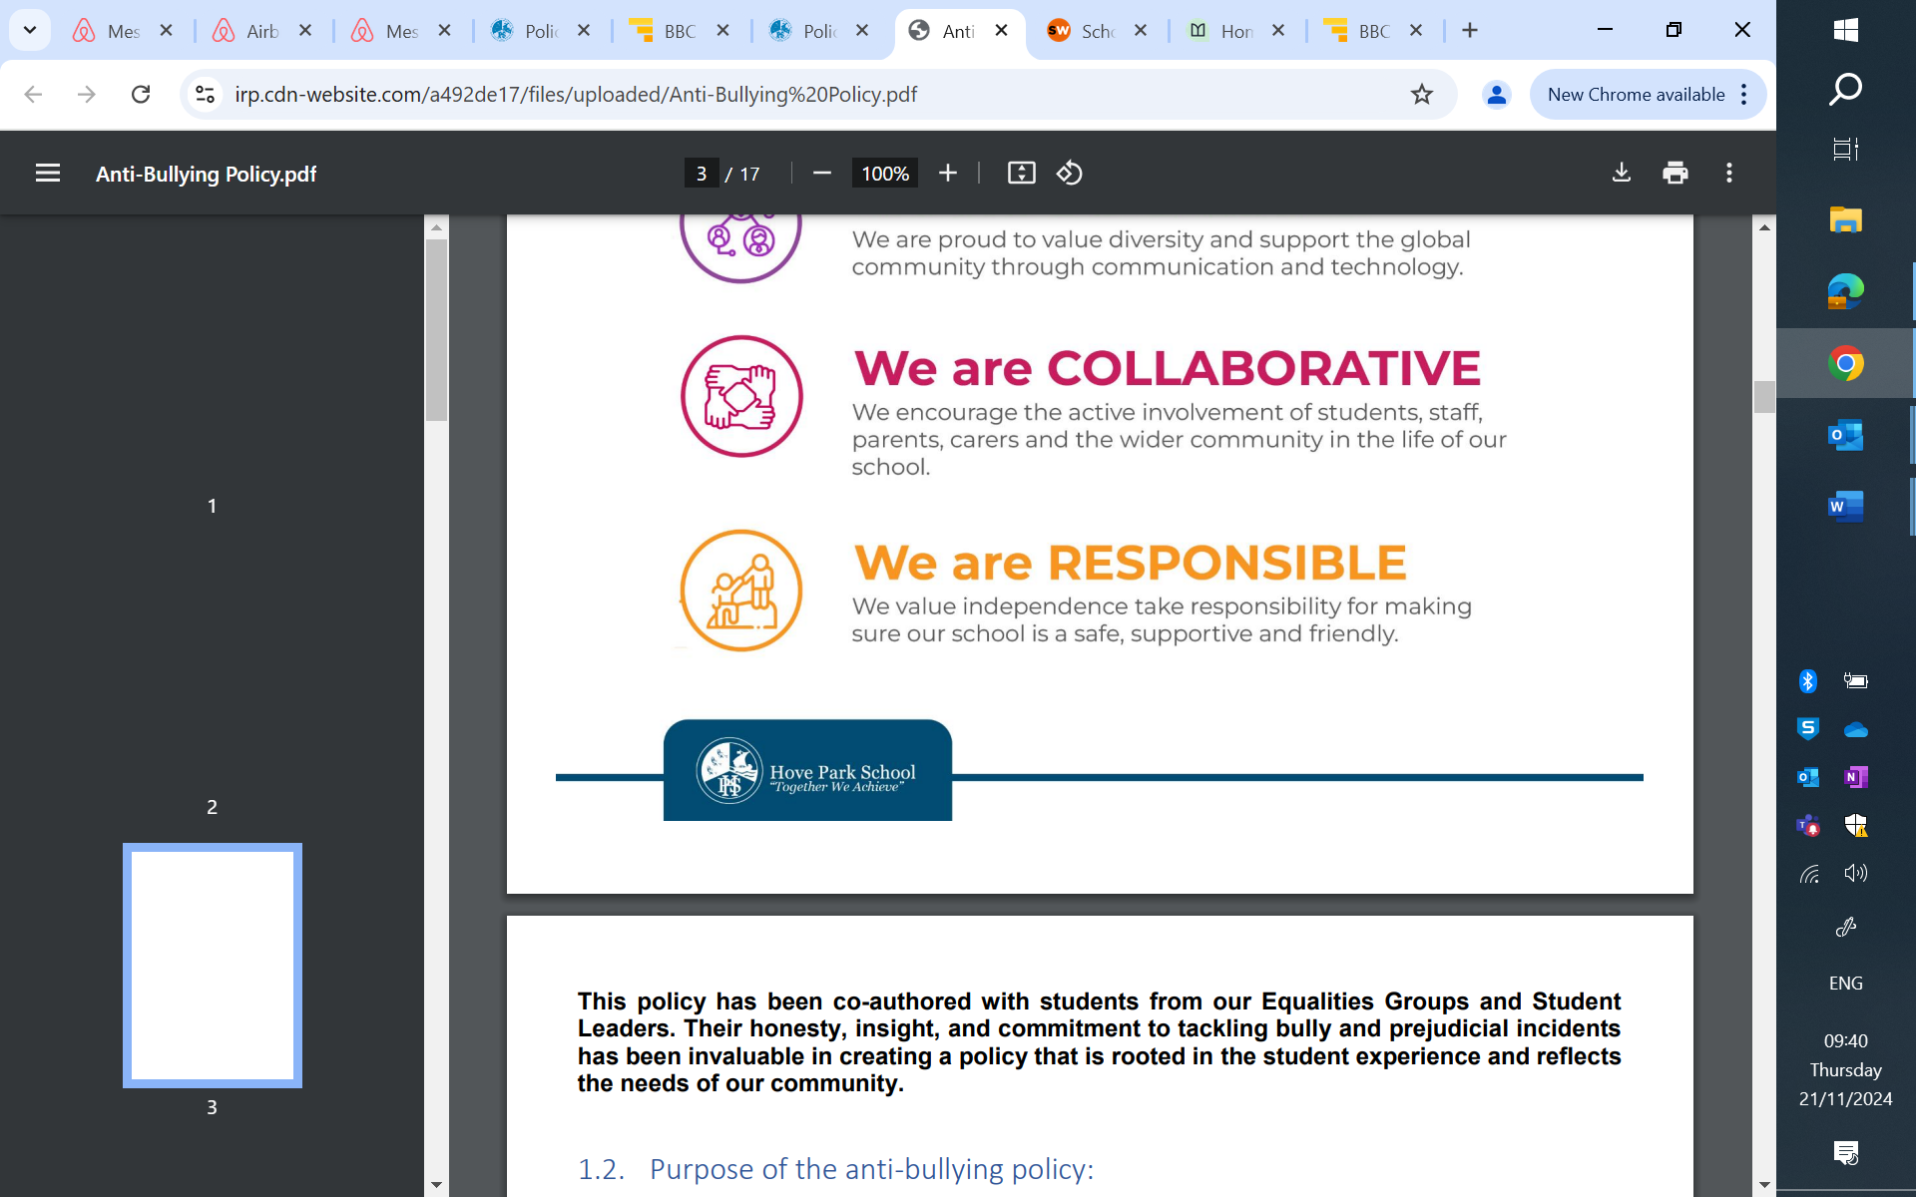

**Statement of Intent**

Hove Park School believes that regular school attendance is essential in enabling pupils to achieve their full potential.

Our Aim is 100% punctuality and attendance. Our minimum expected attendance is 95%.

Our objective is to:

* Ensure parents/carers follow the framework set out in section 7 of the Education Act 1996, which states that the parent/carer of every child of compulsory school age, shall cause them to receive efficient full-time education suitable to their age, ability and aptitude, and to any SEND they may have, either by regular attendance at school or otherwise.
* Promote and model good attendance behaviour.
* Implement our policies to reflect inclusivity and fairness in accordance with the Equality Act 2010.
* Offer early intervention support and work with other agencies to ensure the health and safety of our pupils.

**The Law on School Attendance**

The law entitles every child of compulsory school age to receive a full-time education, it is the legal responsibility of every parent/carer to ensure this. Where parents/carers decide to have their child registered at school, they have an additional legal duty to ensure their child attends that school regularly and punctually, meaning that their child must attend every day that the school is open. There are a few exceptions, such as being too ill to attend or being given permission for an absence in advance from the school.

This policy has due regard to all relevant legislation and statutory guidance including, but not limited to, the following:

[Working together to improve school attendance - GOV.UK (www.gov.uk)](https://www.gov.uk/government/publications/working-together-to-improve-school-attendance) (applies from 19th August 2024)

[The Education (Penalty Notices) (England) (Amendment) Regulations 2024 (legislation.gov.uk)](https://www.legislation.gov.uk/uksi/2024/210/made) (applies from 19th August 2024)

**Definitions**

**Attendance:** Time in school. Shown as a percentage. Our Aim is 100% punctuality and attendance. Our minimum expected attendance is 95%.

**Absence:** Time out of school for any reason.

**Authorised Absence** (this is not limited to)**:**

* An absence for sickness (As long as it is clearly necessary eg on medical advice)
* Medical or dental appointments which unavoidably fall during school time
* Religious or cultural observances for days set aside by a religious body, for which the school has granted leave
* An absence due to a family emergency, taken with the school’s permission

**Unauthorised absence** (this is not limited to)**:**

* Parents/carers keeping children off school unnecessarily or without reason.
* Truancy during the school day.
* Absences which have not been properly explained.
* Arrival at school after the close of registration.
* Absence due to unofficial responsibilities at home.
* Absence due to birthdays.
* Absence due to term-time trips and holidays that have not been authorised by the school.
* Leaving school without reason/the school’s permission during the day.

**Persistent absenteeism:**

* Missing 10% or more of schooling during the academic year, for any reason.

**Severe absenteeism:**

* Missing 50% or more of schooling during the academic year, for any reason.**Working in partnership to improve attendance.**

Addressing the root causes of absence and removing barriers to attendance requires schools and local partners to work collaboratively with families:

|  |
| --- |
| EXPECT  Promote high standards of attendance and build a culture where everyone across the school prioritises attendance improvement. |
|  |
| MONITOR  Make use of attendance data to identify patterns of poor attendance as soon as possible so all parties can work together to resolve them before they become entrenched. |
|  |
| LISTEN AND UNDERSTAND  When an absence pattern is identified, discuss with students and parents/carers to understand, and address barriers to attendance and agree how all partners can work together to improve attendance. |
|  |
| FACILITATE SUPPORT  Remove barriers in school and help families to access the support they need to overcome the barriers outside of school. This may involve referrals to external agencies for further support. |
|  |
| FORMALISE SUPPORT  Where absence persists and voluntary support is not working or being engaged with, partners should work together to explain the consequences clearly to families. Depending on the circumstances, this may include formalising support through an attendance contract. |
|  |
| ENFORCE  Where all other avenues have been exhausted and support is not working or being engaged with, enforce attendance through statutory intervention or prosecution to protect the pupil’s right to an education. |

**Pupils at risk of persistent absence (PA)**

The school will ensure it offers support to pupils at risk of persistent absence (PA), in conjunction with all relevant external authorities, where necessary.

# **Parent/Carer involvement**

The school will support parents and carers in meeting their responsibility to ensure regular and punctual attendance. The school will strive to build positive and respectful relationships with parents/carers to ensure their trust and engagement. Open and honest communication will be maintained with students and their families about the expectations of school life, attendance, and performance, so that they understand what to expect and what is expected of them. The school will liaise with other agencies working with pupils and their families to support attendance, e.g. social services.

**Parents/carers will be expected to:**

* Build positive and respectful relationships with school staff,
* Engage with school support when offered,
* Call/email staff for help when needed – [absence@hovepark.org.uk](mailto:absence@hovepark.org.uk) – alternatively see below for key staff contact details:

|  |  |  |
| --- | --- | --- |
|  | Staff | Assistant Head of Year (Non-Teaching) |
| 7 | Emma Satterly (Director of KS3) [esatterly@hovepark.org.uk](mailto:esatterly@hovepark.org.uk) | Amara Clark  [aclark@hovepark.org.uk](mailto:aclark@hovepark.org.uk) |
| 8 | Emma Satterly (Director of KS3) [esatterly@hovepark.org.uk](mailto:esatterly@hovepark.org.uk) | Sarah Williams  [swilliams@hovepark.org.uk](mailto:swilliams@hovepark.org.uk) |
| 9 | Tom Lowrie (Director of KS4)  [tlowrie@hovepark.org.uk](mailto:tlowrie@hovepark.org.uk) | Sandra Hutchings  [shutchings@hovepark.org.uk](mailto:shutchings@hovepark.org.uk) |
| 10 | Max Adnett (Head of year)  [madnett@hovepark.org.uk](mailto:madnett@hovepark.org.uk) | Sharon Holt  [sholt@hovepark.org.uk](mailto:sholt@hovepark.org.uk) |
| 11 | Nathan Skilton-Day (Head of year)  [nskiltonday@hovepark.org.uk](mailto:nskiltonday@hovepark.org.uk) | Jo Williams  [jwilliams@hovepark.org.uk](mailto:jwilliams@hovepark.org.uk) |
| All Year groups | Lisa Carruthers  (Educational Welfare Officer)  [lcarruthers@hovepark.org.uk](mailto:lcarruthers@hovepark.org.uk)  Nansi Mellor (Head of School – SLT Attendance Lead)  [nmellor@hovepark.org.uk](mailto:nmellor@hovepark.org.uk) | |

* Communicate with the school about possible circumstances which may affect their child’s attendance or require support.
* Inform the school of any change of address and ensure contact details are up to date.

**Attendance expectations at Hove Park School**

**Punctuality**

Students are expected to be at school every day, on time.

|  |  |  |
| --- | --- | --- |
| **Arrival** | **Lessons start** | **End of School Day** |
| 8.25am | 8.30am | 3pm |

Any student arriving late must enter the school via the front office and sign in using the sign-in app (students can be supported with this by our administration team).

Students arriving late to the Valley campus will be escorted to lessons.

Students are expected to be in every lesson, on time.

The register is taken at the start of each lesson.

|  |  |  |  |  |  |  |  |  |
| --- | --- | --- | --- | --- | --- | --- | --- | --- |
| **Arrival** | **Tutorial** | **Lesson 1** | **Break 1** | **Lesson 2** | **Changeover** | **Lesson 3** | **Break 2** | **Lesson 4** |
| 8.25 | 8.30 | 8.55 | 10.10 | 10.40 | 11.55 | 12.00 | 13.15 | 13.45 |

**Registers are taken as follows throughout the school day:**

* Registers are marked at 8.30am. Students who arrive after 8.30am will be marked late (‘L’ code).
* The register closes at 9.00am. Pupils will receive a mark of absence (‘U’ code – unauthorised absence) if they do not attend school before this time.
* Registers are marked at the start time of each lesson. Students who arrive after the start time will be marked late (‘L’ code).
* Where students need to change rooms between Tutorial and Lesson 1 the register will be marked at 8.57. Students who arrive after this time will be marked late (‘L’ code).

**Sickness**

If students are too unwell to attend school:

* Parents/carers must contact the school office on 01273 082858 or email [absence@hovepark.org.uk](mailto:absence@hovepark.org.uk) on the first day of absence by 8.30am.

Absence will only be authorised if it is clearly necessary eg on medical advice.

* Parents/carers must contact the school office each school day thereafter.
* Students with low-level illness are still expected to attend school.
* See NHS guidance here: <https://www.nhs.uk/live-well/is-my-child-too-ill-for-school/>

If your child is ill, please inform the school by:

* Calling 01273 082858
* Emailing – [absence@hovepark.org.uk](mailto:absence@hovepark.org.uk) – or other key staff as listed above.

School will contact parents/carers of any child who does not arrive at school where there has been no contact from the parent/carer, to confirm the reason for absence. Further safeguarding action will be taken if necessary.

Schools will check messages, emails & voicemails for any notifications of pupil absence and will update registers with reasons for absence.

**Appointments**

In accordance with DfE guidance:

* Routine medical and dental appointments should be arranged outside of school hours wherever possible.
* If the appointment time allows your child to come to school for registration and then leave later, this will mean that less school is missed.
* Your child should return to school straight after their appointment wherever possible.

**Term time holidays**

The DfE statutory guidance states that “Generally, the DfE does not consider a need or desire for a holiday or other absence for the purpose of leisure and recreation, to be an exceptional circumstance.” It also states that “a school cannot grant leave of absence retrospectively.”

The fundamental principles for defining 'exceptional' are where requests are rare, significant, unavoidable and short.

For term-time absence to be granted:

a) Permission must be requested at least two weeks before the absence begins.

b) Permission must be requested by the parent/carer who the pupil normally lives with.

c) A parent/carer must explain by completing absence during term time form why they believe the circumstances to be exceptional and provide all necessary evidence to the school at the time the request is made. Absence during term time form can be found on the school website.

It is the parent/carer’s responsibility to provide evidence when making the request.

If a leave of absence is granted, it is for the school to determine the length of the time the pupil can be away from school.

A term-time absence taken without the school’s written permission may trigger a Fixed Penalty Notice, which is issued by the Local Authority.

**Fixed Penalty Notices**

The national threshold for triggering a Fixed Penalty Notice is met when a pupil has been recorded as having had unauthorised absence for 10 or more sessions (5 or more school days) in a period of 10 school weeks. One or a combination of the following codes count as unauthorised absence:

* G-codes (unauthorised term-time holiday)
* N-codes (no reason yet provided for absence)
* O-codes (poor attendance)
* U-codes (lateness after close of registration)

The first fine is £160 *per parent/carer per child,* if paid within 28 days, reduced to £80 if paid within 21 days.

If a second fine is issued to that parent/carer within a period of 3 school years, the fine is £160 *per parent/carer per child* to be paid within 28 days and there is no reduction if paid within 21 days.

A third penalty notice cannot be issued to the same parent/carer in respect of the same child, within 3 years of the first fine being issued. In a case where the national threshold is met for a third time (or subsequent times) within those 3 years, alternative action could be taken, such as prosecution.

There is no right of appeal once a Fixed Penalty Notice is issued, so disputes over how an absence is classified must be settled with the school before the absence is taken.

Full details relating to Fixed Penalty Notice amounts and thresholds can be found in the Code of Conduct on the Brighton & Hove City Council website.

**Religious observances**

Absence can be granted on a day that is exclusively set apart for religious observance by the religious body the parents/carers belong to. Parents/carers must have requested and secured permission from the school in advance. Absence during term time forms can be found on the school website.

**Modelling, sport and acting performances/activities**

Parents/carers of pupils that will be taking part in entertainment/performances, (i.e. modelling, TV, films, theatre, etc) which require them to be absent from school, must obtain permission from the school before a child performance licence can be issued. The agent, organiser or parent/carer will usually be the person who requests the absence from the school. Further information regarding licensing legislation can be found here: [England Performance Legislation - NNCEE - National Network for Children in Employment & Entertainment](https://www.nncee.org.uk/page/39/legislation-england). For more information, please visit Brighton & Hove City Council’s website: [Apply for a child performance licence (brighton-hove.gov.uk)](https://www.brighton-hove.gov.uk/children-and-learning/apply-child-performance-licence) or contact [childperformancelicensing@brighton-hove.gov.uk](mailto:childperformancelicensing@brighton-hove.gov.uk).

**Young carers**

Schools will provide a caring and flexible approach to support the needs of young carers, to help maintain regular attendance at school. Further support from other agencies will be sought, if appropriate. Parents/carers will notify school where their children have young carers responsibilities.