
Hove Park School
Behaviour Policy

Date Ratified | Frequency of Review | Next Review Date
December 2024 | 2 years | December 2026
Governor link | Staff link | Committee
Paul Williams | Jim Roberts | FGB
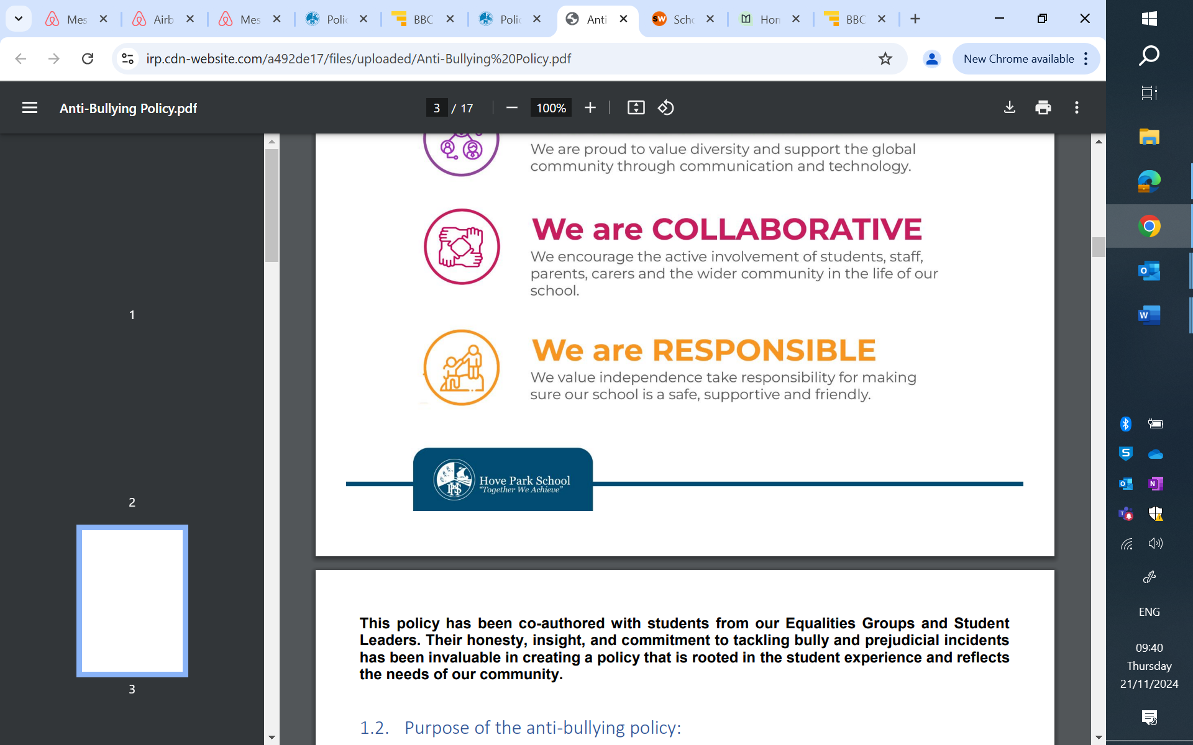

Introduction
The purpose of this policy is to ensure;
- All members of the school community feel safe and valued
- Create an environment for teaching and learning to flourish

At Hove Park School we are committed to inclusivity and celebrate diversity. We are an Anti-Racist School who endeavour to create an environment which allows all our students and staff to thrive and learn from each other's differences; experiences, cultures, backgrounds, identities and abilities.

At Hove Park School we believe that Together We Achieve and every member of the community is expected to uphold our values and be aspirational, respectful, proud, connected, collaborative and responsible.





This policy is based on Guidance provided by B&H Local Authority and has included input from: members of staff including SENCO and Wellbeing team, representatives from the governing body, parents/carers, students, School Nurse and BHISS colleagues.

This policy is for all staff, students, parents/carers, governors, visitors and partner agencies working within the school and provides guidelines and procedures as to how our school supports and responds to behaviour.

Hove Park School is committed to the well-being, emotional and mental health of its staff, students and parents/carers. We wish to work towards this in all aspects of school life, and to provide an ethos, environment and curriculum that supports the social, emotional and mental health of the whole school community.

It is acknowledged that members of the school community may have very different parenting experiences and views on behaviour. However, the aim of our attachment aware Behaviour Policy is to bring us all together to adhere to some basic key principles and practices that reflect our school ethos and ensure that every student understands their right to feel safe, valued and respected, and to learn free from the disruption of others.

We understand that negative behaviour can signal a need for support which we will provide wherever possible without diluting our expectations. We understand that positive behaviour can be learned and needs to be role-modelled. Our staff are empowered to use emotion coaching and understanding of restorative approaches to build robust relationships and support our students in developing personal responsibility and resilience.
The strategies, approaches contained in this policy and the guidance outlined by the DFE are utilised by school staff to create an environment in which all members of our community are not only safe, but feel safe and that creates a culture in which Teaching & Learning flourishes.

Roles and Responsibilities in supporting and responding to behaviour

The Hove Park Approach
- To maintain a happy, caring and orderly community in which excellent learning can take place and where there is mutual respect and positive relationships.
- To support students in having the highest expectations and maintaining the highest standards for themselves and others.
- To equip our students for their futures by helping them to develop a sense of worth, identity and achievement and the ability to listen to others, cooperate and appreciate other ways of thinking and achieving.
- To use emotion coaching and help all children to become self-disciplined, able to accept responsibility for their own actions, learn from mistakes and make positive choices.
- To use praise, rewards, privileges, positive role-modelling and restorative approaches to sanctions to support the development of self-discipline and the capacity to make positive choices and improvements.

Maintaining good behaviour is the responsibility of all staff, students, governors and parents/carers. We expect our staff and parents to be good role models for our students as we develop their attitudes for all aspects of life. All staff, governors and parents/carers are expected to model good behaviour and to promote positive relationships.

Our Home School Contract clarifies the responsibilities of the school, the student and the parent/carer.

All parents/carers are expected to support the school in ensuring each student:

- is a HERO (here every day ready on time) and maintains good attendance.
- Is kind and respectful of all genders, ethnicities, sexualities, abilities and financial circumstances and show pride in the school.
- Does their best to make progress in classwork, homework and extra-curricular activities.
- Celebrates their own and others’ achievements, learn from mistakes and make up for them accepting the school’s behaviour sanctions.
- Brings the right equipment and wears the right uniform.

The expectations of staff are listed below.
All staff will:
- have the highest expectations of students and maintain clear boundaries.
- thank and praise students who do the right thing.
- model how to take responsibility and make up for mistakes.
- show kindness and maintain awareness that sometimes things can be difficult without diluting high expectations.
- Use rewards and sanctions in a fair, reasonable and proportionate way.
- Support students in maximising rewards and dealing restoratively with sanctions.
- Monitor behaviour as appropriate.

Heads of Faculty will:
- lead teachers in using sanctions restoratively.
- support teachers and escalate sanctions where appropriate.
- ensure sanctions are used restoratively.

Tutors will:
- Maintain awareness of rewards and sanctions in the Tutor Group.

Heads of Year will:
- Maintain awareness of rewards and sanctions in the Year Group.
- Support staff in maximising rewards and dealing restoratively with sanctions.
- Support SEND staff and outside agencies in working with students.

Heads of School will:
- Maintain awareness of trends in rewards and sanctions on Campus.
- Support staff in maximising rewards and dealing restoratively with sanctions.
- Support SEND staff and outside agencies in working with students.

Headteacher will:
- Maintain awareness of trends in rewards and sanctions across the school.

Governors will:
- Maintain awareness of trends in rewards and sanctions in the school.

Behaviour expectations and pupils with Special Educational Needs and/or Disability (SEND)
Schools need to manage pupil behaviour effectively, whether or not the pupil has underlying needs. At Hove Park it is important that everyone feels they belong within our school community and that high expectations are maintained for all students.
Some behaviours are more likely be associated with particular types of SEND, such as a pupil with speech, language and communication needs who may not understand a verbal instruction. Behaviour will often need to be considered in relation to a pupil’s SEND, although it does not follow that every incident of misbehaviour will be connected to their specific need.
When a pupil is identified as having SEND, we will use a graduated approach to assess, plan, deliver and then review the impact of the support being provided. This includes trying to anticipate likely triggers of misbehaviour and put in place support to prevent these.

Illustrative examples of preventative measures could include (but are not limited to):
• where appropriate and without causing disruption to wider learning the teacher might provide opportunities for short, planned movement breaks;
• adjusting seating plans to allow a pupil with visual or hearing impairment to sit in sight of the teacher;
• training for staff in understanding conditions such as autism.

Rewards
All staff are expected to use thanks and praise to reward students informally. Formal rewards are given to reward student actions which exemplify our school values.

House Points
A student can receive a House Point from any member of staff for an action that demonstrates being aspirational, respectful, proud, connected, collaborative or responsible. Certificates and other rewards for individuals and groups follow from the accumulation of House Points.

Every Child Should



Students in KS3 receive badges for completion of each of the commitments and challenges that form our Every Child Should strategy. Similarly students in KS4 receive badges for completion of challenges linked to our Shared values.

Consequences and Sanctions

Teachers are expected to use their positive relationship with a student as well as rewards to redirect a student before the behaviour needs a formal consequence. This might be to reengage a student with their learning, to repeat an instruction, to ask the student to avoid doing something that interferes with others’ learning or to challenge unkindness.
- C1
If a student continues to not follow teacher instructions, disrupts learning or is rude they will receive a formal consequence, A C1.
A C1 will involve a repairing conversation normally straight after class in which the teacher will explain what improvement in behaviour is needed and in which the student can take responsibility and make amends (perhaps by completing learning). A C1 may be communicated home by the teacher by email, text or phone.
A C1 may involve a detention of up to 20 minutes usually straight after class in a breaktime or immediately after the end of the next school day
- C2
If either of the below applies a student will receive a C2 formal consequence and will be removed from the class to complete their learning elsewhere.
- following C1 a student persists in disrupting learning to the extent that the teacher decides that the progress of others in the class will be impeded.
- a student who has not received a C1 behaves in a way that is unsafe or unkind to the extent that the teacher decides that the safety of others in the class will be impeded.
A C2 will be communicated home by the teacher by phone wherever possible. Removal from the class to complete learning elsewhere is followed by a 45 minute detention usually arranged for immediately after the end of the next school day. During this detention or as soon as possible following the C2 the teacher will lead a repairing conversation in which they will explain what improvement in behaviour is needed and in which the student can take responsibility and make amends.

Detentions
C1 detentions which do not take place immediately after a lesson will involve a detention of 20 minutes usually immediately after the end of the next school day.
A C2 will involve a detention of 45 minutes usually immediately after the end of the next school day.
Head of School detentions take place after school until 1630 every Monday and Friday.
In detentions students are expected to reflect on how to make amends and avoid further C1 and C2.
Teachers giving C1 and C2 are encouraged to support this process.

Consequences
Consequence name | Behaviour Points | Consequence for student
C1 | 1 | Up to 20 minute detention
C2 | 2 | Up to 45 minute detention

Students who have received C1 or C2 should aim to have a positive balance of more House Points than Behaviour Points meaning they have exemplified school values more often than they have acted against them. Students that do not attend the detention set will be expected to attend on the Friday (same week).

Reflection
As an alternative to suspension or where the school feels appropriate for example; repeated C2 referrals, repeated non-attendance at detentions, students can be directed to work in our Reflection room. The Reflection room is on our Valley campus with amended timings for the school day. The students are expected to work through their timetable of lessons for that day using TEAMs / on-line resources / Oak Academy lessons to support their learning. Part of the day will also be spent reflecting on the behaviour that has caused them to be sanctioned in this way and how they can avoid the same happening in the future. The data for Reflection is monitored fortnightly at both individual and cohort level.

Behaviour Framework
The school uses the Behaviour Framework (BF) to provide a strategic and systematic approach to support and the use of additional resources. The BF is divided into 5 stages. As an example, a student might be put on the Behaviour Framework at Stage 1 for repeated C2 referrals across a number of different subjects or where the pastoral team feels there has been a general decline in their attitude to learning. A student on Stage 5 of the Behaviour Framework is at serious risk of permanent exclusion. All students on the BF will be ‘on report’ meaning their individual subject teachers and tutor will be closely monitoring their behaviour and feeding back on achievements and areas for improvement.

Suspension and Permanent Exclusion
The decision to suspend or exclude a student is not taken lightly. Alternatives including alternative learning times or placements at Alternative Provision (AP) may be used where appropriate. A separate policy provides further information and detail regarding our approach to Suspensions and Permanent Exclusion.

Prohibited items including mobile phones and searching

Mobile phones
Mobile phones should be off and away all day.
Phones seen or used will be confiscated. Confiscated phones will be returned to students at the end of the day unless there is a repeat. In repeated cases arrangements may be made for mobile phones to be returned to parents/carers rather than students. During school hours parents/carers should contact their children through school staff and not directly.

Prohibited items
Students should not be in possession of anything that may be harmful to themselves or others. School staff will confiscate any prohibited item. A list of prohibited items is included as an appendix to this policy and includes
- anything that staff consider harmful or detrimental,
- sharps of any kind, knives, weapons, alcohol, controlled/illegal drugs and stolen items,
- tobacco and cigarette papers, fireworks and pornographic images,
- devices suspected to contain pornographic or inappropriate images,
- any article that staff reasonably suspect has been or is likely to be used to commit and offence or to cause personal injury or damage to property,
- aerosols
- vaping devices and liquids (whether or not they contain nicotine)

Searching
If school staff suspect a student is in possession of anything they consider harmful or detrimental the student will be told a search is necessary and invited to consent. The student will be told by the staff member conducting the search, why they are being searched, how and where the search is going to take place and be given an opportunity to ask any questions. They will then be asked to turn out their pockets and/or bag.

Whilst consent should always be sought, the Headteacher and staff authorised by them have a statutory power to search students or their possessions, without consent, where they have reasonable grounds for suspecting that the student may have a prohibited item.

If a student continues to refuse to co-operate, the member of staff may sanction the student in line with the school’s behaviour policy, ensuring that they are responding to misbehaviour consistently and fairly. However, if the concern regarding immediate risk of serious harm remains, this would not always be appropriate. On occasion, it may be appropriate for a parent/carer to attend and assist with consent and / or the search. Searching without consent should always be considered as a last resort.

Should a member of staff suspect a student of carrying such items and they have refused their consent to be searched the following members of staff have the authorisation to search without consent:
- All members of the Senior Leadership Team
- Heads of Year
- Safeguarding Team
- in addition, all members of staff whilst carrying out their ‘referral’ duty.
However, all members of staff can search if they believe there is an immediate risk that serious harm will be caused to a person if the search is not conducted immediately and where it is not reasonably practicable to summon another member of staff.

Staff can only undertake a search without consent if they have reasonable grounds for suspecting that a student may have in their possession a prohibited item. The staff member must decide in each particular case what constitutes reasonable grounds for suspicion. For example, they may have heard other students talking about the item or they might notice a student behaving in a way that causes them to be suspicious.

A member of staff conducting a search must be the same sex as the student being searched; and there must be a witness (also a staff member) and, if possible, they should be the same sex as the student being searched. The search must take place in a suitably private area and never in front of another student, unless a group of students (the same sex) are being searched and it is with their consent. The person conducting the search may not require the student to remove any clothing other than outdoor clothing. Should a search not reveal anything and the member of staff remains certain that a student may still have in their possession illegal items or something they believe could be used as a weapon then the police must be called.

If a student continues not to co-operate, the member of staff should assess whether it is appropriate to use reasonable force to conduct the search. A member of staff can use such force as is reasonable to search for any ‘prohibited items’ only. The decision to use reasonable force should be made on a case-by-case basis and with consideration as to whether conducting the search will:
- prevent the student harming themselves or others imminently,
- prevent the student damaging property or from causing disorder imminently.
If these criteria are not met, reasonable force should not be used.

The use of reasonable force will differ depending on whether the member of staff is searching the bag or possessions or the students themselves. Searches without consent can only be carried out on the school premises or, if elsewhere, where the member of staff has lawful control or charge of the student, for example on school trips.

Any search of a student must be recorded on CPOMS. In addition, should any member of staff conduct a search without consent, the member of the Senior Leadership Team responsible for behaviour must be informed, in their absence the DSL. Searches must be recorded even if nothing is found.

Also see the DfE guidance Searching, screening and confiscation in schools - GOV.UK and Use of reasonable force in schools - GOV.UK

Reasonable Force
The use of force or restraint in order to control students Section 93 of the Education and Inspections Act 2006 enables school staff to use such force as is reasonable in the circumstances to prevent a student from doing, or continuing to do, any of the following:
- committing an offence
- causing personal injury to, or damage to the property of, any person (including themselves);
- prejudicing the maintenance of good order and discipline at the school or among students receiving education at the school, whether during a teaching session or otherwise.
The staff to which this power applies is any teacher who works at the school and any other person whom the Headteacher has authorised to have control or charge of students. There is no legal definition of reasonable force. However, nothing in the law concerning the use of reasonable force legitimises corporal punishment. Hove Park School expects all staff to always try and diffuse a situation without physical intervention. We also do not expect staff to put themselves at risk. However, should the need arise the member of staff available must use their judgement on whether to intervene. There is a power, not a duty, to use force so members of staff have discretion whether or not to use it. However, teachers and other school staff have a duty of care towards their students and it might be argued that failing to take action (including a failure to use reasonable force) may breach that duty.

The term ‘reasonable force’ covers the broad range of actions used by teachers at some point in their career that involve a degree of physical contact with students. Force is usually used either to control or restrain. This can range from guiding a student to safety by the arm through to more extreme circumstances such as breaking up a fight or restraining a student to prevent violence or injury.
The judgement on whether to use force with students with SEN or disabilities should not only depend on the circumstances of the case but also on information and understanding of the needs of the student concerned. Schools do not require parental consent to use force on a student. Headteachers and authorised school staff may also use such force as is reasonable given the circumstances when conducting a search without consent for knives or weapons, alcohol, illegal drugs, stolen items, tobacco and cigarette papers, fireworks, pornographic images or articles that have been or could be used to commit an offence or cause harm. If physical intervention/restraint is used in any manner it must clearly be written and recorded on CPOMS with the addition that the DSL must be notified.

Policy Links
This policy is based on advice from the Department for Education (DfE) on:
- Behaviour and discipline in schools
- Searching, screening and confiscation at school
- The Equality Act 2010
- Keeping Children Safe in Education
- Use of reasonable force in schools
- Supporting pupils with medical conditions at school
- The special educational needs and disability (SEND) code of practice.
- Section 175 of the Education Act 2002, which outlines a school’s duty to safeguard and promote the welfare of its pupils
- Sections 88-94 of the Education and Inspections Act 2006, which require schools to regulate pupils’ behaviour and publish a behaviour policy and written statement of behaviour principles, and give schools the authority to confiscate pupils’ property
- DfE guidance explaining that maintained schools must publish their behaviour policy online
It also links to other Local Authority policies and guidance:
- Developing an Attachment Aware Behaviour Regulation Policy: Guidance for Brighton & Hove Schools

This Behaviour Policy links to our Home School Contract and other policies we hold in school.

