
August/September

Charger News

2025

August

Rhea L. 6th

Alina C. 12th

Benson Z. 14th

Abel A. 17th

Dee M. 17th

Elizabeth T. 18th

Paisley M. 19th

Ember F. 27th

September

Nefthaly S.L. 8th

Makenna D. 17th

Jaiden S. 20th

George C. 21st

Brooklyn G. 27th

Al
’
Deon A. 28th

Important

Dates

IOWA Testing Beginning of Year:

September 11th, 15th
-
17
)
th (1st and 2nd grade

September 11th Field trip

September 18th Picture Day (Wear Uniforms)

September 24th
-
th (secondary
)
25

October 3rd
-
Friday School

am Elementary Awards
8:00

9:00
-
Elementary Field trip
3:30

October 17th Parent Teacher Conferences 8:00
-

12:00

Sports

Volleyball tryouts

September 23rd and 30th 4:00
-
5:00

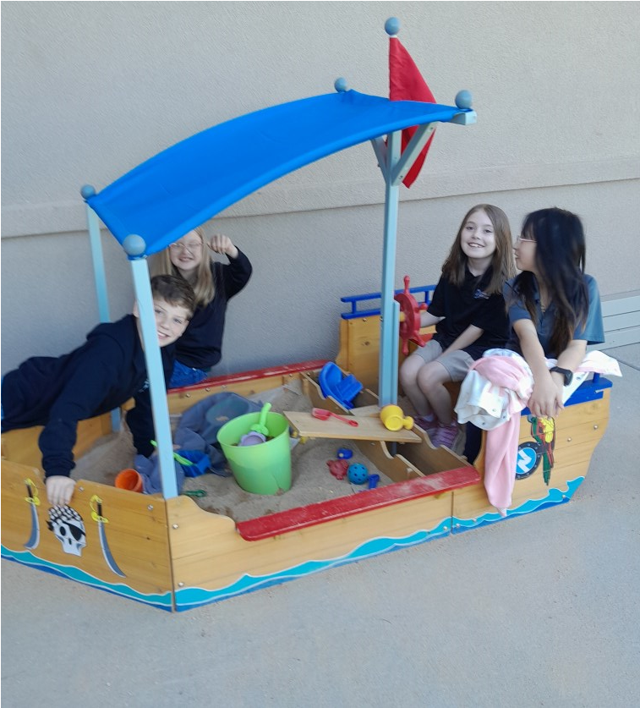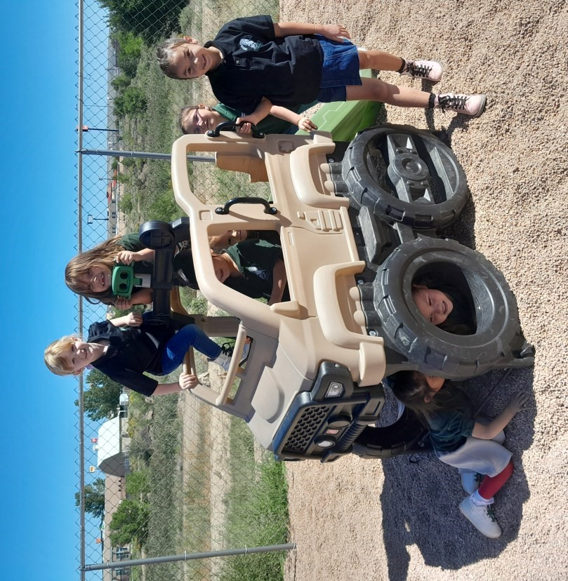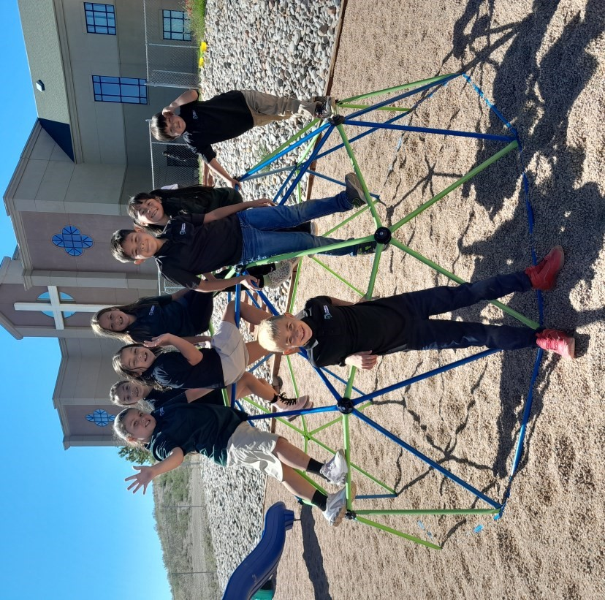
August/September

Charger News

2025

HELP

WANTED!!!

We are so excited about the amazing start that we
’
ve already had these first few weeks of school.

Our students are showing progress and are quickly adjusting to our expectations.

I want to thank Mr. Dietrick, Mr. Rodriguez and Mrs. Trujillo and a few of our students for assisting with the
assembly of our new playground equipment. The students are enjoying the new climbing dome and sandbox. We
are looking forward to playing with the new seesaw and outside basketball goal.

If you work with concrete or would be willing to help install these last two additions to the playground, please
contact the office or me directly to arrange a time to complete these tasks. It would be nice to have a few

volunteers who could complete these projects in the next few weeks. Thank you for making the beginning of the
year so enjoyable. We will continue to pray for God
’
s blessing on your family.

In Him,

Principal Vinson

Welcome Back!!!

