READER SUBMITTED

Dixie Highway arch ready for Blue Star Memorial Marker
Treasure Coast
Updated Oct. 25, 2016, 5:41 p.m. ET
The Blue Star committee of the Jensen Beach Garden Club is busy preparing the historic arch between Jensen Beach and Stuart on Dixie Highway for the Nov. 11 dedication ceremony of the Blue Star Memorial Marker.
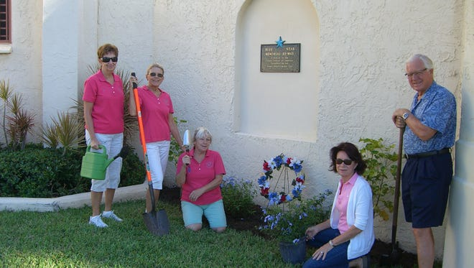
The dedication ceremony will take place on Nov. 11 at 2 p.m. in front of the Log Cabin in Langford Park. The public is urged to attend this patriotic and free event.
The name commemorates the blue star in the center of the white service flags which were first used during World War 1. Usually they were placed in the windows or on the front of the homes to denote a member of the family was serving in the nation's armed forces.
The niche on the south side of the arch will hold the marker. Dixie Highway will become part of a statewide system of Blue Star Memorial By-way Markers. U.S. 1 became the first Blue Star Memorial Highway in Florida in 1950. These highway markers are a tribute to the men and women who have or are now serving in the armed forces of the United States.
Contact JoAnn Labby at jpl219@bellsouth.net or 772-692-7054 for more information.
