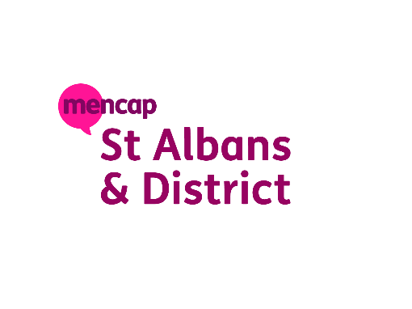

Providing Opportunities & Activities for adults with mental health issues or learning disabilities

St Albans URC, Homewood Road, St Albans, AL1 4BH
Email: deandavis@stalbansmencap.org.uk Mobile : 07399 570675
Service Manager : Dean Davis Chair: David Keen

Christmas Party December 15th 11:00-14:00
As part of the transition from the Trinity Community Project to St Albans Mencap, we would like to host a Christmas Celebration Event to bring members together, staff, volunteers and members of our wider community who would like to get to know us together in a relaxed and joyful atmosphere.
The event aims to:
- Celebrate the new partnership between Trinity and St Albans Mencap.
- Provide an inclusive experience for all members.
- Promote well-being, creativity, and social connection.
- Offer a fun and meaningful Christmas gathering for everyone
- There is a charge of £10.00 for everything carer staff free
- Please pay prior before the 16^{th of} December 2025

Activities will include:
- Create Your Own Christmas bauble
- Disco and Carol singing
- Festive Buffet, hot drinks, and juice
Schedule:
Monday, 15 December: Monday day service as usual 09.30-14.00pm normal charges for Monday day service members at £25.00 and don’t need to pay for Christmas party.
We will be closed on the 23^{rd of} December 2025 and we open again 5th January 2026
Have a great Christmas and new year
Thanks Dean and the Team

