St Albans United Reformed Church
Homewood Road, AL1 4BH
CHARITY CONCERT
in aid of
MENCAP / TCP
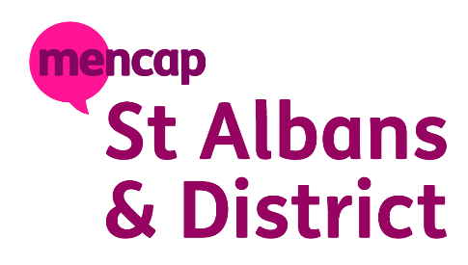

Saturday 20th June
7.00 pm
Homewood Singers and friends will be performing at this FREE concert.
Donations welcome.
REFRESHMENTS provided.

