**BME Suffolk Support Group**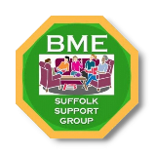

**Address:** Unit 5 Coach Court,

Old Cattle Market,

Ipswich, IP4 1DX

**Email:** Info@bmesuffolk.org

**Website:** www.bmesuffolk.org

Date:

Event:

**Feedback Form**

Feedback helps demonstrate to funders that we provide services to families in the Black community, other minorities, and the wider community. Thank you!

**Name: Postcode: Age: Country of Origin:**

1) How would you describe the event? Was it well planned?

2) What is your opinion on the atmosphere, the music, and the food provided?

3) Regarding the sense of community, how did you feel mentally and socially?

4) Would you be in favour of this event continuing annually? Please explain your reasons.

5) Do you have any suggestions for improvements or additions to future events?