TRI-PARISH PASTORAL PLAN
2026 - 2031
For the following cluster of parishes in the Diocese of Winona-Rochester:

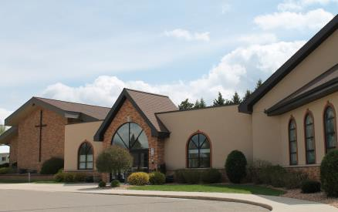
CHURCH OF CHRIST THE KING BYRON, MN

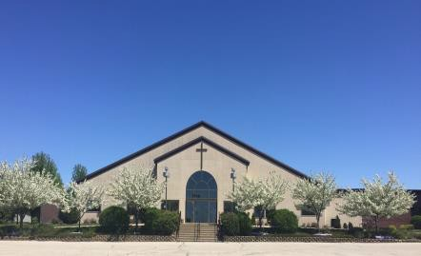
HOLY FAMILY CATHOLIC CHURCH
KASSON, MN
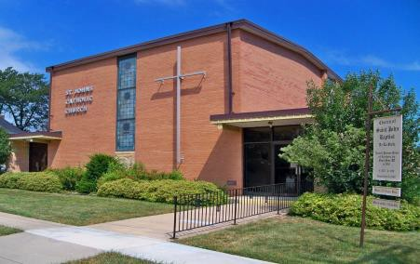
ST. JOHN BAPTIST de la SALLE DODGE CENTER, MN

Approved 01-29-2026


Vision, Mission, Focus Areas and Core Values
Vision: The vision of our parishes is to have active faith communities that worship God, care for the poor, and evangelize.
Mission: The parishioners of Church of Christ the King, Holy Family Catholic Church and St. John Baptist de la Salle are inspired by the Word of God, empowered by the Holy Spirit and nourished by the Eucharist. We are called by Christ to worship, to invite all with love, to nurture our faith and to serve others.


Focus Areas Core Values
Worship and Liturgy | We value active preparation and participation of parishioners in meaningful, inspirational and reverent liturgies. We cherish our faith as a gift from God and seek, recognize and act on opportunities to share it with others.
Faith Formation | We teach the truths of our Catholic faith as taught in the Catechism of the Catholic Church to all ages and reinforce and empower parents in their role as the primary educators of their children’s faith.
Community/Fellowship | We are obligated to respond to Jesus’s call of service to others and His instruction to love others as we love ourselves. We joyfully cooperate and build relationships within the parish and the broader community.
Sacraments | We faithfully celebrate and prepare for the sacraments, deepening understanding and strengthening parishioners to live their faith beyond the church walls.
Administration | We strive to provide knowledgeable, professional staff and principled councils who manage parish operations effectively, ensuring unified communication, strong leadership, and excellent stewardship of resources.

Comprehensive Pastoral Plan

Introduction –
In following Christ Jesus, we must use our resources wisely and to be most effective we must know what we are trying to accomplish, and through prayer and guidance we will do it. We as a faith community need to know where we are going (vision), how we will travel (mission), and we need a map and itinerary (pastoral plan) to guide us.

Pope Benedict XVI said the Church does three essential things: worships God, cares for the poor, and evangelizes. Our Pastoral Plan priorities should fit under one of these three headings.

Our History
Our tri-parish faith community includes The Church of Christ the King in Byron, Holy Family Catholic Church in Kasson, and Saint John Baptist de La Salle in Dodge Center, each rooted in decades of Catholic faith and service in our region.
The Church of Christ the King in Byron was established in 1963 by Bishop Edward Fitzgerald, with Father Vernon Schaefer appointed as its first pastor. The first Mass was celebrated that year in the Byron elementary school gymnasium with approximately 175 parishioners. A church was soon built and dedicated, followed by a rectory with classrooms and a social hall in 1964, which served both parish education and community events.
Continued growth led to the construction of a second church in 1976, dedicated in 1977 by Bishop Loras Watters, with classrooms for religious education. The original church became Schaefer Hall, serving as a social and gathering space for parish events. Several pastors served the parish over the decades, helping guide its expansion and ministries. In 1990, Bishop John Vlazny assigned one pastor to serve both Christ the King and Holy Family parishes. To meet the needs of Christ the King’s growing Catholic community, a new church and gathering space were constructed and dedicated in 2004, providing an updated worship area and improved facilities for parish life.

Holy Family Catholic Church in Kasson was established in 1976, but Catholic life in Kasson dates to 1875, when a small community built its first church – which was destroyed by fire in 1884. Decades later, in 1953, the mission church of Saint Olaf was established. In 1954, a basement church was constructed, and the first Mass was celebrated by Father Vernon Schaefer.

In Mantorville, Saint Margaret, one of the oldest parishes in the Diocese of Winona, began as a faith community served by traveling priests who celebrated Mass in parishioners’ homes. A permanent church building was purchased and dedicated as Saint Margaret in October 1910 by Bishop Patrick Heffron.

In the mid-1970s, the parishioners of Saint Olaf and Saint Margaret joined together, and the first Mass of the combined Holy Family Parish was celebrated on December 19, 1976. Bishop Loras Watters consecrated the church in June 1977. To serve the growing community, a new Holy Family church was built in 1994 and dedicated in 1995, while the 1977 church became Marian Hall, serving as a center for parish gatherings.

Saint John Baptist de La Salle in Dodge Center was established in 1945 after Bishop Lee Binz commissioned Father George Smith in 1944 to form a new parish. Property purchased later that year included a large house, with its lower rooms remodeled to serve as a chapel. The first Mass was celebrated in 1945 with 38 families present. Bishop Binz selected Saint John Baptist de La Salle as the parish patron, honoring the Christian Brothers at Saint Mary’s University in Winona.

Construction of a basement-level church began in 1950 and was completed in 1952, with the church completed and dedicated in 1958, on the Feast of Christ the King. Two decades later, major renovations in 1979 updated the interior through volunteer effort. In 1988, Saint Francis de Sales in Claremont was added as a mission, followed by Saint Vincent de Paul in West Concord in 1990. In October 2016, both were designated as oratories, while Saint John continued as the main parish.
The commitment to outreach by education remains strong and continues to this day as a part of the Tri-Parish.
In 2019, Saint John Baptist de La Salle became part of the tri-parish cluster with Christ the King and Holy Family, with Father John Lasuba serving as pastor for all three parishes.

The Pastoral Plan
The Pastoral Council has the responsibility for approving a Pastoral Plan with clear and concise strategies and initiatives based on the Mission Statement, ensuring compliance with diocesan policies and directives as emerging needs are identified.

The Pastoral Council initiated the planning process on October 15, 2024. A Pastoral Planning Committee was formed with representatives from each of the three parishes. The committee received feedback from parishioners through surveys and a listening session. The committee developed a Pastoral Plan draft for the Pastoral Council to review and revise. This Pastoral Plan was approved by the Pastoral Council on January 29, 2026, for the period of 2026-2031.

The Pastoral Plan strategies and initiatives should be evaluated annually and revised as needed. A new Pastoral Plan should be developed in 2031.

1. WORSHIP AND LITURGY
Core Value
We value active preparation and participation of parishioners in meaningful, inspirational and reverent liturgies. We cherish our faith as a gift from God and seek, recognize, and act on opportunities to share it with others.
Strategy | Initiatives | CK | HF | SJ
Increase understanding of the different aspects of Mass. | - Present information before Mass.  - Conduct a teaching Mass annually.  - Provide handouts in pews about the Mass.  - Printing homilies for parishioners for weekend Masses.
Increase the number of lay volunteers for Mass and parish activities. | - Organize a Stewardship Sunday/Weekend.  - Explain lay ministries.
Provide parishioners with more opportunities for Eucharistic Adoration and prayer. | - Provide access to churches for prayer.  - Establish additional Adoration hours to accommodate different preferences.  - Provide education about Adoration and its beauty.  - Continue First Friday Adoration.
KEY: A = Achieved P = Progress NP = No Progress N/A = Not Applicable

2. FAITH FORMATION
Core Value
We teach the truths of our Catholic faith as taught in the Catechism of the Catholic Church to all ages and reinforce and empower parents in their role as the primary educators of their children’s faith.
Strategy | Initiatives | CK | HF | SJ
Provide more opportunities for multi-generational learning. | - Explore additional opportunities for family faith formation.
Increase/promote opportunities for faith formation for all ages | - Provide information about Steubenville, TEC, SEEK, Lifeline Mass, Diocesan activities, etc.  - Explore ways to provide funding for attendees.  - Encourage previous attendee testimonies.  - Recruit a youth minister.  - Encourage/provide faith formation opportunities for youth/young adults up to 25 years of age.
KEY: A = Achieved P = Progress NP = No Progress N/A = Not Applicable

3. COMMUNITY / FELLOWSHIP
Core Value
We are obligated to respond to Jesus’s call of service to others and His instruction to love others as we love ourselves. We joyfully cooperate and build relationships within the parish and the broader community.
Strategy | Initiatives | CK | HF | SJ
Make our Tri‑Parish grace‑filled and welcoming communities. | - Re-establish parish Welcoming Committees.  - Offer small group opportunities.  - Establish Social Committees.  - Create a welcoming gathering space for sharing parish and tri-parish activities.  - Offer quarterly tri‑parish activities.  - Provide fellowship activities at each parish, such as:  - Donut Sunday,  - Women’s and men’s activities,  - Community events
Strengthen our homebound ministry. | - Identify those unable to attend Mass and the services they may need.  - Reach out to parishioners not recently seen at Mass.  - Communicate homebound ministry with our parishioners and provide information about the ministry.  - Recruit volunteers.
KEY: A = Achieved P = Progress NP = No Progress N/A = Not Applicable

4. SACRAMENTS
Core Value
We faithfully celebrate and prepare for the sacraments, deepening our understanding of the sacraments and strengthening parishioners to live their faith beyond the church walls.
Strategy | Initiatives | CK | HF | SJ
Promote and educate parishioners about the Sacraments of the Catholic faith. | - Utilize various forms of education about the seven sacraments.  - Baptism  - Reconciliation  - Eucharist  - Confirmation  - Holy Orders  - Matrimony  - Anointing of the Sick
Provide more opportunities for parishioners to receive the Sacrament of Reconciliation. | - Continue offering reconciliation during First Friday Adoration.  - Add additional times for reconciliation at each parish.
KEY: A = Achieved P = Progress NP = No Progress N/A = Not Applicable

5. ADMINISTRATION
Core Value
We strive to provide knowledgeable, professional staff and principled councils who manage parish operations effectively, ensuring unified communication, strong leadership, and excellent stewardship of resources.
Strategy | Initiatives | CK | HF | SJ
Review and update personnel policies and staffing needs. | - Revise/update job descriptions, personnel policies, and benefits information.  - Assess the feasibility of hiring an Office Manager.
Unify communication in all forms for the Tri‑Parish. | - Establish a single Facebook page and Flocknote for all three parishes.  - Explore having a single website for all three parishes.
Provide general information to parishioners. | - Inform parishioners of Christ the King that hymnals are available; order a few each year.  - Provide rationale for why Mass times will stay the same. (Father to address)
KEY: A = Achieved P = Progress NP = No Progress N/A = Not Applicable

