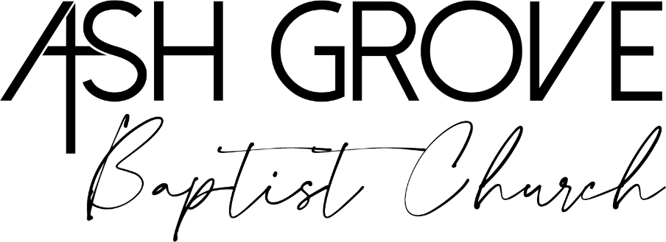
201 E. Walker St.
Ash Grove, Mo 65604
(417)751 - 2441

Parental/Guardian Permission Slip for Church Activity
Child’s Name: _____________________________________________________________________
Parent/Guardian Name: ____________________________________________________________
Activity Name: _____________________________________________________________________
Date(s) & Time: ________________________

I, _______________________________________ (Parent/Guardian Name), give my permission for my child, ________________________________ (Child’s Name), to participate in the above-mentioned activity at ASH GROVE FIRST BAPTIST CHURCH. I understand that reasonable precautions will be taken to ensure their safety. I further understand that by signing this permission slip, I release and hold harmless ASH GROVE FIRST BAPTIST CHURCH and I release and hold harmless trustees, officers, employees, and any volunteers from any liability, past or future, fully and completely.
In case of emergency, I authorize the church staff or designated adult supervisor to seek medical treatment for my child. I understand that I will be notified as soon as possible in the event of an emergency.
Emergency Contact Name: _________________________________________________________
Phone Number: ____________________________________________________________________
Allergies or Medical Concerns: ______________________________________________________

Signature (Parent/Guardian): ________________________________________________________
Date: __________________

