
Issue No. 52
February 2026

BOB AHP Faculty Newsletter


Want to know more about the BOB AHP Faculty? Follow us on  @BOBAHPFaculty

Take a look at our Information and resource Padlet: BOB AHP Faculty Padlet


NHS England Event - Celebrating EDI in the Educator Workforce
This webinar will focus on EDI, sharing best practice and innovation breaking down the barriers to learning as well improving and creating an inclusive workforce.
25 February 10.30-11.30.
There is further information and register Celebrating EDI in the Educator Workforce | NHS England Events


Masterclass Series & CPD
Upcoming events
- Multi-professional Consultant Practice Unpacked: Progress, Purpose, and Possibilities - Date: 10th Feb 2026 Time: 12:30 to 13:30
- Mental Health and Learning Disabilities and Autism - Date: 17th March 2026 Time: 12:30 to 13:30
- Health Inequalities - Date: 23rd April 2026 Time: 12:30 to 13:30

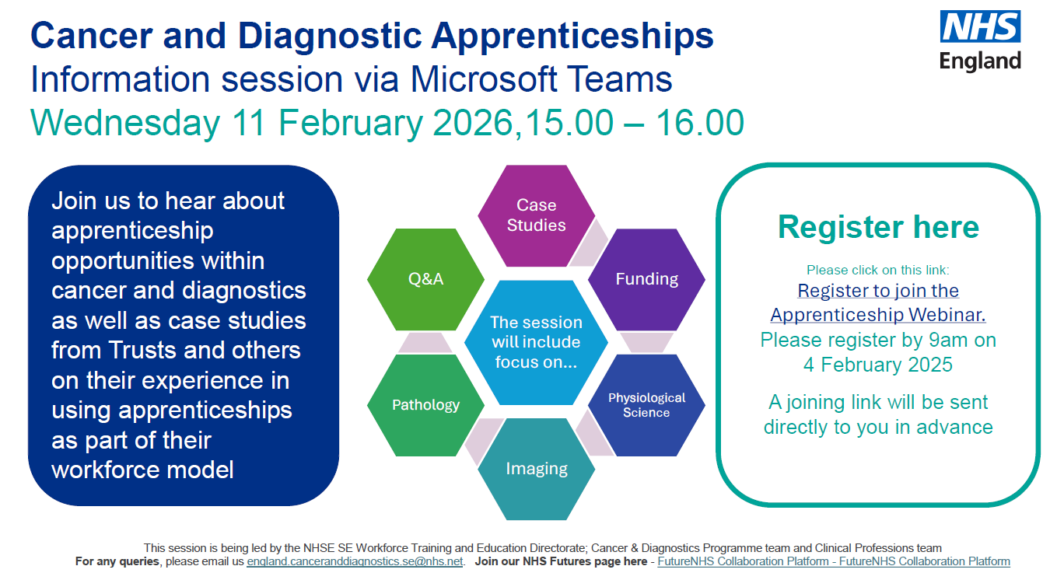
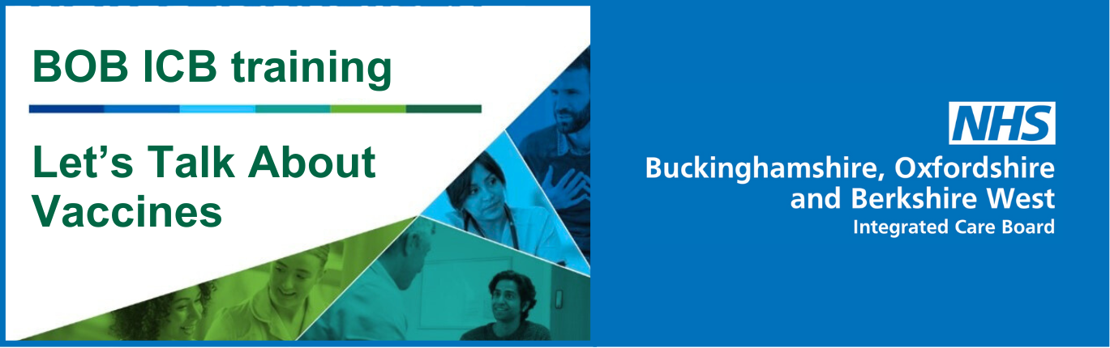
Are you interested in building your discussion skills around vaccine hesitancy?
Let’s Talk About Vaccines is a training session to help build your confidence, skills and knowledge to open up discussions with patients about vaccination decisions.
This 2.5-hour online, interactive session is free to health, social care and voluntary sector staff and students working in Buckinghamshire, Oxfordshire, Berkshire West and Frimley. It explores the issues, myths and barriers around vaccine hesitancy, providing you with the techniques and approaches to help people make informed choices.
The training has resumed with two sessions remaining and available to book on 12 February and 12 March 2026 on BOB ICB’s Let’s Talk About Vaccines training page. Here you can find further information about the training including two videos on why the trainers recommend the session and what staff will get by attending.
Attendees will also be invited to a series of one-hour community of practice (COP) session to enhance learning, share ideas and experience, and ask questions following each training date. Each COP has a pre-advertised topic.

Advancing Healthcare Awards:
The AHP Research Excellence Award
This award has been established to celebrate the vital contribution of Allied Health Professionals to the research landscape and to recognise those who are driving innovation and improving outcomes through evidence-based practice.
Key Details:
- Award: AHP Research Excellence Award
- How to Enter: Visit the Advancing Healthcare Awards portal and click ‘Enter Now.’
- Deadline: Monday, 16th March 2026

