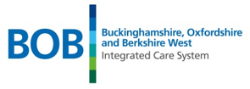
Issue No. 51
January 2026

BOB AHP Faculty Newsletter

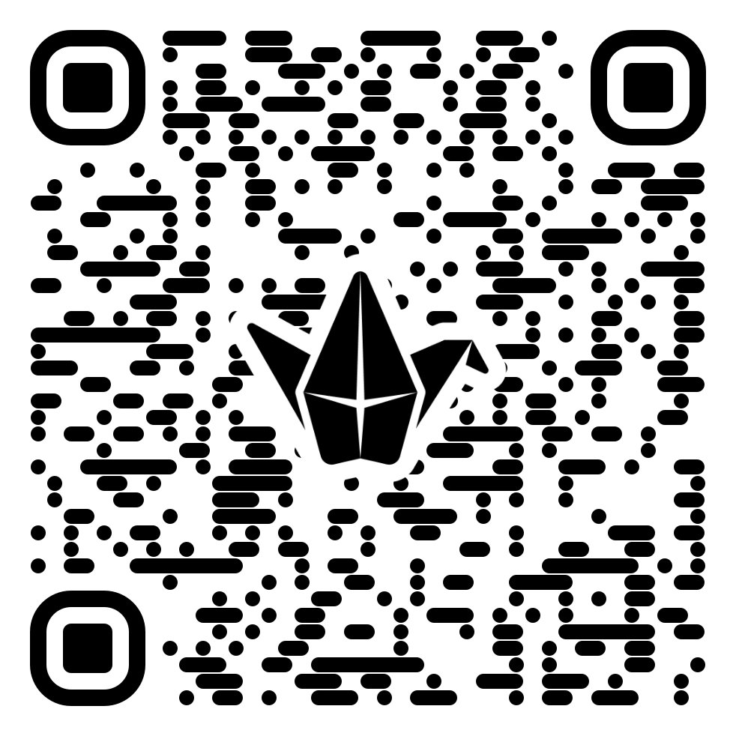
Want to know more about the BOB AHP Faculty? Follow us on  @BOBAHPFaculty

Take a look at our Information and resource Padlet: BOB AHP Faculty Padlet
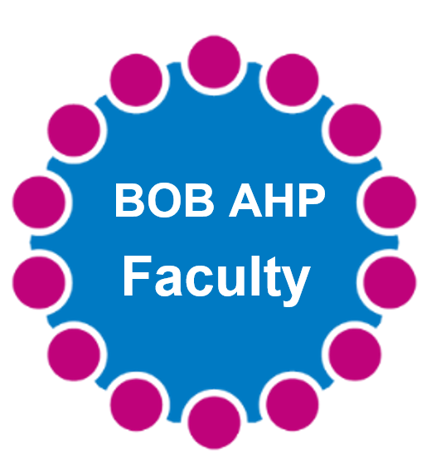

New programme offers all Allied Health Professionals the opportunity to build digital and data skills
A Chartered Society of Physiotherapy (CSP) collaboration has led to the launch of a new digital education programme, giving physiotherapists and all UK Allied Health Professionals (AHPs) access to essential digital and data knowledge and practical skills.The Digital and Data Foundations education programme is funded by the NHS Digital Academy and the CSP Charitable Trust, in collaboration with Keele University, EL Healthcare Education, and other AHP professional bodies.
This free, module-based programme offers bite-sized content, allowing learners to access it at their own pace around work or study commitments. Using interactive content, real-life case studies, and reflective activities, the programme supports AHPs to apply learning within their own team, service, or setting.Access is free for all AHPs, including students and support workers,as well as those not working in the NHS or working in other parts of the UK.
Register now through the NHS Digital Academy Campus
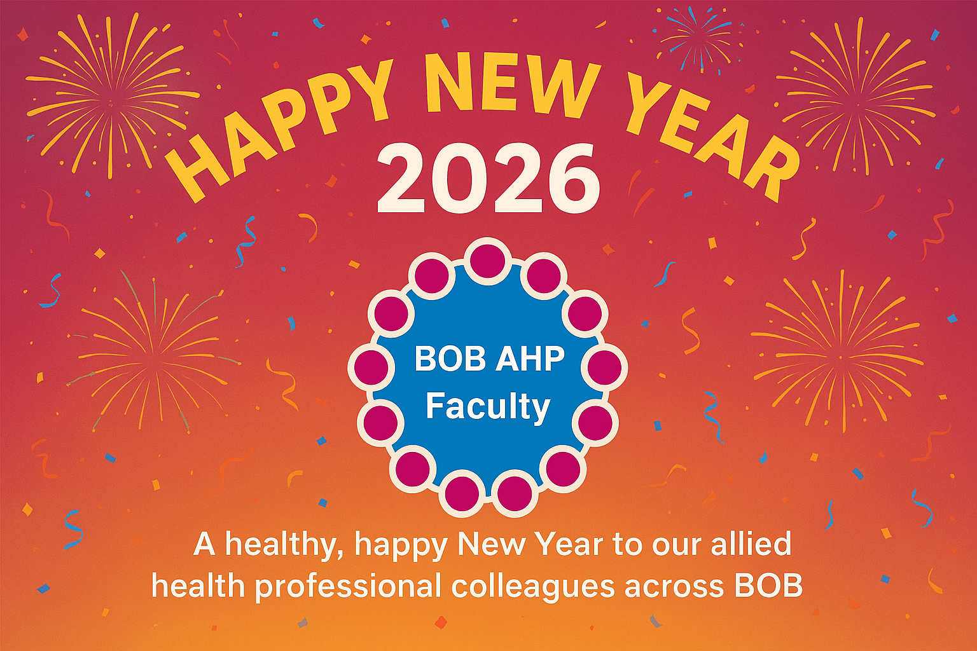
Here’s to a year filled with fresh opportunities, great collaboration, and plenty of wins, big and small.
Let’s make this our best year yet!

Thursday 22nd January 2026 1130-1230 Join the meeting now
Christine Ireland is kindly presenting and sharing Makaton Skills. Sharing with us basic skills to allows us to communicate with our service users and support us with an inclusive delivery of care.

Caseload Management Tool Launch on:
Wednesday 21st January 2026
12:00pm – 1:00pm
The Caseload Management Tool is an in-house digital solution, co-designed with local system colleagues and clinicians across acute, community, and primary care. It provides a shared, near real-time view of patients and their needs, enabling services to work smarter, more integrated, and more collaboratively across boundaries.Think of it as a “Comprehensive Care List” – where all relevant information for each resident and their specialty is displayed in one place.
What to expect from the launch workshop:
- An overview of why the tool was developed.
- A live demonstration of its features and benefits (within existing caseloads CVD, diabetes & advanced care planning)
- Insights from clinicians already using the tool, sharing their experiences and its impact in everyday practice.
Please save the date and sign up to attend the webinar using the link below:
https://forms.office.com/e/kfxHvRPMaM
If you have any questions, please contact: fhft.digitalics@nhs.net
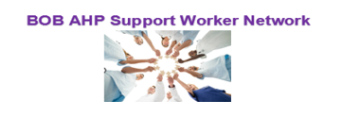
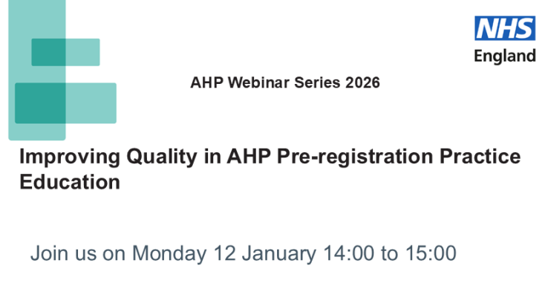

Purpose of the session:
This webinar aims to update attendees on the progress and future direction of the approach to promoting quality in

Session Aims:
- Update attendees on national work to improve AHP practice education, including progress so far and what’s coming next.
- Support organisations to use the Safe Learning Environment Charter, with examples from NHS Trusts.
- Share good practice from across the country to help inspire local improvements.
- Encourage peer learning and connections to support collaboration.
- Signpost useful resources, guidance, and tools to help embed high-quality AHP education in all settings.
Who Should Attend:
This session is ideal for:
- All AHP Leaders – Exploring innovative strategies for workforce development
- AHP System & Provider Leads – Seeking sustainable workforce solutions
- AHP Educators – Focused on advancing training programs and educational initiatives for AHPs.
- Policy Makers & Senior Health Leaders – Tracking AHP-led innovation
- Students & Learners – Looking to explore exciting pathways into AHP careers

Registration link: Microsoft Teams Events Link

