
Issue No. 49
November 2025

BOB AHP Faculty Newsletter


Want to know more about the BOB AHP Faculty? Follow us on  @BOBAHPFaculty

Take a look at our Information and resource Padlet: BOB AHP Faculty Padlet





Wednesday 26th November
9:30 to 10:30
🔹 Join us for an engaging Introduction to Mindful Awareness which will help you better understand stress, its impact, and your personal locus of control. Through practical techniques and guided reflection, you’ll learn how to cultivate calm, strengthen resilience, and shift your perspective toward what you can influence, empowering you to respond to challenges with clarity and balance.Speaker: Rashmi SHARMA, MSc - Mindfulness Lead & Wellbeing specialist
Click on the link to join:
Join the meeting now

Applications Opening Soon: Transforming Healthcare Through Innovation

From 3rd November 2025, the NHS Clinical Entrepreneur Programme will begin accepting applications for its next cohort. These initiatives are designed to support individuals with innovative ideas that have the potential to improve patient care and transform healthcare delivery.
Three distinct programmes will be available:

- Clinical Entrepreneur Programme – For NHS staff, across the UK, with ideas to enhance patient outcomes and service delivery.
- Patient Entrepreneur Programme – For patients and carers in England with lived experience and innovative solutions to healthcare challenges.
- Dementia Innovators Programme – For those health and social care staff developing impactful solutions for people affected by dementia.

Successful applicants will gain access to expert mentoring, tailored education, and a powerful network of healthcare leaders, entrepreneurs, and investors. These programmes aim to help turn ideas into scalable, sustainable innovations that deliver real-world impact.
Applications will be open from the 3rd to the 28th of November 2025.
For more information and how apply, visit: www.nhscep.com or join their CEP Prep Sessions and in person event to get application ready! Questions can be directed to: cep@aru.ac.uk

The webinar is for all health and care professionals including our support workforce and students.
Hear from the experts and learn about blood pressure, understanding the numbers, associated disease risk, advice on reducing BP and more!
📅 Date: Wednesday 19th November 2025⏰ Time: 12.30-2.30pm
Register via the link:
https://forms.office.com/e/Y9a03jLL9t



NETS 2025 is now live!

We are pleased to confirm that the National Education and Training Survey (NETS) 2025 is now live. The survey is open from 7 October to 2 December 2025 and provides a vital opportunity for healthcare learners, trainees, apprentices and resident doctors to share their experiences and help shape the future of healthcare education and training across the NHS.

We kindly ask that you share the survey link and communications toolkit link with your respective networks, including professional, regional, and local contacts.

Survey link: https://www.hee.nhs.uk/nets-2025

.

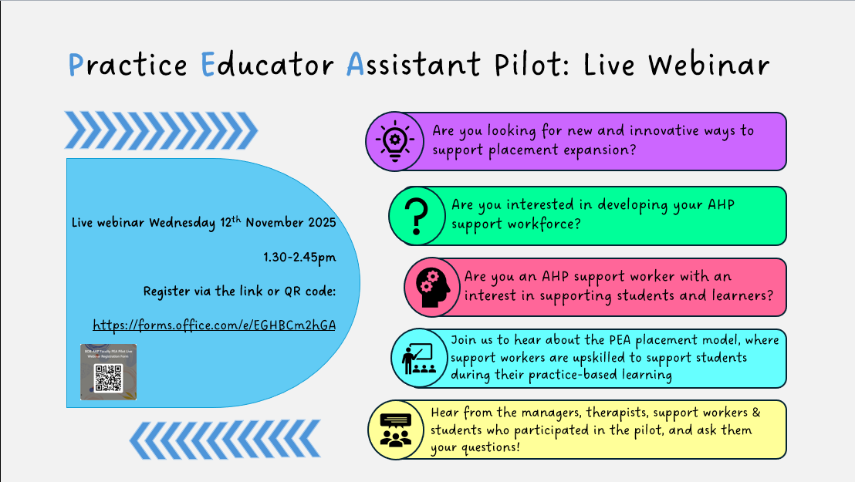Registration Link: https://forms.office.com/e/EGHBCm2hGA



The Centre for Advancing Practice Annual Conference Registration is now open.

Theme: Ten Years, Three Shifts, One Mission: Advancing Practice for the Future NHS

Dates: 10–14 November 2025 / Format: Fully Virtual

Hashtag: #AdvancingPractice2025

Registration Link: https://advanced-practice.hee.nhs.uk

Contact: england.advancedpractice@nhs.net


Serving as a Buckinghamshire, Oxfordshire, Beckshire West (BOB) Allied Health Professional (AHP) Support Worker Project Lead offered me a dynamic and enriching learning experience. The role cultivates key leadership skills such as strategic thinking, stakeholder engagement, communication and change management. It also provides hands-on experience in workforce development, enabling you to influence policy, shape training initiatives and support the growth and recognition of the AHP Support Workforce. Through collaboration across systems and professions, you gain a deeper understanding of service delivery and contribute meaningfully to building a more sustainable and empowered workforce. I would strongly encourage AHP Support Workers to consider taking on the Project Lead role. It offers a valuable opportunity to gain a broader understanding of the healthcare system and explore your professional aspirations. It also enables you to serve as a key point of reference between registered and unregistered staff, fostering communication, collaboration and mutual understanding across the workforce. This experience not only enhances leadership and strategic thinking but also helps shape your vision for the future. I would also like to express my heartfelt gratitude to my close colleagues who made my 12-month secondment truly memorable. A sincere thank you to Sajida Hanif, Geraldine Conway and Gemma Donnelly for your continued support and guidance throughout this journey.

Jaïana Lancien
Unregistered AHP as Band 5 AHP Support Worker Project Lead Secondment


