
Issue No. 48
October 2025

BOB AHP Faculty Newsletter


Want to know more about the BOB AHP Faculty? Follow us on  @BOBAHPFaculty

Take a look at our Information and resource Padlet: BOB AHP Faculty Padlet
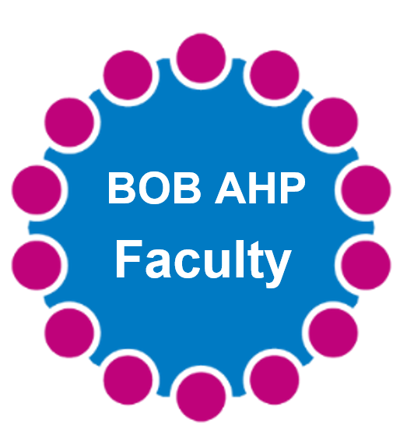


Thursday 16th October
9:30 to 10:30
Join us for two inspiring sessions:
🔹 Empowering Supportive AHPs through ACCEND: Advancing Careers Across BOB ICB’
This presentation highlights how the ACCEND (Aspirant Cancer Career and Education Development) framework supports career progression for this workforce. By offering structured pathways, competency-based development and targeted learning, ACCEND helps unlock potential, build confidence and strengthen cancer care services. Embedding ACCEND into workforce planning ensures clear, supported routes for growth and retention across the system.
Click on the link to join:
Join the meeting now

Advancing the AHP Workforce in Rural & Coastal Communities webinar
Join us for an insightful session exploring the unique challenges and opportunities facing Allied Health Professionals (AHPs) in rural and coastal areas. The aim is to highlight impactful workforce initiatives and foster collaboration for future solutions.Taking place on the Thursday 02 October 2025 1.30-2.30pm. Registration link: Microsoft Virtual Events Powered by Teams We look forward to having you attend the event.

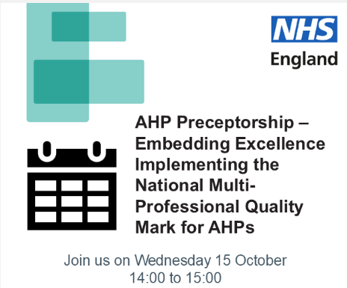

Webinar 9 - We look forward to having you attend the event
Registration link: MICROSOFT Virtual Events Powered by Teams
Registration for this event is required. Slides and evaluation will be shared post the webinar.
Purpose of the session:
This webinar aims to update attendees on the progress and future direction of the National AHP Preceptorship Programme, while supporting system and organisational readiness for the Multi-professional Preceptorship Quality Mark. Through sharing best practice, peer learning, the session will empower participants to drive high-quality preceptorship locally. Attendees will also be signposted to key resources, tools, and national guidance to support implementation and collaboration across the workforce.
Aims of the session:
- Provide a comprehensive update on the National AHP Preceptorship Programme, including key outputs, progress to date, and future direction.
- Support system and organisational readiness for achieving the Multi-Professional Preceptorship Quality Mark, with insights and learning from early implementer sites.
- Share best practice examples from across the country to inspire innovation and support effective local implementation.
- Facilitate peer learning and networking, enabling attendees to identify opportunities for collaboration.
- Signpost to essential resources and support, including national guidance, toolkits and forums to help embed high-quality preceptorship across settings.

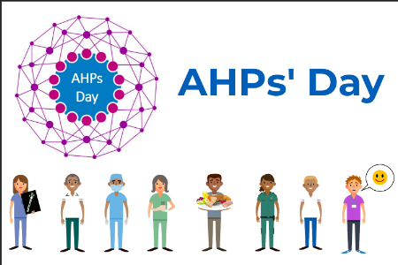
Happy AHPs’ Day!!
A Heartfelt thank you to all our incredible Allied Health Professionals, registered and unregistered for the vital role you play as clinician, leaders, researchers and educators. Your unwavering commitment to providing high-quality of care transforms the lives of patients every day. We’re deeply grateful for your enthusiasm and engagement with our BOB AHP faculty, which strengthens and inspires us all. Today, we celebrate you and the remarkable impact you make.
Thank you everything you do!

The Greener Digital team are running a series of drop in sessions which are open collaboration spaces to enable you to connect, share, and grow.
These sessions won't have an agenda, but you will be invited to:
- share your current work and achievements in digital sustainability
- ask questions or raise challenges you're facing
- highlight your training needs and areas for support
- learn how Greener Digital practices can boost efficiency, accessibility, security and even reduce costs
Session Dates and Times
- Thursday 23 October at 2pm
- Thursday 27 November at 2pm
- Wednesday 17 December at 2pm
To register please email england.greenerdigital@nhs.net a Teams invite link will be sent a few days before.
Colleagues are also encouraged to access the Greener Digital virtual front door via FutureNHS to keep updated on events and updates on guidance / policies etc within Greener Digital.
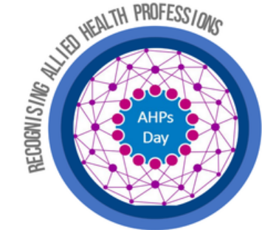The CAHPO for England, Professor Suzanne Rastrick OBE, will deliver a live address to the AHP workforce from
9:30-10.15am on AHPs Day, 14 October. The 2025 CAHPO Awards winners will also be announced at the end of the live address. You can access the livestream here: AHPs Day Live Address. The recording will be saved on the National AHP Virtual Hub on Future NHS (registration required).


Please click on the link below to register: Speech and Language Therapists in Higher Education Registration Form

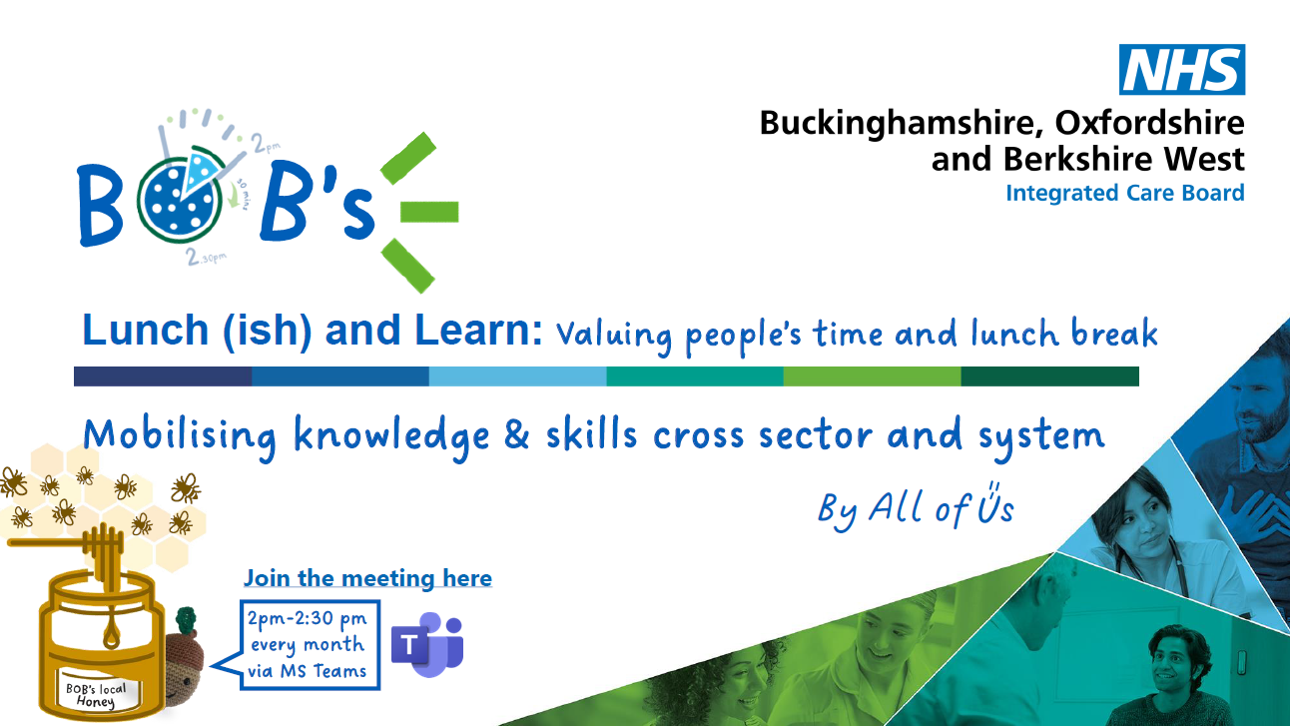
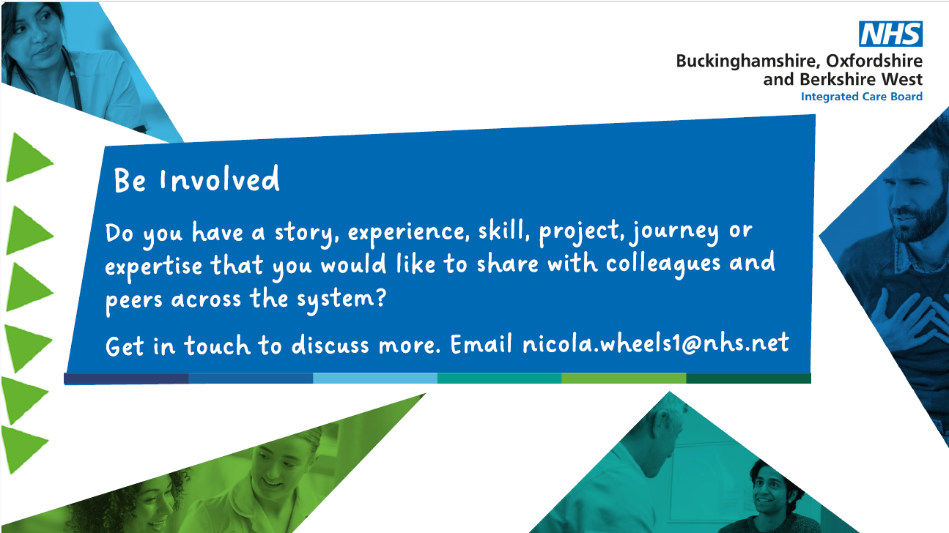
For the new monthly series link to access our forthcoming Lunch(ish) and Learn sessions, please click on Join the meeting now . No booking required. See above flyer with an “In a Nutshell” overview of our Sharers. Forthcoming dates:
21st October 2-2:30pm
18th November 2-2:30pm
16th December 2-2:30pm
Further details for each date will be issued in due course. Please do forward this information on to your colleagues, networks and communities of practice.


Click on this link to register: Microsoft Virtual Events Powered by Teams


Click on this link to register: Microsoft Virtual Events Powered by Teams

