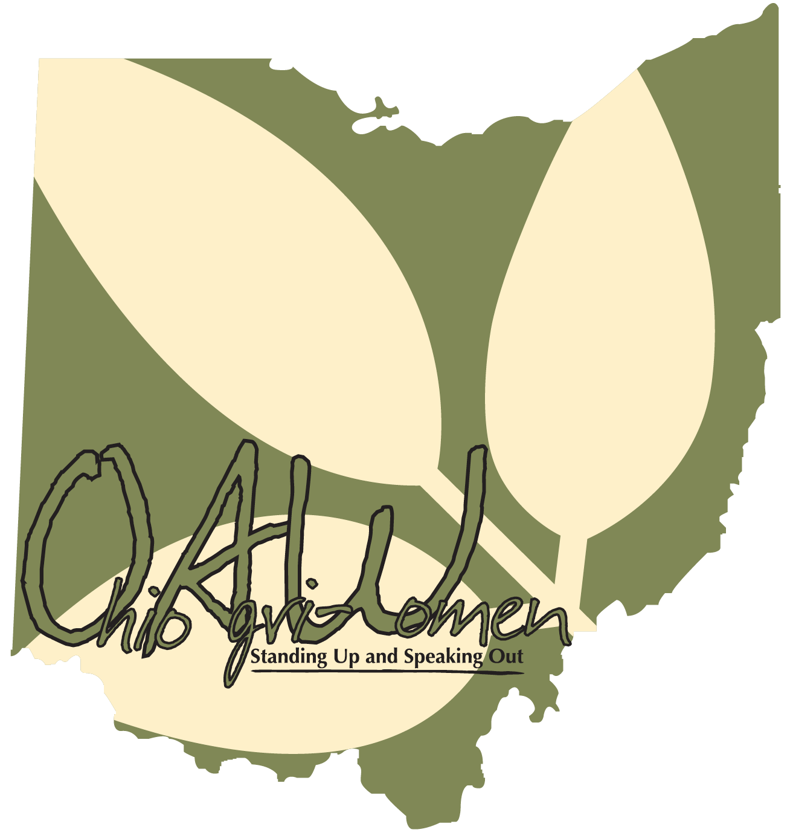**Ohio Agri-Women 2025**

**Scholarship Application**

*Ohio Agri-Women will award two $1,000 undergrad or graduate scholarships to women 24 years or younger for the 2025-2026 school year, with career and life goals to make a difference to better the agriculture industry****. Visit ohioagriwomen.com to download a digital copy of this application to complete.***

***Deadline Friday, August 29***

**Name, mailing address, phone and e-mail of applicant:**

**College/University you are attending, year in school and major:**

**List your on and off campus accomplishments, leadership abilities, community service involvements, etc.** *(can also attach resume if you would like)***:**

**Please give a summary of your experience in agriculture and describe how it has contributed to your life today:**

**What are your long-term goals?**

**Tell us about a current issue/policy facing the agriculture industry you feel should be addressed urgently with our legislature and why is this important to you?**

**Tell us about a time when you educated someone about agricultural practices and if their viewpoint/perspective changed, if not, what do you think would be an effective approach to use in the future?**

Return this application by **August 31** along with a self-picture and one personal letter of reference to: Lauren Eyre, [farmgirlwithcurls@gmail.com](mailto:schwablm@miamioh.edu)

Lauren will reply by email confirming she received your application

Winners will be contacted by Sept. 5 and be invited to our scholarship fundraiser event to be recognized on Sept. 9 at the Olde School House Winery in Eaton, OH if available.