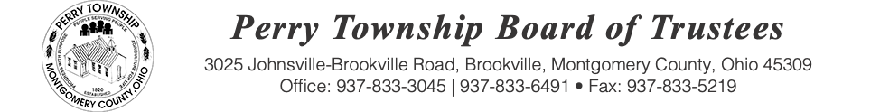

BOARD OF TRUSTEES MEETING AGENDA

January 13, 2026 @ 6:00 p.m.
Location: Administrative Building
3025 Johnsville Brookville Rd, Brookville, OH 45309

Welcome

Meeting called to order

Pledge of Allegiance

Roll Call:

Executive Session pursuant to ORC 121.22 (G)(1)

Consent Agenda: Matters listed under the Consent Agenda are considered to be routine and will be enacted by one motion and one vote of consent. There will be no separate discussion of these items. If a discussion is desired, that item will be removed from the Consent Agenda and considered separately.
-Acceptance of the following minutes
- November 18, 2025
- November 25, 2025
- December 2, 2025
- December 9, 2025
- December 23, 2025
-Acceptance of bills being paid
- Check numbers 39093-39099
- Electronic warrant numbers 609-2025 through 654-2025
-Approval of blanket certificates
- No blanket certificates
Fiscal Officer Report:

Roads and Cemeteries Report:

Zoning Administrator Report:

Police Department Report:

Old Business:

New Business:

Public Comments:

Adjourn:

